Acrise Church News: November 2025
Services for November (9.30am)
Sunday 2nd November Holy Communion Sharon
Sunday 9th November Matins BCP and Act of Remembrance Janet
Sunday 16th November Morning Prayer CW Janet
Sunday 23rd November Service of the Word Janet
Services for Sunday 30th November
Benefice Service at St Peter’s Swingfield 10.00am
Eucharist at Canterbury Cathedral 11.00am

The Rector’s Message for November
The Rector’s wonderings…I wonder if you’ve ever passed a quick judgement on someone without knowing the whole story?
We can sometimes unfairly judge others who we know very little about, based on gossip.
Proverbs is a book of wisdom in the Bible and says, “The words of a gossip are like choice morsels; they go down to a man’s inmost parts.” ( Proverbs 18:8). When we listen to gossip, it goes to our “inmost parts.” Gossip sinks its teeth into our hearts, souls, and minds and corrupts us like a fast spreading cancer.
Gossip is always trouble. Gossip obscures the truth. Gossip drives us from God. Gossip ruins reputations. Gossip destroys relationships. Gossip divides churches. Gossip is incredibly destructive.
Rather than tearing people down, we should build them up!
How do we do that? Well, one of the ways we do that is through encouragement.
Proverbs 12:25 says:
“Anxiety in a person’s heart weighs it down, but a good word cheers it up.”
Don’t weigh down someone’s heart by giving them something to be anxious about through your gossiping. Instead, cheer up someone’s heart by giving them a good word.
Challenge yourself this month in this one way:
Make a pledge to encourage rather than gossip.
Can you imagine how wonderful it would be if all the gossip in our community turned into encouragement?
Ask yourself these questions (attributed to Socrates):
Is it true? Is it necessary? Is it kind?
Let that be your guide. Here’s another tip: If in doubt, don’t say it.
Dear Lord, Set a guard over my mouth ; keep watch over the door of my lips. Help me to be an encourager by speaking a good word.” Amen ( Psalm 141:3)
Foodbank Donations: Folkestone Rainbow Centre
A big thank you to all who made such generous donations of food and some toiletries at our Family Harvest Festival Service and our Harvest Eucharist. The offerings were made as part of our harvest thanksgiving and filled the Chancel pews. There were 12 large boxes of food items and one container of toiletries which just about fitted into one car and were taken to a local food bank collection point at Hawkinge Community Centre. Thanks to Joan and John for organizing, packing and delivering the items.
We need to continue to support our local foodbank as the number of people in need increases. Most urgently needed items are: white cooking sauces, curry sauce, custard, squash(drinking), long life milk and juices, pickles, coffee (large and small), cooking oil, mayonnaise, noodles.
Running low: tined fruit, long life puddings, gluten free foods, marmalade, chocolate spread, chocolate/snacks/crisps, tinned fish (not tuna), pasta in sauce (packets), razors, toilet roll, washing up liquid, deodorant.
As well as food banks, the number of food pantries has increased; there are now six in the Folkestone and Hythe area. Pantries are like shops: members choose food from the shelves after paying a subscription of £7. They do not need to be referred but fill in an application form and need to visit weekly or monthly to remain members. This is a great help for people who are finding it difficult to make ends meet.
The Rainbow Centre also has a Homeless Support Service which earlier this year received planning permission to convert a Folkestone hotel into accommodation for emergency and supported housing for local people experiencing homelessness. The aim is to identify people before they spiral further into a life of poverty. On average there are 25 people a night sleeping rough in Folkestone.
The Royal Kentish Camino
This is a 23 mile walking route from Canterbury to Folkestone that has been developed as a joint initiative by the churches of St Martin, Canterbury, St Mary and St Ethelburga, Lyminge, and St Mary and St Eanswythe, Folkestone. It was launched on 27th April 2024 with funding from Folkestone and Hythe District Council to celebrate the achievements of three incredibly brave and influential women from successive generations of the Kentish Royal Family in the 6th and 7th Centuries AD. These three women were Queen Bertha, her daughter Ethelburga and her granddaughter Eanswythe.
St Martin’s at Canterbury is the oldest church in the English-speaking world and was used by Queen Bertha by the end of the 6th Century. (Possibly from 580). She is believed to have encouraged her husband Aethelberht to invite the Pope to send a Christian mission that led to the conversion of England.
At Lyminge Bertha’s daughter, Ethelburga, founded a church in the 630s. She was Queen of Northumbria and began conversion of the north of England in 625.
Bertha’s granddaughter, Eanswythe, founded a church in Folkestone around 660, where her bones have been preserved ever since. It is the only church in Britain where the relics of its founding saint are still preserved. (The story of how they came to be preserved appeared in Acrise News 2 years ago).
On the 11th and 12th of October this year, the Reverend Stuart Huntley from the Exeter Diocese, completed the Kentish Camino stopping to take services at St Mary’s Elham and St Mary and St Ethelburga Lyminge. From there he went to St Oswald’s at Paddlesworth where he said prayers before completing his journey at St Mary and St Eanswythe, Folkestone.
The main reason for Stuart’s journey was to raise funds for Pete’s Dragon, a charity that supports families impacted by suicide. He was raising awareness of the effects of suicide and how difficult life becomes. A close friend of his had committed suicide a few months ago leaving family and friends behind, which was devastating. Stuart decided to carry out a medieval reenactment of a pilgrimage dressed in medieval kit. (While most people lived in villages in Anglo Saxon times, many went on pilgrimage). As we go through life we are not alone; others can walk with us on our journey and we can support each other through difficult times.
Christmas Services and Events
Christmas Fair - Saturday 29th November
Family Carol Service – Sunday 14th December 9.30am
Carol Singing evening around the houses – to be confirmed
Nine Lessons and Carols – Sunday 21st December 9.30am
Christmas Day Morning Service - 9.30am

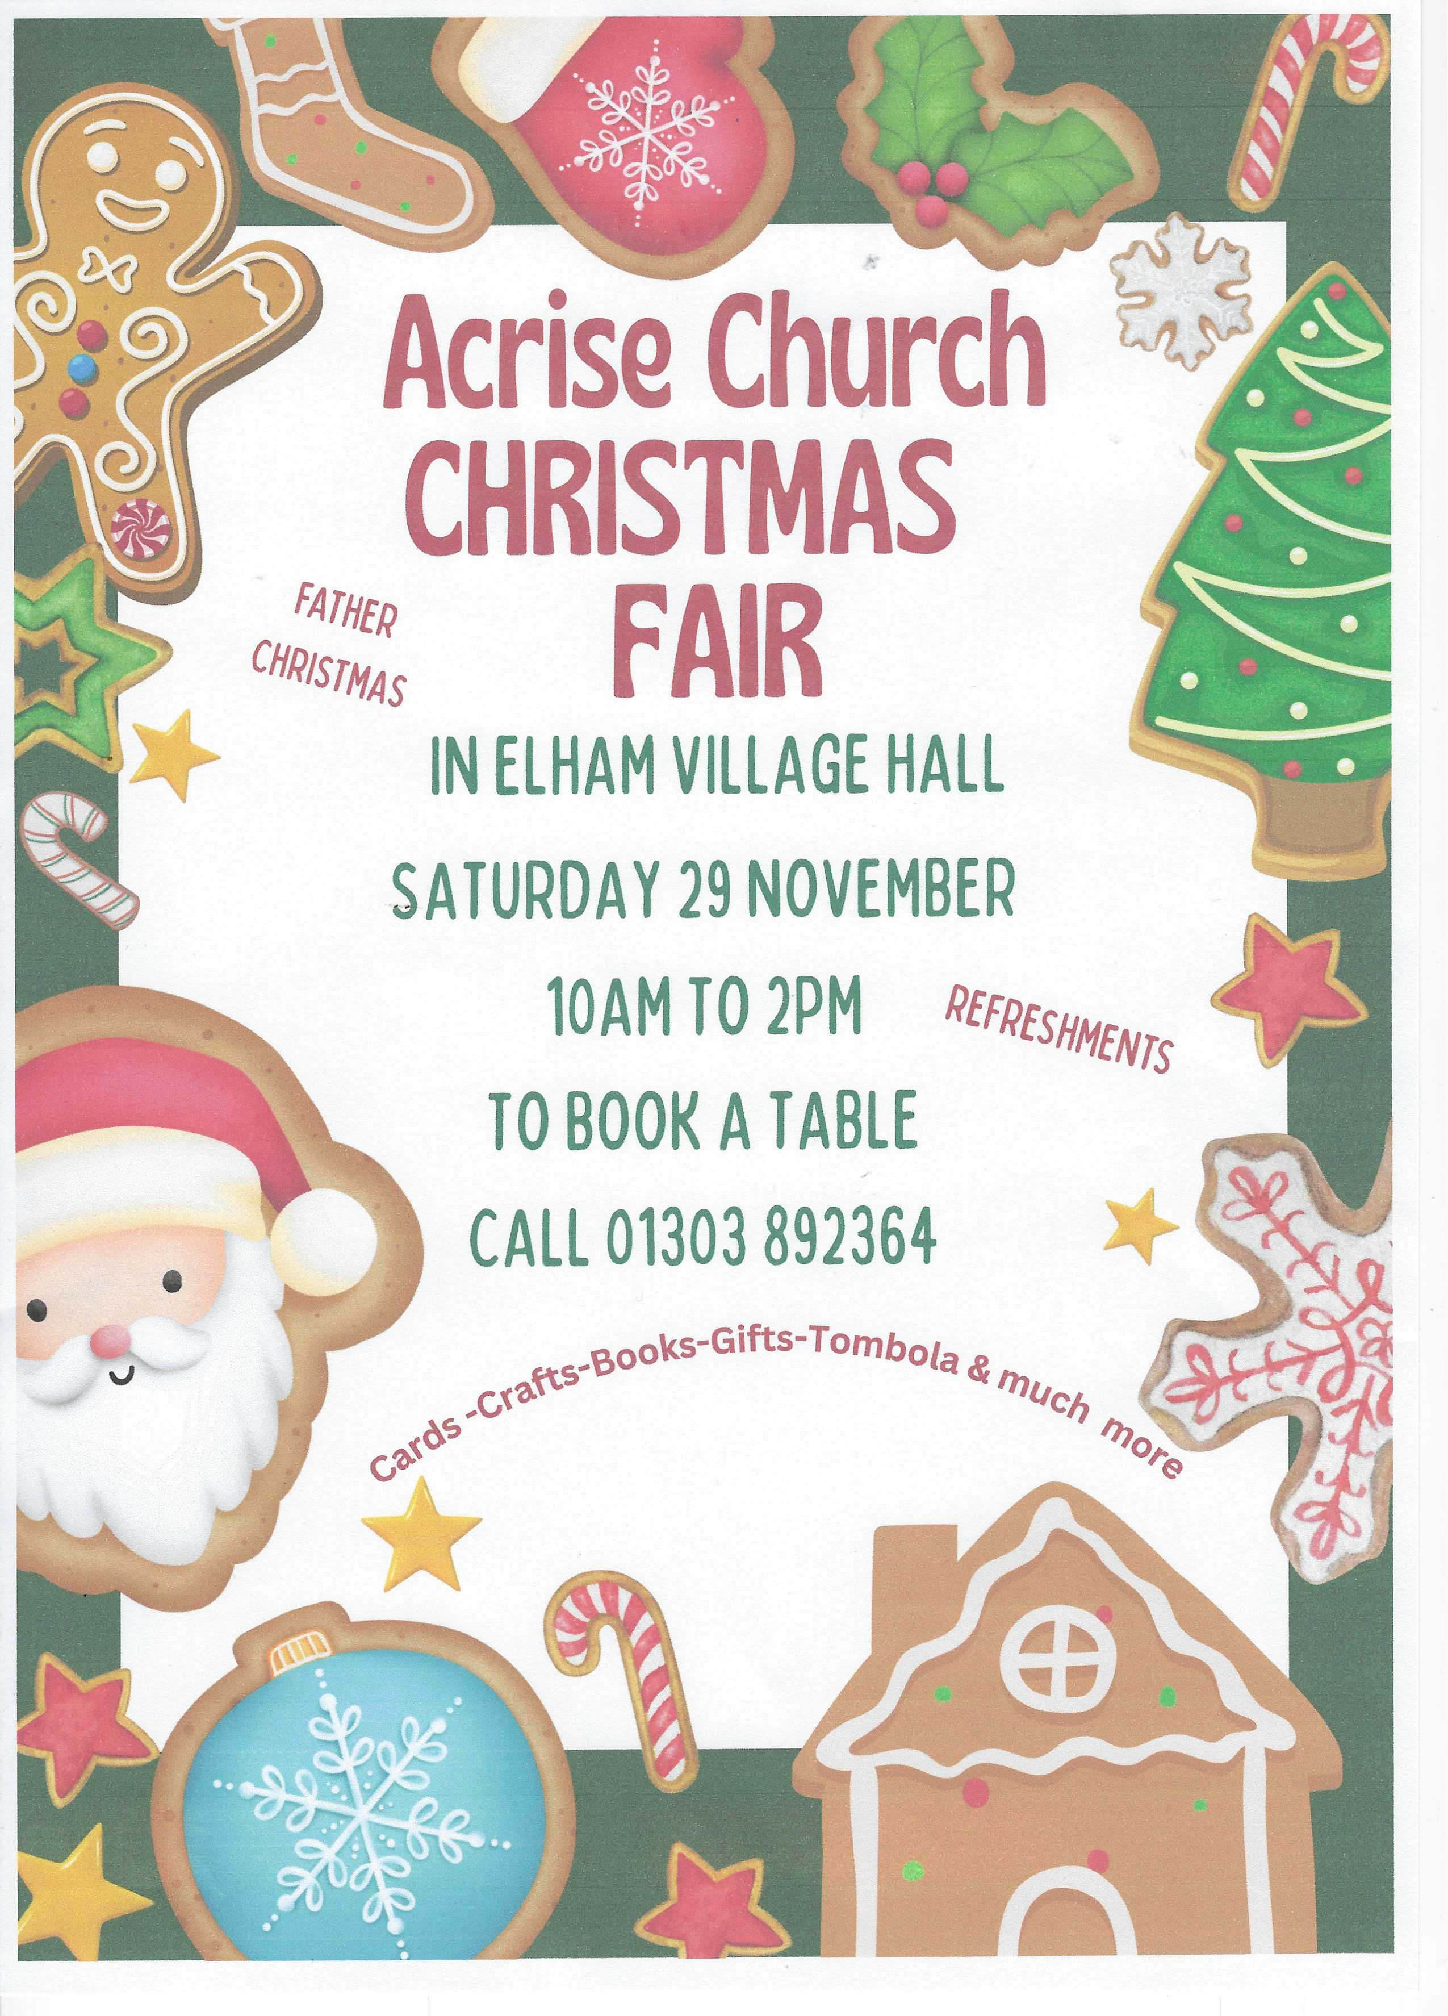
We would welcome any help to set up the hall for the Fair on Friday 28th November from about 4.00pm (ring 01303844640 if you could help).c

We would also be grateful for anyone who could help with running a stall (phone as above).
Any tombola prizes to Jean please. Raffle prizes and items for the cake stall would also be welcome.
There are still tables available. If you would like to book one please contact Jean Grieb (phone 01303 892364)

