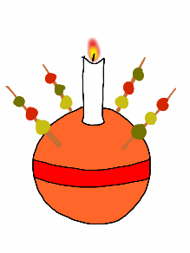

ST PETER’S CHURCH
St Peter’s Road N9 8JP
Invites you to come and celebrate Christmas

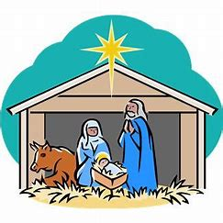
Sunday 21st December
3.30pm Carols & Christingles

Christmas Eve
5pm Family Crib Service 11.30pm Midnight Mass

Christmas Day
10am Sung Mass with Carols

Boxing Day St Stephen: 10.30am Said Mass by the crib
27 December St John:10.30am Said Mass by the crib

Sunday 28th December: Holy Innocents
9.30am Sung Mass

4 January: The Feast of the Epiphany
9.30am Sung Mass
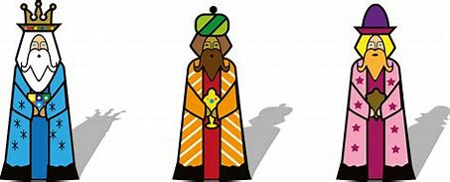

Thank you to all who have helped us this year
We wish everyone a peace filled Christmas & New Year

