Psalm 46
Distribution of Communion –currently the Priest will dip the communion wafer in the wine while we discern a safe way to bring the common cup back into worship, as we want everyone to feel included and safe. We also have gluten free wafers available.
Please stand, if able, and join in the verses in bold

God is our refuge and strength,
a very present help in trouble.
Therefore we will not fear, though the earth should change,
though the mountains shake in the heart of the sea;
though its waters roar and foam,
though the mountains tremble with its tumult.

There is a river whose streams make glad the city of God,
the holy habitation of the Most High.
God is in the midst of the city; it shall not be moved;
God will help it when the morning dawns.
The nations are in an uproar, the kingdoms totter;
he utters his voice, the earth melts.
The Lord of hosts is with us;
the God of Jacob is our refuge.

Come, behold the works of the Lord;
see what desolations he has brought on the earth.
He makes wars cease to the end of the earth;
he breaks the bow, and shatters the spear;
he burns the shields with fire.
‘Be still, and know that I am God!
I am exalted among the nations, I am exalted in the earth.’
The Lord of hosts is with us;
the God of Jacob is our refuge.
Our 4pm services are now in Friendship House (except on 21st December for the Carol Service) until Sunday 15th February.
Glory be to the Father and to the Son and to the Holy Spirit,
as it was in the beginning, is now and ever shall be,
world without end. Amen
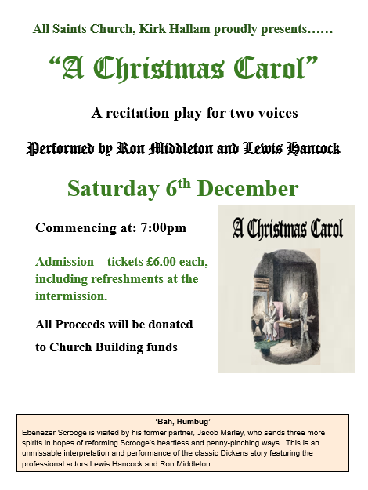

In our weekly prayers for our parish
This week we pray for God’s blessing on Valley Road, Valley View and Vine Farm Close.

New Testament Readings from the Lectionary

Monday 24th Matthew 9:18 to 34
Tuesday 25th Matthew 9:35 to 10:15
Wednesday 26th Matthew 10: 16 to 33
Thursday 27th Matthew 10: 34 to 11:1
Friday 28th Matthew 11: 2 to 19
Saturday 29th Matthew 11: 20 to end

We are using the readings from the
Church of England’s Morning Prayer service.
All Saints Church
Church contact information
Contact: Rev’d Christine - revchristine@outlook.com
The Rectory, The Village, West Hallam, DE7 6GR
Landline 0115 646 1497
Rev’d Ailsa -revailsahunt@gmail.com
Tel - 07356064856

Churchwardens – Mrs Janet Wheeldon, -Tel: 0115 8771593
Mrs Linda Gregory – linda.gregory3@icloud.com
https://www.achurchnearyou.com/church/13402/
https://www.facebook.com/allsaintskirkhallam
Refreshments After the Morning Service
Please stay seated after the service and a hot drink will be brought to you in the pews.
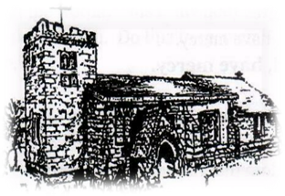
Kirk Hallam
Disabled Toilet in Friendship House.
Disabled Toilet in Friendship House.

Working with God to transform lives & communities.
Please can you ensure your mobile is on silence, or off during the service, it is affecting people with hearing aids and the loop system.
23rd November – Christ the King &
Sunday Next Before Advent
10.00am CW Communion Service with Rev’d Jan
4.00pm BCP Evening Prayer in Friendship House
with Rev’d Ailsa & Eileen

Forthcoming Events
Tues 25th 6.00pm Home Group in Friendship House
Weds 26th 9.30am Morning Prayer at UCAS, Stanley Common
Fri 27th 2.00pm Set up Christmas Fayre at Hall
Fri 27th 6.00pm Choir Practice in Friendship House
Sat 28th 9.00am Setting up for Fayre
Sat 28th 10.00am Prayer Meeting in Friendship House
Sat 28th 10am to 2pm Christmas Fayre in Community Hall

30th November – Advent Sunday
10.00am Iona Holy Communion Service with Rev’d Ailsa,
and Fr Peter Mallinson preaching.
4.00pm Iona Evening Prayer in Friendship House
with Rev’d Jan and Julie
It’s Good to Talk! If you spot that someone is missing, please pop a news sheet through their door, & if you’ve time, call for a chat - just to check they’re OK & to let them know that they are not forgotten!
‘Jesus Christ is the same yesterday and today and forever’ Hebrews 13:8

