Psalm 98
Distribution of Communion –currently the Priest will dip the communion wafer in the wine while we discern a safe way to bring the common cup back into worship, as we want everyone to feel included and safe. We also have gluten free wafers available.
Please stand, if able, and join in the verses in bold

O sing to the Lord a new song, for he has done marvellous things.
His right hand and his holy arm have gained him victory.
The Lord has made known his victory;
he has revealed his vindication in the sight of the nations.
As from Sunday 16th November the 4pm service will be in Friendship House (except on 21st December for the Carol Service) until Sunday 15th February.
He has remembered his steadfast love and faithfulness
to the house of Israel.
All the ends of the earth have seen the victory of our God.

Make a joyful noise to the Lord, all the earth;
break forth into joyous song and sing praises.
Sing praises to the Lord with the lyre,
with the lyre and the sound of melody.
With trumpets and the sound of the horn
make a joyful noise before the King, the Lord.

Let the sea roar, and all that fills it;
the world and those who live in it.
Let the floods clap their hands;
let the hills sing together for joy
at the presence of the Lord, for he is coming
to judge the earth.
He will judge the world with righteousness,
and the peoples with equity.

Glory be to the Father and to the Son and to the Holy Spirit,
as it was in the beginning, is now and ever shall be,
world without end. Amen
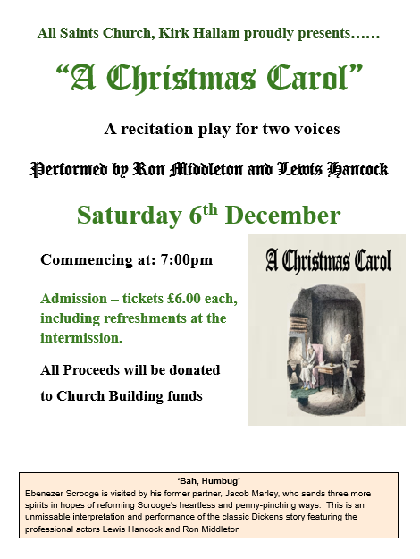

In our weekly prayers for our parish
This week we pray for God’s blessing on Toad Hole Close, Trent Road and Tudor Place.

New Testament Readings from the Lectionary

Monday 17th Bishop Hugh of Lincoln Revelation 10
Tuesday 18th Revelation 11: 1 to 14
Wednesday 19th Hilda, Abbess of Whitby Revelation 11: 15 to end
Thursday 20th King Edmund of East Angles Revelation 12
Friday 21st Revelation 13: 1 to 10
Saturday 22nd Cecilia, Martyr at Rome Revelation 13: 11 to end

We are using the readings from the
Church of England’s Morning Prayer service.
All Saints Church
Refreshments After the Morning Service
Please stay seated after the service and a hot drink will be brought to you in the pews.
Church contact information
Contact: Rev’d Christine - revchristine@outlook.com
The Rectory, The Village, West Hallam, DE7 6GR
Landline 0115 646 1497
Rev’d Ailsa -revailsahunt@gmail.com
Tel - 07356064856

Churchwardens – Mrs Janet Wheeldon, -Tel: 0115 8771593
Mrs Linda Gregory – linda.gregory3@icloud.com
https://www.achurchnearyou.com/church/13402/
https://www.facebook.com/allsaintskirkhallam
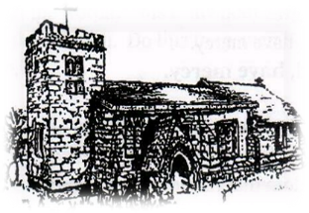
Kirk Hallam
Disabled Toilet in Friendship House.
Disabled Toilet in Friendship House.

Working with God to transform lives & communities.
Please can you ensure your mobile is on silence, or off during the service, it is affecting people with hearing aids and the loop system.

16th November – Second Sunday Before Advent
10.00am CW Communion Service with Rev’d Ailsa and Julie
11.00am Interring of ashes of Mavis Harrison by Rev’d Christine
2.00pm Baptism of Knightley-Rose Llewellyn by Rev’d Christine
3.00pm Building Faith, Lego Church at Community Hallam
with Rev’d Ailsa
4.00pm BCP Holy Communion in Friendship House
with Rev’d Christine

Forthcoming Events
Tues 18th 6.00pm Home Group in Friendship House
Weds 12th 9.30am Morning Prayer at UCAS, Stanley Common
Fri 21st 6.00pm Choir Practice in Friendship House
Sat 22nd 10.00am Prayer Meeting in Friendship House

23rd November – Sunday Next Before Advent
10.00am CW Communion Service with Rev’d an & Eileen
4.00pm BCP Evening Prayer in Friendship House
with Rev’d Ailsa & Eileen
‘Let the word of Christ dwell in you richly in all wisdom’ Colossians 3:16
It’s Good to Talk! If you spot that someone is missing, please pop a news sheet through their door, & if you’ve time, call for a chat - just to check they’re OK & to let them know that they are not forgotten!

