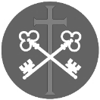
St Peter and the Holy Apostles, Plymouth- Sunday 30th November 2025
The First Sunday of Advent (Year C)
Welcome to the Parish Mass
Welcome to St Peters Church. This sheet provides all that you will need for today’s Mass. If you need any assistance before, during or after the service or need a large print copy of this order of service please speak to one of our welcome team. (identifiable by a lanyard)
Please respond to the words in non-italic Bold, The Hymns are sung by all. Please inform the people on the door when you enter if you require a Gluten Free Host
…………………………………………………………………………………
We Stand for The Entrance Hymn

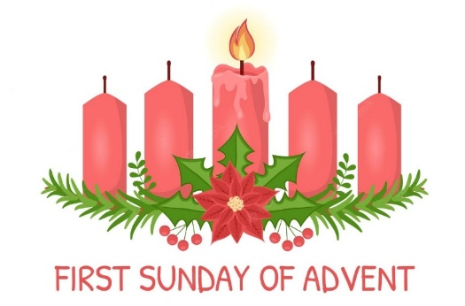
1. Hark the glad sound! The Saviour comes,
The Saviour promised long!
Let every heart prepare a throne,
And every voice a song.
2. He comes the prisoners to release
In Satan's bondage held;
The gates of brass before him burst,
The iron fetters yield.
3. He comes the broken heart to bind,
The bleeding soul to cure,
And with the treasures of his grace
Enrich the humble poor.
4. Our glad hosannas, Prince of peace,
Thy welcome shall proclaim,
And heaven's eternal arches ring
With thy belovèd name.

The Introductory Rite
In the name of the Father and of the Son and of the Holy Spirit. Amen.
Following the greeting we respond.
And with your spirit.
The Priest introduces the Mass
The Lighting of Advent Candle 1 – the Advent hope
Jesus said, ‘Keep awake, for you do not know on what day your Lord is coming.’
Amen. Come soon, Lord Jesus!
The first candle is lit and this response is used
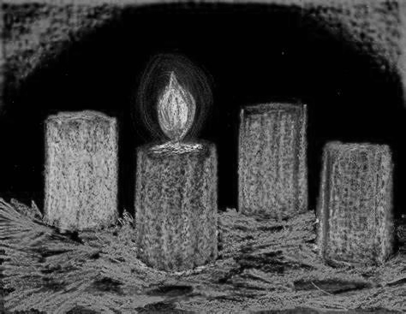
Jesus is the light of the world.
A light no darkness can ever put out.
We sing:
Advent candles tell their story
as we watch and pray,
longing for the Day of Glory,
‘Come, Lord, soon,’ we say.
Pain and sorrow, tears and sadness, changed for gladness on that Day.

The Penitential Rite
Cantor- Show mercy to us, loving Father.
We have sinned against you, please make us anew.
In your love and your grace You forgive us.
(Lord have mercy…)
All- Lord have mercy, Lord have mercy.
Cantor- Look not on our failings, Lord, Jesus.
We have sinned against you, please make us anew.
By your life and your death, You redeem us.
(Christ have mercy…)
All- Christ have mercy, Christ have mercy.
Cantor- Come fill our hearts Holy Spirit.
We have sinned against you, please make us anew.
Forgive us and heal us and save us.
(Lord have mercy…)
All- Lord have mercy, Lord have mercy.
Priest- May almighty God have mercy on us, forgive us our sins, and bring us to everlasting life. Amen.

The Collect
Let us pray.

Grant your faithful, we pray, almighty God, the resolve to run forth to meet your Christ with righteous deeds at his coming, so that, gathered at his right hand, they may be worthy to possess the heavenly kingdom. Through our Lord Jesus Christ, your Son,
who lives and reigns with you in the unity of the Holy Spirit, God, for ever and ever. Amen.

We sit for The First Reading- Isaiah 2:1-5

The word that Isaiah the son of Amoz saw concerning Judah and Jerusalem. It shall come to pass in the latter days that the mountain of the house of the Lord shall be established as the highest of the mountains, and shall be lifted up above the hills; and all the nations shall flow to it, and many peoples shall come, and say: ‘Come, let us go up to the mountain of the Lord, to the house of the God of Jacob, that he may teach us his ways and that we may walk in his paths.’ For out of Sion shall go forth the law,
and the word of the Lord from Jerusalem. He shall judge between the nations, and shall decide disputes for many peoples; and they shall beat their swords into ploughshares, and their spears into pruning-hooks; nation shall not lift up sword against nation, neither shall they learn war any more. O house of Jacob, come, let us walk in the light of the Lord.

The word of the Lord. Thanks be to God.

The Responsorial Psalm- Ps 122(121):1-2. 3-4a. 8-9. ℟ cf. 1

Response- Let us go rejoicing to the house of the Lord.

I rejoiced when they said to me, ‘Let us go to the house of the Lord.’
And now our feet are standing within your gates, O Jerusalem. R

Jerusalem is built as a city bonded as one together.
It is there that the tribes go up, the tribes of the Lord. R

For the sake of my family and friends, let me say, ‘Peace upon you.’
For the sake of the house of the Lord, our God, I will seek good things for you. R

The Second reading- Romans 13:11-14a

Brothers and sisters: You know the time, that the hour has come for you to wake from sleep. For salvation is nearer to us now than when we first believed. The night is far gone; the day is at hand. So then let us cast off the works of darkness and put on the armour of light. Let us walk properly as in the daytime, not in orgies and drunkenness, not in sexual immorality and sensuality, not in quarrelling and jealousy. But put on the Lord Jesus Christ.

The word of the Lord. Thanks be to God

We stand for- The Gospel Procession and Acclamation- Psalm 85(84):8

Alleluia, alleluia.
Show us, O Lord, your mercy, and grant us your salvation.
Alleluia.

The Gospel- Matthew 24:37-44

The Lord be with you. And with your spirit.
A reading from the holy Gospel according to N. Glory to you, O Lord.
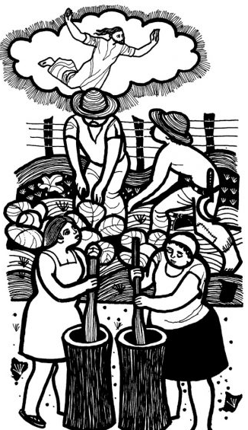
At that time: Jesus said to his disciples: ‘For as were the days of Noah, so will be the coming of the Son of Man. For as in those days before the flood they were eating and drinking, marrying and giving in marriage, until the day when Noah entered the ark, and they were unaware until the flood came and swept them all away, so will be the coming of the Son of Man. Then two men will be in the field; one will be taken and one left. Two women will be grinding at the mill; one will be taken and one left. Therefore, stay awake, for you do not know on what day your Lord is coming. But know this, that if the master of the house had known in what part of the night the thief was coming, he would have stayed awake and would not have let his house be broken into. Therefore you also must be ready, for the Son of Man is coming at an hour you do not expect.’
The Gospel of the Lord. Praise to you, Lord Jesus Christ.

We sit for The Homily

We stand The Creed
I believe in one God, the Father almighty, maker of heaven and earth,
of all things visible and invisible.
I believe in one Lord Jesus Christ, the Only Begotten Son of God, born of the Father before all ages. God from God, Light from Light, true God from true God, begotten, not made, consubstantial with the Father; through him all things were made. For us men and for our salvation he came down from heaven,
At the words that follow, up to and including ‘and became man’, all bow.
and by the Holy Spirit was incarnate of the Virgin Mary, and became man.
For our sake he was crucified under Pontius Pilate, he suffered death and was buried, and rose again on the third day in accordance with the Scriptures.
He ascended into heaven and is seated at the right hand of the Father. He will come again in glory to judge the living and the dead and his kingdom will have no end.
I believe in the Holy Spirit, the Lord, the giver of life, who proceeds from the Father and the Son, who with the Father and the Son is adored and glorified, who has spoken through the prophets.
I believe in one, holy, catholic and apostolic Church. I confess one Baptism for the forgiveness of sins and I look forward to the resurrection of the dead and the life of the world to come. Amen.
……………………………………………………………………………..
We remain standing for The Prayers of the Faithful

Cantor- There is a longing in our hearts, O Lord, for you to reveal yourself to us.
There is a longing in our hearts for love we only find in you, our God.

All- There is a longing in our hearts, O Lord, for you to reveal yourself to us.
There is a longing in our hearts for love we only find in you, our God.
Cantor- For justice, for freedom, for mercy, hear our prayer.
In sorrow, in grief, be near, hear our prayer, O God.
All- There is a longing in our hearts…
Cantor- For wisdom, for courage, for comfort, hear our prayer.
In weakness, in fear, be near, hear our prayer, O God.
All- There is a longing in our hearts…
Cantor- For healing, for wholeness, for new life, hear our prayer.
In sickness, in death, be near, hear our prayer, O God.
All- There is a longing in our hearts…
Cantor- Lord save us, take pity, light in our darkness.
We call you, we wait, be near, hear our prayer, O God.
All- There is a longing in our hearts…

The Priest Concludes the Prayers of the Faithful
No collection is taken during the Mass, but there is a collection box at the back of church for you to give your financial contribution. All money collected helps towards the mission and ministry of our churches. If you would prefer, a card reading machine is available at the back of the church for your contribution.
The Offertory Hymn

1. Lo, he comes with clouds descending,
once for favoured sinners slain;
thousand thousand saints attending
swell the triumph of his train:
Alleluia, Alleluia,
Alleluia,
God appears on earth to reign.
2. Every eye shall now behold him
robed in dreadful majesty;
those who set at naught and sold him,
pierced and nailed him to the Tree,
deeply wailing, deeply wailing,
deeply wailing,
shall the true Messiah see.
3. Those dear tokens of his passion
still his dazzling body bears,
cause of endless exultation
to his ransomed worshippers:
with what rapture, with what rapture,
with what rapture
gaze we on those glorious scars!
4. Yea, Amen, let all adore thee,
high on thine eternal throne;
Saviour, take the power and glory,
claim the kingdom for thine own:
Alleluia, Alleluia,
Alleluia,
Thou shalt reign, and thou alone.

The Liturgy of the Eucharist
Pray, brethren (brothers and sisters), that my sacrifice and yours may be acceptable to God, the almighty Father.
May the Lord accept the sacrifice at your hands for the praise and glory of his
name, for our good and the good of all his holy Church.

The Lord be with you. And with your spirit.
Lift up your hearts. We lift them up to the Lord.
Let us give thanks to the Lord our God. It is right and just.
The Priest continues with the Preface. The Sanctus is the said or sung:
Holy, Holy, Holy Lord God of hosts.
Heaven and earth are full of your glory. Hosanna in the highest.
Blessed is he who comes in the name of the Lord. Hosanna in the highest.

The Priest continues the Eucharistic prayer. The following is said or sung
The mystery of faith….
We proclaim your Death, O Lord, and profess your Resurrection until you come again.

The Priest concludes the Eucharistic prayer.
Through him, and with him, and in him, O God, almighty Father, in the unity of the Holy Spirit, all glory and honour is yours, for ever and ever. Amen.

The Lord’s Prayer
At the Saviour’s command and formed by divine teaching, we dare to say:
Our Father, who art in heaven, hallowed be thy name; thy kingdom come, thy will be done on earth as it is in heaven. Give us this day our daily bread, and forgive us our trespasses, as we forgive those who trespass against us; and lead us not into temptation, but deliver us from evil.
Deliver us, Lord, we pray… and the coming of our Saviour, Jesus Christ.
For the kingdom, the power and the glory are yours now and for ever.

The Peace
Lord Jesus Christ, who said to your Apostles: Peace I leave you, my peace I give you,
look not on our sins, but on the faith of your Church, and graciously grant her peace and unity in accordance with your will. Who live and reign for ever and ever. Amen.
The peace of the Lord be with you always: And with your spirit.
Let us offer each other the sign of peace.
All are invited to make an acknowledgement to each other to mark the sign of the peace.

The Agnus Dei
All say or sing:
Lamb of God, you take away the sins of the world, have mercy on us.
Lamb of God, you take away the sins of the world, have mercy on us.
Lamb of God, you take away the sins of the world, grant us peace.

The Invitation to Communion
Behold the Lamb of God, behold him who takes away the sins of the world. Blessed are those called to the supper of the Lamb.
Lord, I am not worthy that you should enter under my roof, but only say the word and my soul shall be healed.
All who are regular communicants in their own tradition are welcome to receive the sacrament if you are not a communicant you are welcome to come forward at this point in the service to receive a blessing To indicate that it is just a blessing you require, please take this service sheet up with you. We have returned to offering the chalice at the time of communion but please do not feel any pressure to receive from the common cup as the church teaches that the sacrament is received fully in one kind. We request that you do not intinct (dip) your host in the Chalice but either take a sip from the cup or return directly to your seat. This is for reasons of good hygiene.

The Communion Hymn

1. Thou didst leave thy throne and thy kingly crown,
when thou camest to earth for me;
but in Bethlehem's home was there found no room
for thy holy nativity:
O come to my heart, Lord Jesus;
there is room in my heart for thee.
2. Heaven's arches rang when the angels sang,
proclaiming thy royal degree;
but in lowly birth didst thou come to earth,
and in great humility:
O come to my heart, Lord Jesus;
there is room in my heart for thee.
3. The foxes found rest, and the bird had its nest
in the shade of the cedar tree;
but thy couch was the sod, O thou Son of God,
in the desert of Galilee:
O come to my heart, Lord Jesus;
there is room in my heart for thee.
4. Thou camest, O Lord, with the living word
that should set thy people free;
but with mocking scorn and with crown of thorn
they bore thee to Calvary:
O come to my heart, Lord Jesus;
there is room in my heart for thee.
5. When the heavens shall ring, and the angels sing,
at thy coming to victory,
let thy voice call me home, saying, 'Yet there is room,
there is room at my side for thee:'
O come to my heart, Lord Jesus;
there is room in my heart for thee.
We stand for The Prayer After Communion

May these mysteries, O Lord, in which we have participated profit us, we pray, for even now, as we walk amid passing things, you teach us by them to love the things of heaven and hold fast to what endures. Through Christ our Lord. Amen

The priest may give some brief notices
The Concluding Rites
The Lord be with you. And with your spirit.

May almighty God bless you, the Father, and the Son, ✠ and the Holy Spirit. Amen.

The Dismissal
Go forth, the Mass is ended. Thanks be to God

The Final Hymn

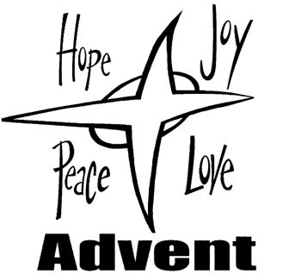
1. Christ is the world's true light,
its Captain of salvation,
the Daystar clear and bright
of every land and nation;
new life, new hope awakes,
for all who own his sway:
freedom her bondage breaks,
and night is turned to day.
2. In Christ all races meet,
their ancient feuds forgetting,
the whole round world complete,
from sunrise to its setting:
when Christ is throned as Lord,
all shall forsake their fear,
to plough-share beat the sword,
to pruning hook the spear.
3. One Lord, in one great name
unite us all who own thee;
cast out our pride and shame
that hinder to enthrone thee;
the world has waited long,
has travailed long in pain;
to heal its ancient wrong,
come, Prince of Peace, and reign.
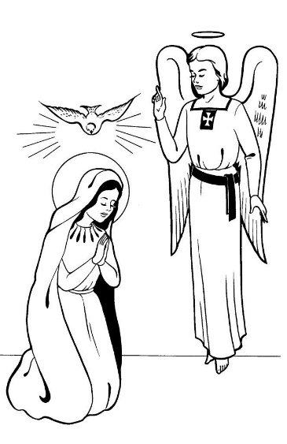
The Angelus
The Angel of the Lord declared unto Mary.
And she conceived of the Holy Spirit.

Hail Mary, full of grace, The Lord is with Thee;
Blessed art thou among women,
And blessed is the fruit of thy womb, Jesus.
Holy Mary, Mother of God, Pray for us sinners,
Now and at the hour of our death.

Behold the handmaid of the Lord.
Be it done to me according to thy word. Hail Mary. . .

And the Word was made flesh.
And dwelt among us. Hail Mary…

Pray for us, O holy Mother of God.
That we may be made worthy of the promises of Christ.

Let us pray:

Pour forth, we beseech Thee, O Lord, Thy grace into our hearts, that we to whom the Incarnation of Christ Thy Son was made known by the message of an angel, may by His Passion and Cross be brought to the glory of His Resurrection. Through the same Christ Our Lord. Amen.
……………………………………………………………………………..
The Notices

Advent across the Society Parishes in Plymouth
Through Advent at St Peter’s the Blessed Sacrament will be exposed from 8.00am – 9.00am (except Monday’s)

Sunday 30th November- Advent Carol Services- at St Peters, 6pm

Sunday 14th December- Christingle Service- at St Francis, 4pm

Sunday 21st December- Christmas Carol Service- at St Gabriels, 6pm

All services followed by seasonal refreshments

Christmas in Stonehouse Event CANCELLED

Help Needed for our Winter night Shelter-
help is needed to support our winter night shelter between December and March on Wednesdays…
splitting the shifts and duties will make this more manageable for volunteers!
Therefore, Help is needed with…
- preparing beds and welcoming night shelter users with a hot drink 8pm- 11pm on Wednesdays.
- Overnight cover 11pm Wednesdays to 7.00am Thursday (you need to be able to stay awake to cover this shift!)
- Making hot drinks and toast and clearing beds- 7am- 9.30am on Thursday.
For further information please speak to Fr David or Ben

Through the winter months we will be supplying toast for those in need and on Wednesday lunchtimes we will also be supplying soup.

For Prayer

Those who have asked for our prayers…. Denise, Janice Allin, Leslie Porch,
Sheila Tucker, Tina Smart, Kathy Haydon, Bobby Lilicrap, June Brock,
Emma Addison, Georgie Maher, Ian Craggs, Brenda Alderson, Lois Tobin, Brenda Steed, Anne Lewis, Jenny Harvey, Jackie Morrison, Anna, Gwen Lamb, Anna Lynch, Jackie Fisher, Helen Lewis, Val Bradden, Cynthia Way, Pauleen Stewart, Amelia Coughlan, Roger Lewis, Shaun Carrie, Fr Jon Bielawski, Catherine Samuel.

Recently Departed-

Anniversaries of Death
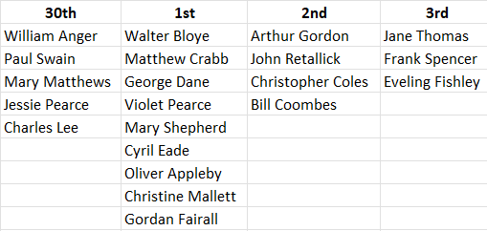
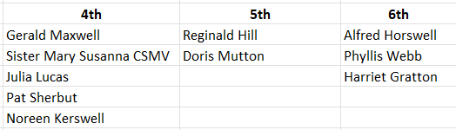
The Mission Community of St Peter and the Holy Apostles
St Peter, Wyndham Square + St Thomas, Royal Navy Avenue + St James-the-Less, Ham Drive
A Church of England Parish in the care of the Bishop of Oswestry
Parish Priest Fr. David Way SSC: 01752 240119 fr.davidway@gmail.com
.com
Mission Development Minister/ LLM/ Parish Ordinand: Ben Otley 07939800544 benotley.mission.plym@gmail.com

Parish Website: plymouthstpeter.co.uk ~ FOR MUCH MORE INFORMATION ON EVENTS, ETC.

This week’s services
Sunday 30th-  The First Sunday of Advent  (Liturgical Year A, Weekday Cycle 2)  (Psalter Week 1) | 8.30am St Thomas Fr DCW  10.00am St Peter Fr DCW  6.00pm St Peter | Mass with Hymns  Sung Mass  Advent Carol Service
Monday 1st December-  Weekday of Advent | St Peter 10.00am Fr PL | Mass
Tuesday 2nd- Weekday of Advent | St Peter 10.00am Fr DCW | Mass
Wednesday 3rd- St Francis Xavier | St Peter 10.00am Fr DCW | Mass
Thursday 4th- Weekday in Advent/  St John Damascene | St Peter 10.00am Fr DCW | Mass
Friday 5th- Weekday in Advent | St Peter 10.00am Fr DCW | Sung Mass
Saturday 6th- Weekday in Advent/  St Nicholas | St Peter 10.00am Fr DCW | Mass
Sunday 7th-  The First Sunday of Advent  (Psalter Week 2) | 8.30am St Thomas Fr DCW  10.00am St Peter Fr DCW | Mass with Hymns  Sung Mass
St Peters is open daily 8.30am- 12noon- Place of Welcome, Place of Prayer, food larder etc.

Safeguarding: If you have any concerns regarding the safety of children and others who are vulnerable, regardless of age, you must tell the Duty Priest or our parish Lay Safeguarding Representative- Jackie Morrison- email randj49@gmail.com Tel 07848859124.
For online donations please scan the QR code

