SPECIAL SERVICES AND EVENTS  In Loving Memory Service  Sunday 2nd November at 9.30 am  A time to remember loved ones who are with us no more.  Remembrance Sunday  Sunday 9th November at 10.30 am on the Village Green; service in church starts at 10.50 am  Christmas Coffee Morning  Wednesday, 3 December, 10.30-12.30 pm  The Long Barn, Blackwell Farm  Christmas Wreath Making Workshop  Monday 15th December, 11am-2pm, Parish Hall  Service of Lessons and Carols  Sunday 21st December at 4 pm followed by mulled wine and mince pies at Latimer House, courtesy of De Vere Hotels  Christmas Day  Thursday 25th December at 9.30 am  Benefice Service at St George’s, Little Chalfont  Sunday 28th December at 10.15 am  No service at Latimer  2026  Vivaldi Concert by candlelight  Saturday, 14 February – evening  Details to follow | CONTACTS FOR LATIMER  Revd Dr Brian Ludlow  07902 590559  brian.ludlow@cheniesbenefice.org  Revd Peggy Ludlow  peggy.ludlow@cheniesbenefice.org  Rector of Benefice  Revd David Whale  01923 286131  rector@cheniesbenefice.org  www.cheniesbenefice.org  Benefice Administrator  Mrs Rebecca Newman  parishoffice@benefice.org  If you would like to make a donation to help Latimer  Church’s work, you can use the QR code below   | CHENIES BENEFICE  ST MARY MAGDALENE  LATIMER  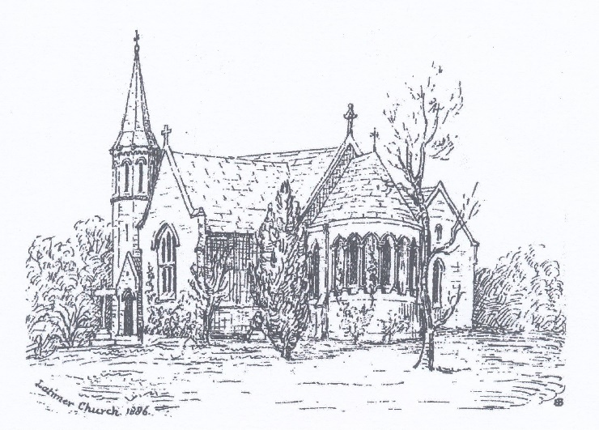  Services and Events  October – December 2025
 | SUNDAY SERVICES
OCTOBER | NOVEMBER |  | DECEMBER
5th at 9.30 am | 2nd at 9.30 am |  | 7th at 9.30 am
BCP Holy Communion | In Loving Memory Service |  | BCP Holy Communion
12th at 9.30 am | 9th at 10.30 am on the Village Green; 10.50 in Church |  | 14th at 9.30 am
Morning Worship | Remembrance Sunday |  | Morning Worship
19th at 9.30 am | 16th at 9.30 am |  | 21st at 4 pm
CW Holy Communion | CW Holy Communion |  | Service of Lessons and Carols
26th at 9.30 am | 23rd at 9.30 am |  | Thursday 25th at 9.30 am
Morning Worship | Morning Worship |  | Christmas Day
 |  |  | Morning Worship followed by Holy Communion
 | 30th at 9.30 am
 | Morning Worship |  | 28th at 10.15 am
Benefice Service
St George’s, Little Chalfont
No service at Latimer

