MASS & SERVICE TIMES THIS WEEK

SUNDAY 16TH NOVEMBER
THIRTY-THIRD SUNDAY IN ORDINARY TIME
(SAFEGUARDING SUNDAY)

PARISH MASS
4 PM

MONDAY 17TH NOVEMBER Holy Hour 10 am

TUESDAY 18TH NOVEMBER Communion by Extension 11 am

SUNDAY 23RD NOVEMBER
OUR LORD JESUS CHRIST, KING OF THE UNIVERSE
Parish Mass 10 am
Celebrant: Father Chris Burrows

Parish Priest
In Vacancy
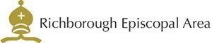



Please contact the churchwarden: Valerie Rice 07946 175105

Email: marshfarmholycross@gmail

