St Peter and the Holy Apostles, Plymouth- Sunday 16th November 2025
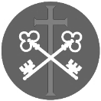
The Thirty Third Week in Ordinary Time (Year C)
Welcome to the Parish Mass
Welcome to St Peters Church. This sheet provides all that you will need for today’s Mass. If you need any assistance before, during or after the service or need a large print copy of this order of service please speak to one of our welcome team. (identifiable by a lanyard)
Please respond to the words in non-italic Bold, The Hymns are sung by all. Please inform the people on the door when you enter if you require a Gluten Free Host
…………………………………………………………………………………
We Stand for The Entrance Hymn
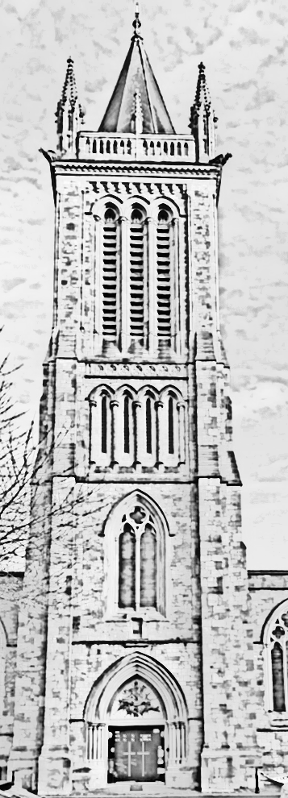
1. At the name of Jesus every knee shall bow,
every tongue confess him King of glory now:
'tis the Father's pleasure, that we call him Lord,
who from the beginning was the mighty Word.
2. At his voice creation sprang at once to sight,
all the angel faces, all the hosts of light,
thrones and dominations, stars upon their way,
all the heavenly orders, in their great array.
3. Humbled for a season, to receive a name
from the lips of sinners unto whom he came,
faithfully he bore it spotless to the last,
brought it back victorious, when from death he passed:
4. Bore it up triumphant with its human light,
through all ranks of creatures, to the central height,
to eternal Godhead, to the Father's throne;
filled it with the glory, of his triumph won.
5. In your hearts enthrone him; there let him subdue
all that is not holy, all that is not true:
crown him as your Captain in temptation's hour;
let his will enfold you in its light and power.
6. With the Fathers glory, Jesus comes again,
angel host attend him and announce his reign;
for all wreaths of empire meet upon his brow,
and our hearts confess him King of glory now.
The Introductory Rite
In the name of the Father and of the Son and of the Holy Spirit. Amen.
Following the greeting we respond. And with your spirit.
The Priest introduces the Mass
The Penitential Rite
Brothers and sisters, let us acknowledge our sins,
and so prepare ourselves to celebrate the sacred mysteries.

I confess to almighty God and to you, my brothers and sisters, that I have greatly sinned, in my thoughts and in my words, in what I have done and in what I have failed to do, through my fault, through my fault, through my most grievous fault; therefore I ask blessed Mary ever-Virgin, all the Angels and Saints, and you, my brothers and sisters, to pray for me to the Lord our God.

May almighty God have mercy on us, forgive us our sins, and bring us to everlasting life. Amen.Either:
Lord, have mercy. Lord, have mercy.
Christ, have mercy. Christ, have mercy.
Lord, have mercy. Lord, have mercy.
Or:
Kyrie, eleison. Kyrie, eleison.
Christe, eleison. Christe, eleison.
Kyrie, eleison. Kyrie, eleison.

The Gloria
Glory to God in the highest, and on earth peace to people of good will.
We praise you, we bless you, we adore you, we glorify you, we give you thanks for your great glory, Lord God, heavenly King, O God, almighty Father.
Lord Jesus Christ, Only Begotten Son, Lord God, Lamb of God, Son of the Father, you take away the sins of the world, have mercy on us; you take away the sins of the world, receive our prayer; you are seated at the right hand of the Father, have mercy on us.
For you alone are the Holy One, you alone are the Lord, you alone are the Most High, Jesus Christ, with the Holy Spirit, in the glory of God the Father. Amen.

The Collect
Let us pray.

Grant us, we pray, O Lord our God, the constant gladness of being devoted to you, for it is full and lasting happiness to serve with constancy the author of all that is good. Through our Lord Jesus Christ, your Son, who lives and reigns with you in the unity of the Holy Spirit, God, for ever and ever. Amen.

We sit for The First Reading- Malachi 4:1-2a

Behold, the day is coming, burning like an oven, when all the arrogant and all evildoers will be stubble. The day that is coming shall set them ablaze, says the Lord of hosts, so that it will leave them neither root nor branch. But for you who fear my name, the sun of righteousness shall rise with healing in its wings.

The word of the Lord. Thanks be to God.

The Responsorial Psalm- Ps 98(97):5-6. 7-8a. 8b-9b. 9cd. ℟ cf. 9

Response- The Lord comes to judge the peoples with fairness.

Sing psalms to the Lord with the harp, with the harp and the sound of song.
With trumpets and the sound of the horn, raise a shout before the King, the Lord. R

Let the sea and all within it thunder; the world, and those who dwell in it.
Let the rivers clap their hands. R

The hills ring out their joy at the presence of the Lord, for he comes.
He comes to judge the earth. R

He will judge the world with justice, and the peoples with fairness. R

The Second reading- 2 Thessalonians 3:7-12

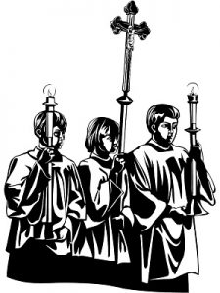
Brothers and Sisters: You know how you ought to imitate us, because we were not idle when we were with you, nor did we eat anyone’s bread without paying for it, but with toil and labour we worked night and day, that we might not be a burden to any of you. It was not because we do not have that right, but to give you in ourselves an example to imitate. For even when we were with you, we would give you this command: If anyone is not willing to work, let him not eat. For we hear that some among you walk in idleness, not busy at work, but busybodies. Now such persons we command and encourage in the Lord Jesus Christ to do their work quietly and to earn their own living.The word of the Lord. Thanks be to God

We stand for-
The Gospel Procession and Acclamation- Luke 21:28

Alleluia, alleluia.
Straighten up and raise your heads,
because your redemption is drawing near.
Alleluia.
The Gospel- Luke 21:5-19

The Lord be with you. And with your spirit.
A reading from the holy Gospel according to N. Glory to you, O Lord.
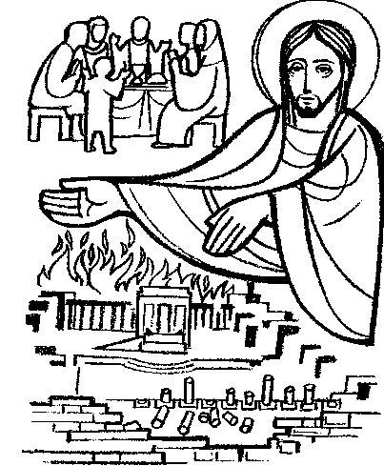
At that time: While some were speaking of the Temple, how it was adorned with noble stones and offerings, Jesus said, ‘As for these things that you see, the days will come when there will not be left here one stone upon another that will not be thrown down.’ And they asked him, ‘Teacher, when will these things be, and what will be the sign when these things are about to take place?’ And he said, ‘See that you are not led astray. For many will come in my name, saying, “I am he!” and, “The time is at hand!” Do not go after them. And when you hear of wars and tumults, do not be terrified, for these things must first take place, but the end will not be at once.’
Then he said to them, ‘Nation will rise against nation, and kingdom against kingdom. There will be great earthquakes, and in various places famines and pestilences. And there will be terrors and great signs from heaven. But before all this they will lay their hands on you and persecute you, delivering you up to the synagogues and prisons, and you will be brought before kings and governors for my name’s sake. This will be your opportunity to bear witness. Settle it, therefore in your minds, not to meditate beforehand how to answer, for I will give you a mouth and wisdom, which none of your adversaries will be able to withstand or contradict. You will be delivered up even by parents and brothers and sisters, and relatives and friends, and some of you they will put to death. You will be hated by all for my name’s sake. But not a hair of your head will perish. By your endurance you will gain your lives.’
The Gospel of the Lord. Praise to you, Lord Jesus Christ.

We sit for The Homily

We stand The Creed
I believe in one God, the Father almighty, maker of heaven and earth, of all things visible and invisible.
I believe in one Lord Jesus Christ, the Only Begotten Son of God, born of the Father before all ages. God from God, Light from Light, true God from true God, begotten, not made, consubstantial with the Father; through him all things were made. For us men and for our salvation he came down from heaven,
At the words that follow, up to and including ‘and became man’, all bow.
and by the Holy Spirit was incarnate of the Virgin Mary, and became man.
For our sake he was crucified under Pontius Pilate, he suffered death and was buried, and rose again on the third day in accordance with the Scriptures.
He ascended into heaven and is seated at the right hand of the Father. He will come again in glory to judge the living and the dead and his kingdom will have no end.
I believe in the Holy Spirit, the Lord, the giver of life, who proceeds from the Father and the Son, who with the Father and the Son is adored and glorified, who has spoken through the prophets.
I believe in one, holy, catholic and apostolic Church. I confess one Baptism for the forgiveness of sins and I look forward to the resurrection of the dead and the life of the world to come. Amen.


We remain standing for The Prayers of the Faithful

Each biding concludes with the following said or sung-

We pray to the Lord. Lord in your Mercy hear our prayer.

The Priest Concludes the Prayers of the Faithful
……………………………………………………………………………..
No collection is taken during the Mass, but there is a collection box at the back of church for you to give your financial contribution. All money collected helps towards the mission and ministry of our churches. If you would prefer, a card reading machine is available at the back of the church for your contribution.
The Offertory Hymn


1. O Lord my God, when I in awesome wonder,
Consider all the worlds thy hands have made;
I see the stars, I hear the rolling thunder,
Thy power throughout the universe displayed:
Then sings my soul, my Saviour God, to thee:
How great thou art! How great thou art!
Then sings my soul, my Saviour God, to thee:
How great thou art! How great thou art!
2. When through the woods and forest glades I wander
And hear the birds sing sweetly in the trees,
When I look down from lofty mountain grandeur,
And hear the brook and feel the gentle breeze: Then sings my soul…
3. And when I think how God, his Son not sparing,
Sent him to die, I scarce can take it in;
That on the cross, my burdens gladly bearing,
He bled and died to take away my sin: Then sings my soul…
4. When Christ shall come with shouts of acclamation,
To take me home, what joy will fill my heart!
Then I will bow in humble adoration,
And there proclaim, my God, how great thou art! Then sings my soul…
The Liturgy of the Eucharist
Pray, brethren (brothers and sisters), that my sacrifice and yours may be acceptable to God, the almighty Father.
May the Lord accept the sacrifice at your hands for the praise and glory of his
name, for our good and the good of all his holy Church.

The Lord be with you. And with your spirit.
Lift up your hearts. We lift them up to the Lord.
Let us give thanks to the Lord our God. It is right and just.
The Priest continues with the Preface. The Sanctus is the said or sung:
Holy, Holy, Holy Lord God of hosts.
Heaven and earth are full of your glory. Hosanna in the highest.
Blessed is he who comes in the name of the Lord. Hosanna in the highest.

The Priest continues the Eucharistic prayer. The following is said or sung
The mystery of faith….
We proclaim your Death, O Lord, and profess your Resurrection until you come again.

The Priest concludes the Eucharistic prayer.
Through him, and with him, and in him, O God, almighty Father, in the unity of the Holy Spirit, all glory and honour is yours, for ever and ever. Amen.

The Lord’s Prayer
At the Saviour’s command and formed by divine teaching, we dare to say:
Our Father, who art in heaven, hallowed be thy name; thy kingdom come, thy will be done on earth as it is in heaven. Give us this day our daily bread, and forgive us our trespasses, as we forgive those who trespass against us; and lead us not into temptation, but deliver us from evil.
Deliver us, Lord, we pray… and the coming of our Saviour, Jesus Christ.
For the kingdom, the power and the glory are yours now and for ever.
The Peace
Lord Jesus Christ, who said to your Apostles: Peace I leave you, my peace I give you,
look not on our sins, but on the faith of your Church, and graciously grant her peace and unity in accordance with your will. Who live and reign for ever and ever. Amen.
The peace of the Lord be with you always: And with your spirit.
Let us offer each other the sign of peace.
All are invited to make an acknowledgement to each other to mark the sign of the peace.

The Agnus Dei
All say or sing:
Lamb of God, you take away the sins of the world, have mercy on us.
Lamb of God, you take away the sins of the world, have mercy on us.
Lamb of God, you take away the sins of the world, grant us peace.

The Invitation to Communion
Behold the Lamb of God, behold him who takes away the sins of the world. Blessed are those called to the supper of the Lamb.
Lord, I am not worthy that you should enter under my roof, but only say the word and my soul shall be healed.

All who are regular communicants in their own tradition are welcome to receive the sacrament if you are not a communicant you are welcome to come forward at this point in the service to receive a blessing To indicate that it is just a blessing you require, please take this service sheet up with you. We have returned to offering the chalice at the time of communion but please do not feel any pressure to receive from the common cup as the church teaches that the sacrament is received fully in one kind. We request that you do not intinct (dip) your host in the Chalice but either take a sip from the cup or return directly to your seat. This is for reasons of good hygiene
The Communion Hymn

1. O Jesu Christ, remember,
When Thou shall come again,
Upon the clouds of heaven,
With all thy shining train;
When ev'ry eye shall see Thee,
In Deity revealed,
Who now upon this altar
In silence art concealed.
2. Remember then, O Saviour,
I supplicate of Thee,
That here I bowed before Thee
Upon my bended knee;
That here I owned thy presence,
And did not Thee deny;
And glorified thy greatness,
Tho' hid from human eye.
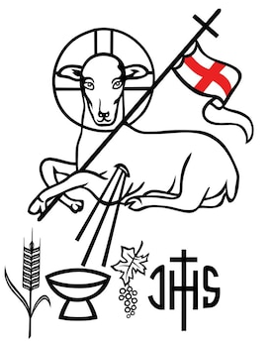
3. Accept, divine Redeemer,
The homage of my praise;
Be Thou the light, and honour,
And glory of my days.
Be Thou my consolation
When death is drawing nigh:
Be Thou my only Treasure,
Through all eternity.
We stand for The Prayer After Communion
We have partaken of the gifts of this sacred mystery,
humbly imploring, O Lord, that what your Son commanded us to do in memory of him may bring us growth in charity. Through Christ our Lord. Amen
We remain standing for Our Mission Prayer for 2025
Lord Jesus, you call us to be your missionary disciples.
Guide and strengthen us to share your love with all we meet.
Give us courage to reach out to help others.
Give us wisdom to know how best to care,
And give us hope to believe we can make a difference.
Bless us all who bring your compassion and mercy to the poor and marginalised.
Together, may we make known your love on earth.
We make our prayer through Christ Our Lord. Amen.

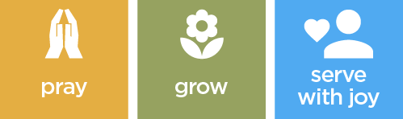

The priest may give some brief notices
The Concluding Rites
The Lord be with you. And with your spirit.

May almighty God bless you, the Father, and the Son, ✠ and the Holy Spirit. Amen.
The Dismissal
Go forth, the Mass is ended. Thanks be to God
The Final Hymn
1. Thy kingdom come, O God,
Thy rule, O Christ, begin;
Break with thy iron rod
The tyrannies of sin.
2. Where is thy reign of peace
And purity and love?
When shall all hatred cease,
As in the realms above?
3. When comes the promised time
That war shall be no more,
And lust, oppression, crime,
Shall flee thy face before?
4. We pray thee Lord, arise,
And come in thy great might;
Revive our longing eyes,
Which languish for thy sight.

5. O'er lands both near and far
Thick darkness broodeth yet:
Arise, O morning Star,
Arise, and never set.

……………………………………………………………………………..
The Angelus
The Angel of the Lord declared unto Mary.
And she conceived of the Holy Spirit.

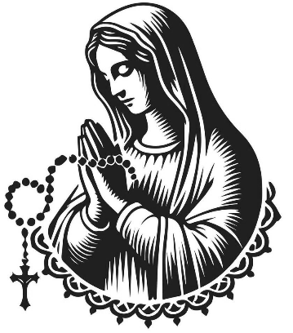
Hail Mary, full of grace, The Lord is with Thee; Blessed art thou among women,
And blessed is the fruit of thy womb, Jesus.
Holy Mary, Mother of God, Pray for us sinners,
Now and at the hour of our death.

Behold the handmaid of the Lord.
Be it done to me according to thy word.
Hail Mary. . .

And the Word was made flesh.
And dwelt among us.
Hail Mary…

Pray for us, O holy Mother of God.
That we may be made worthy of the promises of Christ.

Let us pray:

Pour forth, we beseech Thee, O Lord, Thy grace into our hearts, that we to whom the Incarnation of Christ Thy Son was made known by the message of an angel, may by His Passion and Cross be brought to the glory of His Resurrection. Through the same Christ Our Lord. Amen.

For Prayer

Those who have asked for our prayers…. Denise, Janice Allin, Leslie Porch,
Sheila Tucker, Tina Smart, Kathy Haydon, Bobby Lilicrap, June Brock,
Emma Addison, Georgie Maher, Ian Craggs, Brenda Alderson, Lois Tobin, Brenda Steed, Anne Lewis, Jenny Harvey, Jackie Morrison, Anna, Gwen Lamb, Anna Lynch, Jackie Fisher, Helen Lewis,Val Bradden, Cynthia Way, Pauleen Stewart, Amelia Coughlan, Roger Lewis, Shaun Carrie, Fr Jon Bielawski, Catherine Samuel’s

Recently Departed-

Anniversaries of Death
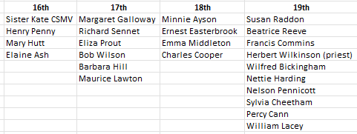
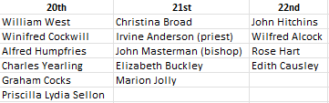

The Notices

Christmas meal at the Dartmoor Lodge, on Friday 5th December, sitting down to eat at 12.30pm. The cost is £32 for two courses and £37 for three courses. If you wish to go, please put your name on the invite sheet which is available in each church. Transport will be cars. A non-refundable deposit needs to be paid by Sunday 16th November (this Sunday), with the balance being paid the following week (Sunday 23rd November), together with your menu choices. Thank you Graham
Summary of Outcomes from the P.C.C. Meeting
The PCC met on Wednesday to review our current strengths, weaknesses, and future direction as a parish. The primary focus of discussion was Item 3: Future Planning, which produced several important reflections and priorities.
1. Mutual Support and Parish Life
Members expressed a shared sense that we need to deepen our mutual support for one another, both within the PCC and across the wider congregation. This includes being more intentional in how we care for, encourage, and communicate with each other as we share responsibility for the parish’s mission.
2. Prayerful Atmosphere
A key theme was the importance of cultivating a more prayerful foundation to our common life.
- We agreed on the need to maintain and deepen an atmosphere of reverence and prayerfulness during Morning Prayer and in the time before Mass.
- This is both a spiritual need and an opportunity to strengthen the parish’s identity as a community centred on worship and contemplation.
3. Social Action
The PCC recognised and celebrated the parish’s strong tradition of social action, noting that this work remains one of our core strengths. However, members also stressed:
- the importance of continually re-evaluating where the greatest needs lie,
ensuring that we remain responsive rather than formulaic, and encouraging more people to take part so that the work can grow sustainably.
4. Priority Areas for the Year Ahead
From the discussion, the PCC agreed on several concrete priorities to shape our planning going forward:
- Develop our Social Media Output
  - Improve communication, visibility, and engagement with the wider community.
- Rebuild an Entertainment Committee
  - Revitalise parish social life, hospitality, and opportunities for fellowship.
- Improve our Catechesis
  - Strengthen teaching, formation, and preparation for the sacraments across all age groups.
- Create a Joint Society Parish Plan of Activities
  - Coordinate events, services, and initiatives across the parish to ensure coherence, shared ownership, and better communication.

If you want to be part of the vision let a PCC member know.
The Mission Community of St Peter and the Holy Apostles
St Peter, Wyndham Square + St Thomas, Royal Navy Avenue + St James-the-Less, Ham Drive
A Church of England Parish in the care of the Bishop of Oswestry
Parish Priest Fr. David Way SSC: 01752 240119 fr.davidway@gmail.com
.com
Mission Development Minister/ LLM/ Parish Ordinand: Ben Otley 07939800544 benotley.mission.plym@gmail.com

Parish Website: plymouthstpeter.co.uk ~ FOR MUCH MORE INFORMATION ON EVENTS, ETC.

This week’s services
Sunday 16th-  The Thirty Third  Week in Ordinary Time  (Psalter Week 1) | 8.30am St Thomas Fr DCW  10.00am St Peter Fr DCW  6.00pm St Peter | Mass with Hymns  Sung Mass  Holy Rosary/ Walsingham cell
Monday 17th- St Hilda of Whitby | St Peter 10.00am Fr PL | Mass
Tuesday 18th- Weekday in OT/  The Dedication of the Basilica of  St Peter and St Paul | St Peter 10.00am Fr MB | Mass
Wednesday 19th- Weekday in OT | St Peter 10.00am Fr MB | Mass
Thursday 20th- Weekday in OT | St Peter 10.00am Fr MB | Mass
Friday 21st- The Presentation of the Blessed Virgin Mary | St Peter 10.00am Fr MB | Mass
Saturday 22nd- St Cecilia | St Peter 10.00am Fr DCW | Mass
Sunday 23rd  Our Lord Jesus Christ,  King of the Universe  (Christ the King)  (Psalter Week 2) | 8.30am St Thomas Fr DCW  10.00am St Peter Fr DCW | Mass with Hymns  Sung Mass
St Peters is open daily 8.30am- 12noon- Place of Welcome, Place of Prayer, food larder etc.

Safeguarding: If you have any concerns regarding the safety of children and others who are vulnerable, regardless of age, you must tell the Duty Priest or our parish Lay Safeguarding Representative- Jackie Morrison- email randj49@gmail.com Tel 07848859124.
For online donations please scan the QR code

