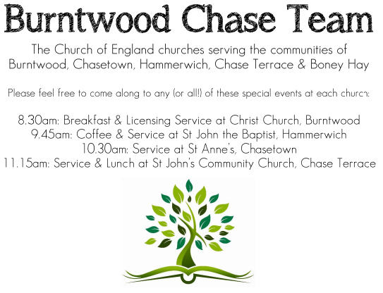 CHRIST CHURCH
SUNDAY 23rd November 2025 at 10am

SERVICES:
Sunday 23rd November 2025
Holy Communion
Christ the King Sunday

Readings:
Colossians 1: 11-20
¹¹ May you be made strong with all the strength that comes from his glorious power, and may you be prepared to endure everything with patience, while joyfully ¹² giving thanks to the Father, who has enabled you to share in the inheritance of the saints in the light. ¹³ He has rescued us from the power of darkness and transferred us into the kingdom of his beloved Son, ¹⁴ in whom we have redemption, the forgiveness of sins.
¹⁵ He is the image of the invisible God, the firstborn of all creation; ¹⁶ for in^{[d]} him all things in heaven and on earth were created, things visible and invisible, whether thrones or dominions or rulers or powers—all things have been created through him and for him. ¹⁷ He himself is before all things, and in^{[e]} him all things hold together. ¹⁸ He is the head of the body, the church; he is the beginning, the firstborn from the dead, so that he might come to have first place in everything. ¹⁹ For in him all the fullness of God was pleased to dwell, ²⁰ and through him God was pleased to reconcile to himself all things, whether on earth or in heaven, by making peace through the blood of his cross.

Luke 23: 33-43
³³ When they came to the place that is called The Skull, they crucified Jesus there with the criminals, one on his right and one on his left. ³⁴ Then Jesus said, ‘Father, forgive them; for they do not know what they are doing.’ And they cast lots to divide his clothing. ³⁵ And the people stood by, watching; but the leaders scoffed at him, saying, ‘He saved others; let him save himself if he is the Messiah of God, his chosen one!’ ³⁶ The soldiers also mocked him, coming up and offering him sour wine, ³⁷ and saying, ‘If you are the King of the Jews, save yourself!’ ³⁸ There was also an inscription over him, ‘This is the King of the Jews.’
³⁹ One of the criminals who were hanged there kept deriding him and saying, ‘Are you not the Messiah? Save yourself and us!’ ⁴⁰ But the other rebuked him, saying, ‘Do you not fear God, since you are under the same sentence of condemnation? ⁴¹ And we indeed have been condemned justly, for we are getting what we deserve for our deeds, but this man has done nothing wrong.’ ⁴² Then he said, ‘Jesus, remember me when you come into your kingdom.’ ⁴³ He replied, ‘Truly I tell you, today you will be with me in Paradise.’

COLLECT FOR TODAY
Eternal Father,
whose Son Jesus Christ ascended to the throne of
heaven that he might rule over all things
as Lord and King:
keep the Church in the unity of the Spirit
and in the bond of peace,
and bring the whole created order to worship
at his feet;
who is alive and reigns with you,
in the unity of the Holy Spirit,
one God, now and for ever.

WHAT’S GOING ON
Upcoming Services
Wednesday 26th November Morning Prayer 9.30am
Sunday 30th November Morning Worship 10am
Wednesday 3rd December Morning Prayer 9.30am
Saturday 6th December Art Cafe 3-5pm
Sunday 7th December In Loving Memory 4pm
Monday 8th December Cameo Cafe 10-12noon

An Evening of Christmas Music and Readings – Thursday, 11th December, 7.00pm
Time to dig out those Christmas jumpers! Come along to an informal evening of Christmas readings, carols and Christmas songs including the ever popular “White Christmas”. Bring your own drinks, if you wish, and a small amount of Christmas food to share.
Poppy Collection
Our Poppy collection amounted to £60 Thanks to all who contributed.

Christmas Tree
The large Christmas tree will be up standing proud by Saturday 29th November. If you would like to come along to help decorate the tree and anything else needs to be decorated, Church will be open at 10:30am on Saturday 29th November.

Christmas Fayre
Thank you to Chris and team for all their hard work and making the
Christmas Fayre a success. We raised £1369 thank you

FLOODLIGHTING
If you think about commemorating a special occasion by floodlighting our Church. Please contact Chris Brown on 01543 683862 for details.

PRAYER CHAIN
Christ Church is blessed with a very active prayer chain. If you, or anyone you know, feel that they would like others to pray for them, please speak to Chris Brown on 01543 683862.

HOME COMMUNION
For anyone who is unable to attend church and would like Home Communion,
Steve Morgan is able to carry this out.

VICAR CONTACT DETAILS
Stephen Morgan Tele: 07305 852152
CHURCH WARDENS CONTACT DETAILS
Judith Rogers Tele: 01543 324718
Mike Holmes Tele: 01543 672970
Church Office Tele: 01543 642187 [leave a message and we will respond]
Church Web Site:www.christchurchburntwood.org.uk
Church Email: christchurchburntwood15@gmail.com
Facebook: www.facebook.com/group/christchurchburntwood/

Other Contacts
Matt Wallace St. John’s, Chase Terrace— Tele: 01543 670078
Richard Westwood St. Anne’s, Chasetown—Tele: 01543 686111

NEXT SUNDAY SERVICE
Sunday 30th November at 10am
Morning Worship
Isaiah 2: 1-5
Matthew 24: 36-44
Advent Sunday

