The Parishes of St Anne’s Greenland’s and St Paul’s North Shore  Week Commencing: 23rd November 2025 | 
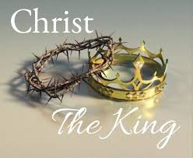  Sunday 23rd November 2025  Christ the King  Sunday next before Advent  St Anne’s Eucharist Service 9.30am  St Paul’s Morning Service11.15am  Sunday 30th November 2025  Advent Sunday  St Anne’s Eucharist Service 9.30am  St Paul’s Morning Service11.15am  St Paul’s Tuesday Prayer meeting  9-30am in church  St Paul’s Wednesday 10-00am  Mid week Eucharist Service  St Anne’s Thursday 27th November 6-00pm  Evening Prayer  Contemplative Prayer  Monday 15th December at 7pm at Sallie’s  Prayer for today:  Lord Jesus Christ, King of Heaven and Earth,  On this day we lift our hearts in worship,  acknowledging Your reign over all creation.  You are the Shepherd who guides, the Judge who is just,  and the King whose crown is love. Rule in our hearts with gentleness and truth. Bring peace where there is conflict,  hope where there is despair, and light where shadows linger.  Teach us to serve You faithfully, to walk in Your ways,  and to reflect Your kingdom in our words and deeds.  May Your glory shine through our lives, until the day when every knee shall bow and every tongue confess that You are Lord of all. Amen.    Sunday and Wednesday at 6-30pm At St Paul’s church Phone 07955597771  jim@libertychurchblackpool.org.uk Liberty Church is a safe inclusive church that welcomes everyone who celebrates the diversity of LGBT+ |   Please pray for:  June Lockett, David Lee Fletcher, Maureen Allen; Amanda Smith; Wendy Booth, Sue Heelam, Iain Thompson Snr, Michael Eaton; Barry Key; Janet Walsh; Sue Simpson; Dave Walters; Darren Marchant; Kath Olsson; Liam Evitts; Denise Murphy; Doreen and Chris Waller; Marion Farrar; Lauren Hamilton; Margaret Crook.    IN MEMORIUM: remembering this week:  Alice May Farnworth; Mary Lawton Jones; Annie Greaves; Sidney Shaw; Alfred Wright; Alfred Podmore; Charles Fletcher; John Arton; Betty Arton; Heather Arton; Louise Foster; Jennie Irene (Rene) Applin.  We pray for the staff and patients of Trinity Hospice, Brian House, Victoria Hospital, Clifton Hospital, the Harbour, Pennystone Court, Belgravia Nursing Home and all local rest homes and nursing homes.  In your prayers this week remember our parishes and the families in; In your prayers this week remember our parishes and the families in:  Galway Avenue, Greenbanks, Gresley Place, Bromley Close, Chelsea Avenue, Bispham Road, Pearl Avenue, Armadale Road and Rathmore Gardens.  Diocesan Vision Prayer  Heavenly Father, we embrace Your call for us to make disciples, to be witnesses, to grow leaders and inspire children and young people. Give us eyes to see Your vision, ears to hear the prompting of Your Spirit and courage to follow in the footsteps of your Son, our Lord and Saviour Jesus Christ. Amen  WALSINGHAM CELL  After a very successful pilgrimage to Walsingham, some of us have decided to rekindle the Walsingham Cell meetings once a month on the first Thursday in every month at 6pm at St Anne’s. It will mean once a month on that Thursday the service may well be slightly different. We start on the first Thursday in December at 6pm.
St Anne’s and St Paul’s Social News  Week Commencing:  23rd November 2025 | 
Low Moor Community Centre  Coffee Morning every Monday from 10am–12noon. Everyone welcome.  Come along and join in Pilates at St Anne’s Church Monday, Tuesday & Thursday mornings.  For more information:  Please phone Claire on 07599659154  St Anne’s Mothers Union Meetings are held in the community room at 2-00pm :  26th November – Christmas lunch  St Paul’s Allsorts  Every first and third Wednesday after Mid-week Communion.  St Paul’s Thursday – Drop In Café      9-30am to 12- 00 noon  Hot drinks 60p– Bacon sandwich £1-00 - Toast 50p  Come along and meet friends.  Volunteers wanted at St Anne’s!  If you would be willing and able to post Christmas cards, containing our Christmas services, in the streets close to church and in the new estate, please see Jane or  Sandra. Thank you. | 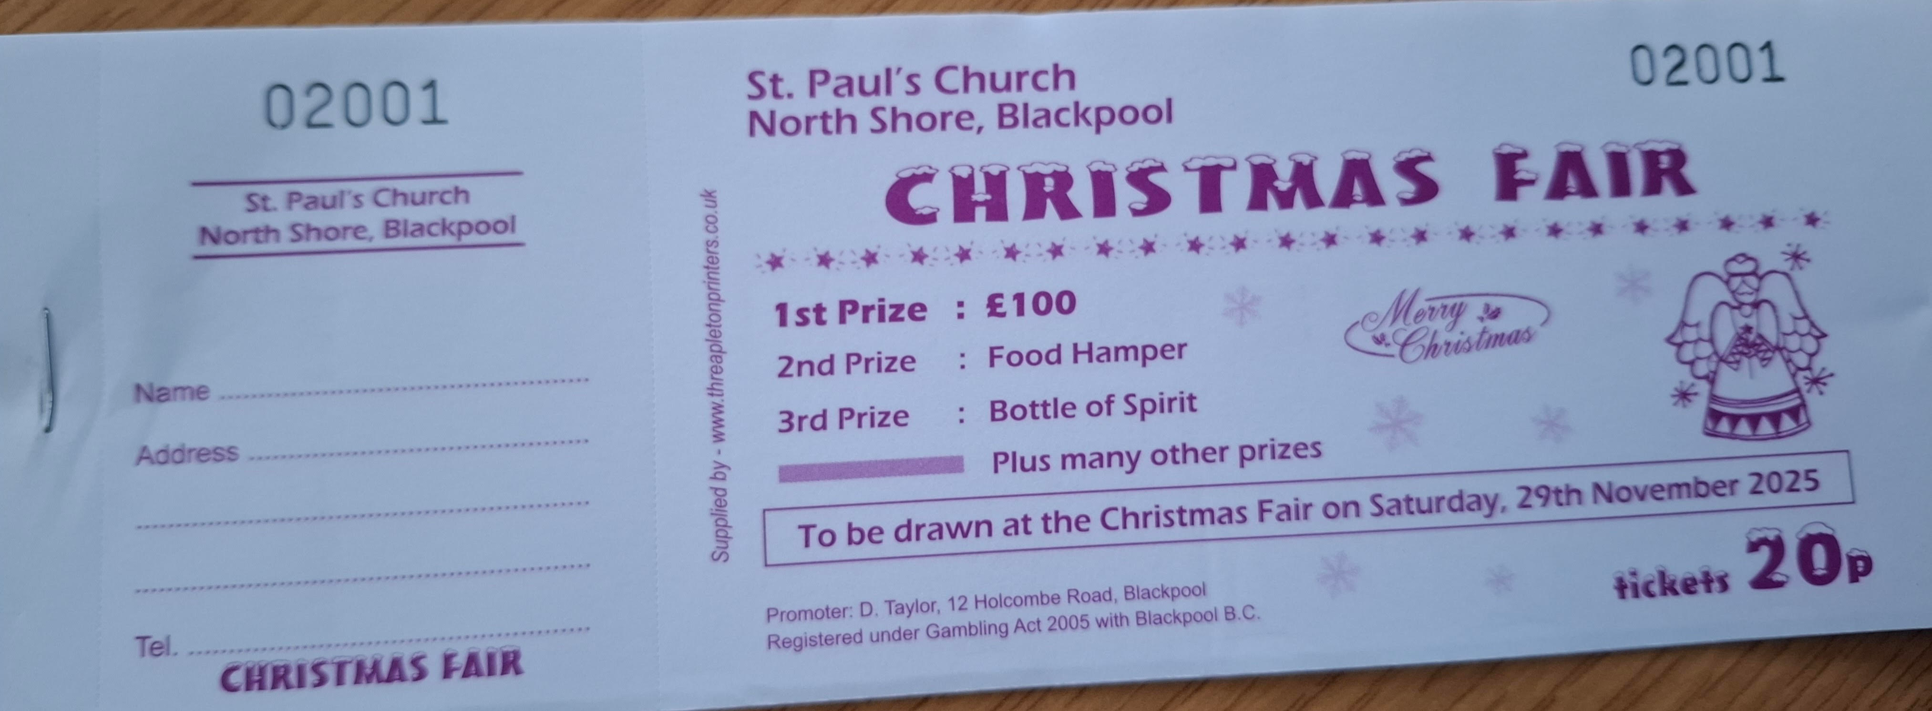  St Paul’sChristmas Fair  Raffle Tickets  Now available! Buy yours before the rush and please take a few books to sell to family and friends  St Paul’s – non-perishable items, nice and Christmassy, are requested for the hamper at the Christmas Fair and also any bottles for the Brownies’ bottle tombola.    Church Christmas meals  St Paul’s Christmas meal at the Gynn Pub on Wednesday 10th December at 12noon.  St Annes Christmas Meal at the Venue on 3rd December at 12noon.

