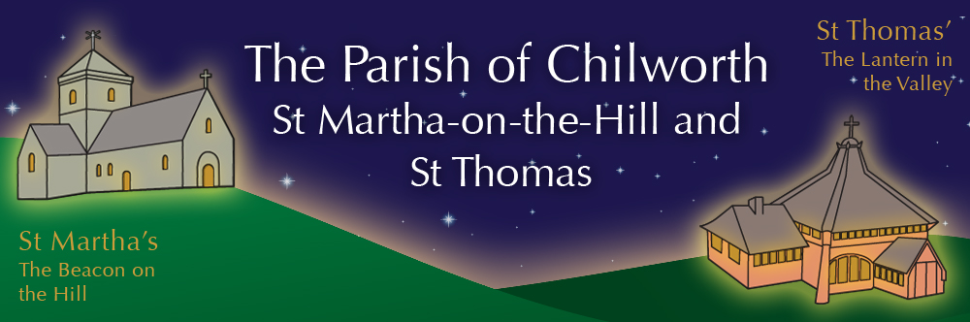

NOTICES: - 9th NOVEMBER 2025
Priest David Oakden – Revdavid@parishofchilworth.org.uk - 01483 534293 (day off Friday)
Do let me know of anybody or anything that you would like to be prayed for.
www.parishofchilworth.org.uk and find us on https://www.achurchnearyou.com

**********Matthew 15:9(NLT)***********
Their worship is a farce, for they teach man-made ideas as commands from God.
***********************************

Opportunities to pray together: -
Ecumenical Prayer Breakfast 1st Saturday of the month at the Vicarage, from 9am, prayer, coffee and croissant. Next is the 6th December – Thursday evening at St Thomas at 7:30 pm for an hour every other week. **20th November & 4th December.

This Sunday Services: – Remembrance
10:30 St. Thomas. Holy Communion
10:45 St. Martha’s – BCP Communion
15:00 Outside War Memorial – Act of Remembrance.

Next Sunday Services: - 16th November
9:30 St. Thomas. Holy Communion
11:15 St. Martha’s – BCP Mattins
15:00 St ThomasIn Memory of.

Looking further ahead: -
Chilworth Tinies and Toddler Group: St T’s Monday 9:15 – 10:30am
Benefice Autumn Course: 10th Nov 7:30 Albury Village Hall
REMEMBRANCE Sunday: 9th November
Brian Channell, Funeral: 14th Nov St T’s
In Memory of: 16th Nov St T’s 15:00

Food & Hygiene Bank: -
The Foodbank Larder box is located in the porch of St Thomas Church. Suggested items: - Long life milk /tins tuna/ tins meat/ sachets microwaveable rice /pasta sauces/curry sauces/cereal/spreads/ tea/ coffee/ hot chocolate/ tins soup/ baked beans. Please assist, especially as the autumn is now upon us.

Chilworth Tinies and Toddler Group: -
Mondays from 9:15 -10:30 meet in St Thomas, play chat, pray and support.

Autumn Sale, Gingerbread & Hot Chocolate: -
Saturday 15th November at St T’s - our Autumn Sale with Gingerbread & Hot Chocolate from 11.00 – 3.00pm. Usual stalls plus various craft stalls and a ‘recycle your last year’s Christmas Gifts’ tombola to get you in the mood for Christmas gift buying. Donations of cakes and gifts welcome. Contact Carole on shattocks@hotmail.com or call 07711 864 488 with offers of help or to have your own stall.

Benefice Autumn Study Course: -
7:30pm Monday evenings at Albury Village Hall
Can simply being with God, being with each other and being with our community really form the heart of our mission and ministry as a church? Join us to explore together how the concept of “being with” rather than “doing for” or “working for” can guide us as individuals as well as churches. Each session will look at a different aspect, so just come to as many as you can

In Memory of: -
Simple service where we light a candle for each name read out. Please let David know the name you would like remembered. St Thomas service is 16th November at 3pm.

Act of Remembrance 9th November: -
Our morning services will incorporate an Act of Remembrance, so start at different times, also we hope the RAF Chinook will once again do a fly over at around 11am. We meet at the outside War Memorial in Dorking Road at 3pm as well.

Benefice News - David Oakden: -
He will be licenced to this additional role by Archdeacon Catherine on December 9th at 2.30pm at Albury Parish Church – St Peter & St Paul, Church Lane, Albury.

Advent Bring and Share Lunch 30th Nov: -
This year's Bring and Share Advent Lunch (with a curry theme) will be held at St Thomas' @ 12.00pm for 12.30 sit down. A sign up sheet will be available shortly (curry, rice, chutneys, pickles, poppadums, wine, soft drinks etc) but please bring mince pies for desserts as this is when we begin to 'collect' our mince pies for refreshments following the Christmas Tree Lighting at the beginning of December and other special Christmas Services during December. Many thanks.

