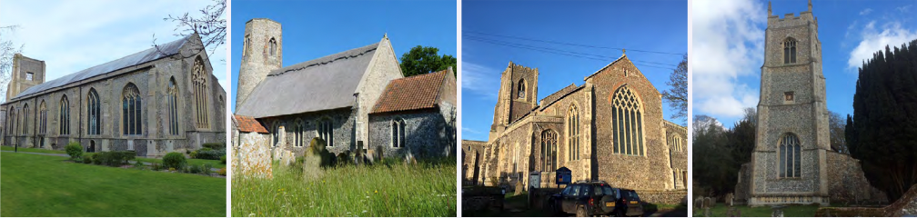

N.E.W.
North Walsham
Edingthorpe
Worstead and Westwick
NEWS
The Magazine for the North Walsham Benefice December 2025 and January 2026 40p
Transformed by Christ: Prayerful, Pastoral, Prophetic

Editor’s Bit

Contents in this issue:
- Vicar’s Page
- From the Assistant Curate
- Dates from the Diary
- December/January 2026 service Dates
- Upcoming Events
- Christmas services for 2025 and the New Year
We hope to see you at our services; you are all welcome.

Please note the date for items to go in the February edition of NEWS needs to be at the Parish office by January 20th 2026 latest.
Please note also that Christmas cards are available now on the bookstall.

It was announced in September that the Revd Canon Susanna Gunner has been appointed to a part time role in the Brooke and Hempnall Benefices with her induction on 4th January 2026. We pray for Susanna and Ben, thank them for all they have given this community, and pray for the parishes that will be receiving Susanna as their new priest.

Anna, our Treasurer at St Nicholas is stepping down after many years of service. We thank her for all she has done to support PCC and our wider life. We begin the search for a successor - could it be you or someone you know? Contact David for information!

Financial Information

Please may we remind you, that if you are giving us a cheque for any of the Churches, they need to be made payable to the following:
St Nicholas’ Church – North Walsham PCC
All Saints’ – Edingthorpe PCC
St Mary’s – Worstead PCC
St Botolph’s – Diocesan Churches Trust
Please may we ask if you are sending any payments to us via an online service that you put a meaningful reference on the payment to ensure we know where the payment should go to.

Live-streamed services are available on YouTube - please search St Nicholas North Walsham. Do you participate in our live-streamed services - we would love to hear your feedback: contact David on 07506 723946 or davidnorthwalsham@gmail.com

If you are considering a change to your Committed Giving for St. Nicholas, please inform Chris Sherman (Committed Giving Officer)
Please support St. Nicholas Church, North Walsham on #easyfundraising, you can raise FREE donations when you shop online with over 5,000 retailers. It is simple and only takes 2 minutes to sign up! Plus, once you have raised your first £15, easy fundraising will match it!
Sign up now: https://www.easyfundraising.org.uk/causes/stnicholaschurchnw/

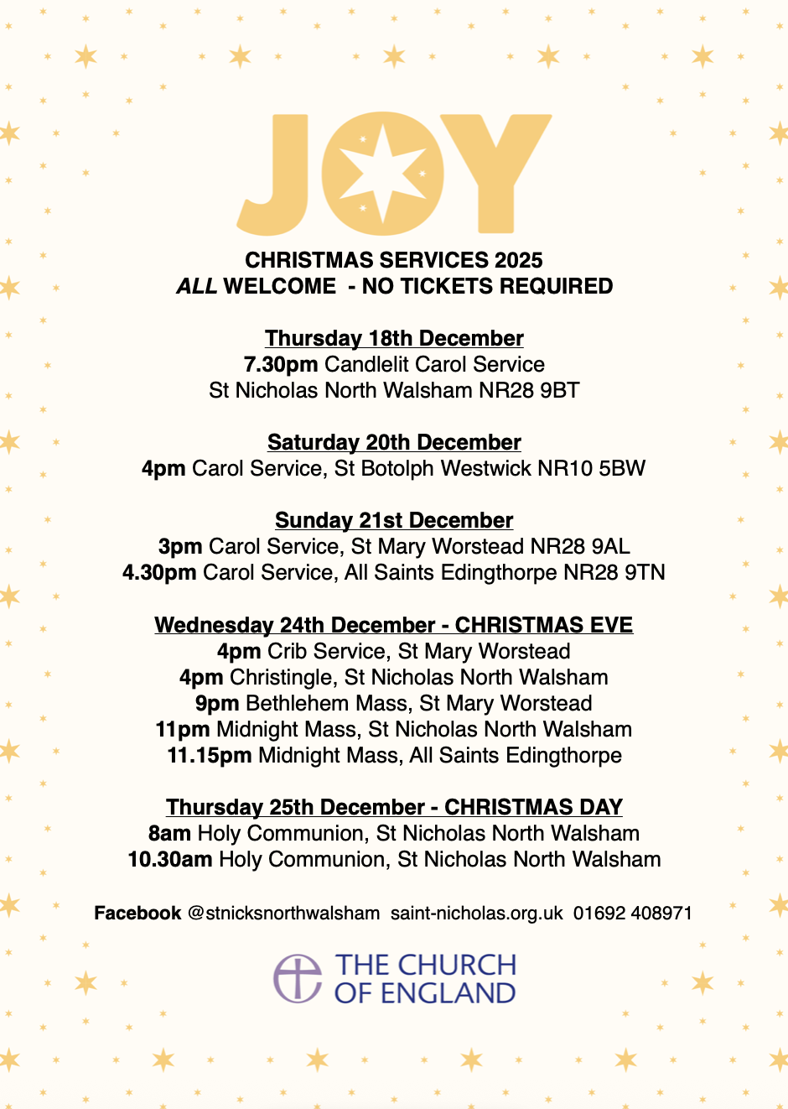
The Vicar’s page:
From David:
The arrival once more of the season of Advent reminds us that the circle of life continues and the circle of worship continues within it. There is so much to get ready for, to plan for, and to prepare for, and we shall never truly be ready in this world, but we keep on trying for that is what we are called to.
Much exciting stuff is going on across the Benefice just now. At Edingthorpe, we’ve received permission to re-plaster the West wall and received a generous donation to fund that work. When the weather is better we will get on with the job and look forward to other works that need doing.
At Worstead, thanks to the generosity of the Festival, we are ready to install a new kitchen in January and the automatic locking is already proving itself hugely valuable to the local community. We thank God for the generosity of all who give to support the life of Worstead Church.
Westwick continues to stand ready for worship when we are able to use it and across the Christmas season it is good to be able to gather in that place to worship as generations have before us.
North Walsham prepares for Advent and Christmas as ever. We look forward to welcoming the Community Fridge in January and to all the people that will come to use that service. The Nicholas Project is continuing in the background with much work in preparation. Among these particularly is the document known as the ‘statement of significance:’ this is a hugely important document for any work to be done and we’re grateful to our support team for enabling this to be put together.
There is much to do and we are grateful for those who joined in the discussion sessions earlier in the year: it is obvious that various things need to be addressed, not least facilities like toilets and kitchens in the church but also the basic layout of the nave and how we make best use of the enormous space that we have at our disposal. It’s important to note that no changes beyond technical and practical ones are expected or planned beyond the rood screen. Thank you to all who continue to work and pray for the development of the church as many generations have over its life.
In December I take on the work of Rural Dean and look forward to working with my colleagues across the Deanery for the furtherment of the Gospel and the advancement of the kingdom in this place. I’m grateful to Bishop Graham for his trust and for the support of my colleagues in this difficult endeavour. It’s also a good moment to look back and say thank you to God for the gift that Dan has already been in our life since he arrived in June (I know it seems a lot longer ago than that).
So let us look forward to the season ahead, both of preparation and of celebration as we give thanks to God again for the gift of his son Jesus Christ, for the redemption of the world, for the salvation of all people and for the hope of our calling.

With my prayers and good wishes,

David

The Curate’s Page
The last Sunday of the Church year is the one when we celebrate Christ the King.
But it is also known to those of the Prayer Book tradition as ‘Stir up Sunday’.
It comes from the first words of the Collect from Sunday next before Advent:
‘Stir up, we beseech thee, O Lord, the wills of thy faithful people; that they, plenteously bringing forth the fruit of good works, may of thee be plenteously rewarded; through Jesus Christ our Lord. Amen.’

Traditionally, this is known as the last Sunday to stir up your Christmas pudding, so it’s ready in time for the celebration of the Incarnation of our Lord.
When the weather gets colder and colder, and days ever shorter, we begin the time of Advent, during which we prepare our hearts to welcome our Newborn Saviour in our midst.
This time is there to prepare our hearts and minds, to stir them up, so that we are ready to welcome our Saviour: the ultimate Love, the ultimate Perfection, and the ultimate Salvation.
He comes, the Sinless One, to take upon himself our sins, He died so that we may live.
May this time of Advent be a time of openness, of welcome towards strangers, of warmth in our hearts and relationships with others and a time of stirring up ourselves and those around us, so that, when the time comes, we are ready. Ready to sing with the choirs of angels: ‘Gloria in excelsis Deo!’

Dan



Edingthorpe Village news for December/January
All Saints Church, Edingthorpe.
Services
14th December 9.15am. Holy Communion
21st December. Carol Service 4.30pm
24th December. Christmas Eve. 11.15pm Midnight Mass
28th December 9.15am. Morning Prayer
11th January. 9.15am. Holy Communion
25th January. 9.15am. Morning Prayer

On 3rd November All Saints Church Edingthorpe celebrated a Patronal Festival with a Choral Evensong service at 4pm with the wonderful choir from St Nicholas church taking part. This is the occasion on which a parish annually honours the saint that was chosen as the Patron Saint of the parish. It was very different from our normal service, but very moving. Our usual refreshments were served afterwards.
We held a well-attended Remembrance Service on 9th November when we were able to remember all those who sacrificed their lives during the wars past and present. A wreath was laid by Andrew Withers and Graham de Feyter read the names of all in the village who had given their lives in the two World Wars.
Our Christmas Coffee morning is being held at St Benet’s Hall at the back of the Church in North Walsham on Thursday 11h December from 9am to12 noon. Tea, Coffee, cakes and mince pies will be served. There will also be cakes and preserves. tombola, bric-a-brac. Christmas crafts, Hamper raffle and other stalls. Do come along and join us.
The Carol Service is being held on 21st December at 4.30pm. You are warmly invited to celebrate with Carols and Readings to tell the Christmas Story. Refreshments after the service.
We will be celebrating the beginning of Christmas at 11.15pm on Christmas Eve. All welcome to this special service.
Details of all future events to follow in the New Year.
We wish you all a peaceful Christmas and a happy, healthy and safe New Year.

June Hannant 01692 402337.
All events about the Church are on https://www.achurchnearyou.com/church/10076/ or the village website www.edingthorpe.village.org.uk
June Hannant 01692 402337

ST MARY’S WORSTEAD

Some important dates for your diary:

18th December - School Christingle Service - 2.15 pm
21st December - Carol Service - 3.00 pm
24th December - Crib Service - 4.00 pm
24th December - Midnight Mass (midnight in Bethlehem) - 9.00 pm

We look forward to welcoming you to your Church.
As the ‘busy’ summer season draws to a close, we’ve time to reflect on our
successes – porch window panes replaced, our new electronic door, complete
with timer, and, of course, the Festival.
We were blessed with good weather and an enormous number of visitors who
came to the many craft stalls and beautiful floral displays. Our hard-working
catering team worked wonders with all the delicacies they produced, to say
nothing of endless teas and coffees. Over £3000 was raised, on refreshments
alone, thanks to their hard work and our ever-generous customers.
Our Patronal service, in August, was well supported, with a congregation of
some thirty six people, all of whom were made welcome. Coffee &amp; biscuits
rounded off an enjoyable morning.
Autumn approaches, and with it, our thoughts turn towards the Festive
Season.
Events and Services already planned include:
23rd October - Worstead School Service - 2.15 pm
9th November - Remembrance Sunday service - 10.45 am
22nd November - “Made in Worstead” Craft Fair - 10am – 2pm
18th December - School Christingle Service - 2.15 pm
21st December - Carol Service - 3.00 pm
24th December - Crib Service - 4.00 pm
24th December - Midnight Mass (midnight in Bethlehem) - 9.00 pm

We look forward to seeing you all as we head towards the end of another
rewarding year.

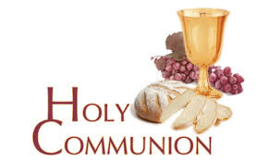
You may have read items in the press relating to the use of 'gluten free' wafers at Holy Communion - for those who require them, we use wafers which are approved and recommended for use by Coeliac UK - more information here. If you need a gluten free wafer, please advise the churchwardens/welcomers when you arrive for the service, and please indicate to the clergy distributing Holy Communion.
The Church teaches that receiving Holy Communion in both kinds (wafer and wine), or in one kind (the wafer or the wine) are acceptable and contain the fulness of the Sacrament. There are many reasons why this will be the case at different times in our lives, and there will be times when we cannot physically receive but join in an Act of Spiritual Communion (as those who watch online do - see below).

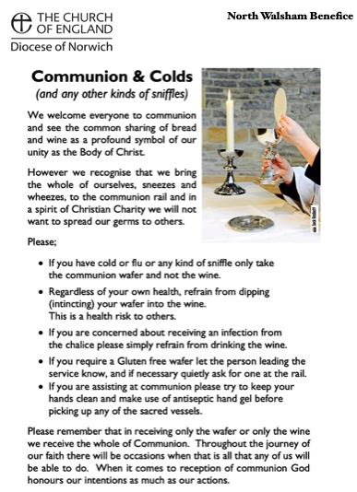
​Intinction (that is, dipping your wafer into the wine) is not permitted, both for hygiene reasons and because it might introduce gluten to the wine, which could be consumed by someone who is allergic to it.
If you wish to discuss any of this, please speak to David.

An Act of Spiritual Communion
In union, O Lord, with the faithful at every altar of your Church, where the Holy Eucharist is celebrated, I desire to offer you praise and thanksgiving. I present to you my soul and body with the earnest wish that I may always be united to you. And since I cannot now receive you sacramentally, I ask you to come spiritually into my heart.
I unite myself to you and embrace you with all the affections of my soul. Let nothing ever separate you from me. May I live and die in your love. Amen.



Why not come along to Sunday Kids and find out how to learn about what we do? We meet on the 1st and 3rd Sunday of the month at St Nicholas Church during the 10.30am service. You are most welcome.

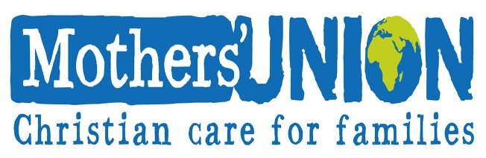

North Walsham Mothers’ Union. We meet in St Nicholas Room on the second Tuesday of the month at 2.00 p.m. Following a short act of worship and a few notices our speaker then takes the floor, after which, over tea and biscuits, there is an opportunity to ask questions and socialise. We usually finish about 3.30 pm.

Services for December 2025 and January 2026

Saturday 29th November
Christmas Lights Switch on in North Walsham
Sunday 30th November - Advent Sunday
8am Holy Communion (1662) at North Walsham
10.30am Holy Communion at North Walsham
5pm Advent Carol Service at North Walsham
Monday 1st December
9am Morning Prayer at North Walsham
Tuesday 2nd December
9am Morning Prayer at North Walsham
Wednesday 3rd December
9am Morning Prayer at North Walsham
10am Worstead Wednesday coffee morning at the Village Hall
7pm Murrell Cork Carols and Candles Service at North Walsham
Thursday 4th December
9am Morning Prayer at North Walsham
9.30am Market Day coffee morning in the St Nicholas Room
10.30am Holy Communion at North Walsham
Friday 5th December
9am Morning Prayer at North Walsham
9.30am Quiet Prayer at North Walsham
Sunday 7th December - St Nicholas
8am Holy Communion (1662) at North Walsham
10.30am Patronal Holy Communion at North Walsham
5pm Choral Evensong with commissioning of the Revd David Warner as Rural Dean, at North Walsham
Monday 8th December
9am Morning Prayer at North Walsham
10am Knitting group at North Walsham
Tuesday 9th December
9am Morning Prayer at North Walsham
2pm Mothers’ Union at North Walsham
Wednesday 10th December
9am Morning Prayer at North Walsham
10am Worstead Wednesday coffee morning at the Village Hall

Thursday 11th December
9am Morning Prayer at North Walsham
9.30am Market Day coffee morning in the St Nicholas Room
10am Edingthorpe Christmas Fair at St Benet Hall/St Nicholas Room
10.30am Holy Communion at North Walsham
Sunday 14th December - 3rd Sunday of Advent
8am Holy Communion (1662) at North Walsham
9.15am Holy Communion at Edingthorpe
10.30am Holy Communion at North Walsham
5pm Choral Evensong at North Walsham
Monday 15th December
9am Morning Prayer at North Walsham
Tuesday 16th December
9am Morning Prayer at North Walsham
7pm NW High School Christmas at North Walsham
Wednesday 17th December
9am Morning Prayer at North Walsham
10am Worstead Wednesday coffee morning at the Village Hall
1.45pm NW Junior Federation Christingle at North Walsham
Thursday 18th December
9am Morning Prayer at North Walsham
9.30am Market Day coffee morning in the St Nicholas Room
10.30am Holy Communion at North Walsham
2.15pm Worstead School Christmas at Worstead
7.30pm Candlelit Carol service at North Walsham
Friday 19th December
9am Morning Prayer at North Walsham
9.30am Quiet Prayer at North Walsham
Saturday 20th December
4pm Carol Service at Westwick
Sunday 21st December - 4th Sunday of Advent
8am Holy Communion (1662) at North Walsham
9.15am Holy Communion at Worstead
10.30am Holy Communion at North Walsham
3pm Carol service at Worstead
4.30pm Carol service at Edingthorpe
Monday 22nd December
9am Morning Prayer at North Walsham
Tuesday 23rd December
9am Morning Prayer at North Walsham

Wednesday 24th December - Christmas Eve
9am Morning Prayer at North Walsham
4pm Christingle at North Walsham
4pm Christingle at Worstead
9pm Bethlehem Mass at Worstead
11pm Midnight Mass at North Walsham
11.15pm Midnight Mass at Edingthorpe
Thursday 25th December - Christmas Day
8am Holy Communion (1662) at North Walsham
10.30am Holy Communion at North Walsham
No weekday Morning Prayer until 5th January
Sunday 28th December - 1st Sunday of Christmas
8am Holy Communion (1662) at North Walsham
9.15am Morning Prayer at Edingthorpe
10.30am Holy Communion at North Walsham
Thursday 1st January 2026
10.30am Holy Communion at North Walsham
Sunday 4th January - Epiphany
8am Holy Communion (1662) at North Walsham
9.15am Morning Prayer at Worstead
10.30am Holy Communion at North Walsham
2.30pm Canon Susanna Gunner's licensing at St Peter, Brooke
No 5pm service at North Walsham
Monday 5th January
9am Morning Prayer at North Walsham
Tuesday 6th January
9am Morning Prayer at North Walsham
Wednesday 7th January
9am Morning Prayer at North Walsham
Thursday 8th January
9am Morning Prayer at North Walsham
9.30am Market Day coffee morning in the St Nicholas Room
10.30am Holy Communion at North Walsham
Friday 9th January
9am Morning Prayer at North Walsham
9.30am Quiet Prayer at North Walsham
Sunday 11th January - Baptism of Christ
8am Holy Communion (1662) at North Walsham
9.15am Holy Communion at Edingthorpe
10.30am Holy Communion at North Walsham
5pm Epiphany Carols at North Walsham
Monday 12th January
9am Morning Prayer at North Walsham
Tuesday 13th January
9am Morning Prayer at North Walsham
2pm Mothers’ Union at North Walsham
Wednesday 14th January
9am Morning Prayer at North Walsham
7.30pm North Walsham PCC
Thursday 15th January
9am Morning Prayer at North Walsham
9.30am Market Day coffee morning in the St Nicholas Room
10.30am Holy Communion at North Walsham
Friday 16th January
9am Morning Prayer at North Walsham
9.30am Quiet Prayer at North Walsham
Sunday 17th January - 2nd Sunday of Epiphany
8am Holy Communion (1662) at North Walsham
9.15am Holy Communion at Worstead
10.30am Holy Communion at North Walsham
5pm Evening Prayer at North Walsham
Monday 18th January
9am Morning Prayer at North Walsham
Tuesday 19th January
9am Morning Prayer at North Walsham
Wednesday 20th January
9am Morning Prayer at North Walsham
Thursday 21st January
9am Morning Prayer at North Walsham
9.30am Market Day coffee morning in the St Nicholas Room
10.30am Holy Communion at North Walsham
Friday 22nd January
9am Morning Prayer at North Walsham
9.30am Quiet Prayer at North Walsham
Sunday 25th January - 3rd Sunday of Epiphany
8am Holy Communion (1662) at North Walsham
9.15am Morning Prayer at Edingthorpe
10.30am Holy Communion at North Walsham
5pm Choral Evensong at North Walsham
Monday 26th January
9am Morning Prayer at North Walsham
Tuesday 27th January
9am Morning Prayer at North Walsham
Wednesday 28th January
9am Morning Prayer at North Walsham
Thursday 29th January
9am Morning Prayer at North Walsham
9.30am Market Day coffee morning in the St Nicholas Room
10.30am Holy Communion at North Walsham
Friday 30th January
9am Morning Prayer at North Walsham
9.30am Quiet Prayer at North Walsham
Saturday 31st January
11am Baptism of James Warner at Worstead
Sunday 1st February - Candlemas
8am Holy Communion (1662) at North Walsham
9.15am Morning Prayer at Worstead
10.30am Holy Communion at North Walsham
4pm Choral Evensong at Westwick
Monday 2nd February
9am Morning Prayer at North Walsham
Tuesday 3rd February
9am Morning Prayer at North Walsham
Wednesday 4th February
9am Morning Prayer at North Walsham
Thursday 5th February
9am Morning Prayer at North Walsham
9.30am Market Day coffee morning in the St Nicholas Room
10.30am Holy Communion at North Walsham
Friday 6th February
9am Morning Prayer at North Walsham
Sunday 8th February - 2nd before Lent
8am Holy Communion (1662) at North Walsham
9.15am Holy Communion at Edingthorpe
10.30am Holy Communion at North Walsham
2.30pm Air Cadets service at North Walsham
5pm Choral Evensong at North Walsham
Monday 9th February
9am Morning Prayer at North Walsham
Tuesday 10th February
9am Morning Prayer at North Walsham
Wednesday 11th February
9am Morning Prayer at North Walsham
Thursday 12th February
9am Morning Prayer at North Walsham
9.30am Market Day coffee morning in the St Nicholas Room
10.30am Holy Communion at North Walsham
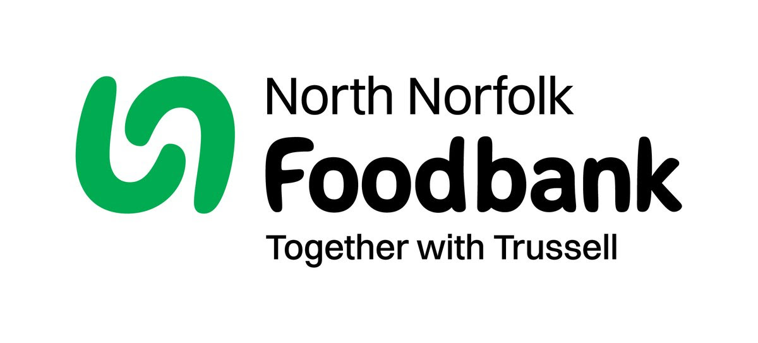Dear Harvest Festival Donors

Thank you for your generous Harvest Donations of 52.60 kg, we do appreciate it.
As we rely on food and financial donations to operate, we are extremely grateful when people choose to support us. So, thank you for thinking of us and enabling us to serve people facing hardship across North Norfolk.
In 2024/25 we fed 4520 people. Thanks to the generosity of our donors, we are able to provide clients with everything they need, with 50,349kg of stock coming in, which was down on the previous year.
Financial donations are always welcome. Please see our website for details https://northnorfolk.foodbank.org.uk/give-help/

Once again thank you so much for your generous donations.

Kind regards,

Julie Hunter Jennings
Foodbank Manager
North Norfolk Foodbank
07826 376343

We are privileged to hold special
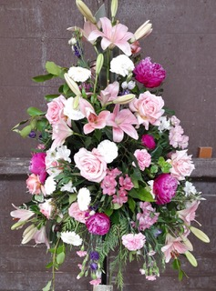
services at any of our churches
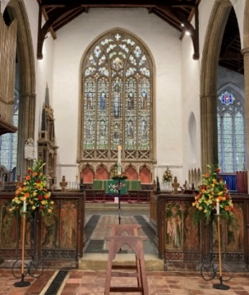
All who live in the benefice are entitled to a baptism, wedding or funeral service in church, and our clergy can officiate at the crematorium and cemeteries too. The church is here for you, through every moment of life.
************************************************************************************


Dates from the Diary

Baptisms

30th November Sienna Gabriel, Yasmin Gabriel and Daniel Gabriel - St Mary's

Funerals

4th November Marguerite Spanton - Cromer Crematorium
7th November John Louis Sexton - St Nicholas
11th November Gladys Ivy May Sayer - St Nicholas
13th November Christine Margaret Smith - NW Cemetery
24th November Lionel Frank Taylor - St Nicholas
25th November William Henry Davison - St Mary's
25th November Joyce Irene Keeler - Colney Woodland Burial Park

Please hold those above and their families in your prayers.

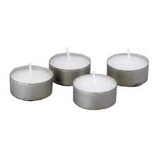
Thanks to all who’ve provided tealights for prayer stations at St Nicholas!
All donations of white, unscented tealights gratefully received!
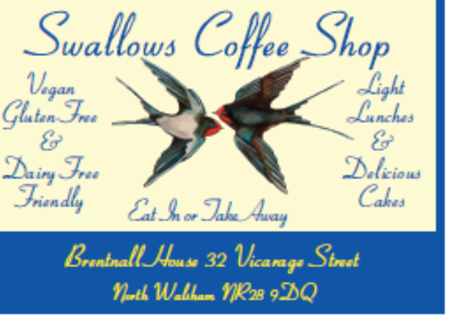




We're pleased that our weekly coffee mornings at North Walsham and Worstead are now registered with Warm Welcome Spaces
North Walsham Market Day Coffee Morning
Thursdays 9.30 – 12.00noon
The space is open to all (and their well-behaved dogs on leads), every Thursday! A warm welcome and refreshments available

Thank you to everyone for raising donations for St. Nicholas Church, North Walsham with #easyfundraising! If you have not signed up yet, it is easy and completely FREE. 8,100 brands will donate to us when you use easy fundraising to do your everyday online shopping - at no extra cost to you! Every donation you raise makes a difference to us so please sign up & share today. https://join.easyfundraising.org.uk/stnicholaschurchnw/XT7MPH/at/TSX8RX7z/RTND2/facebook/
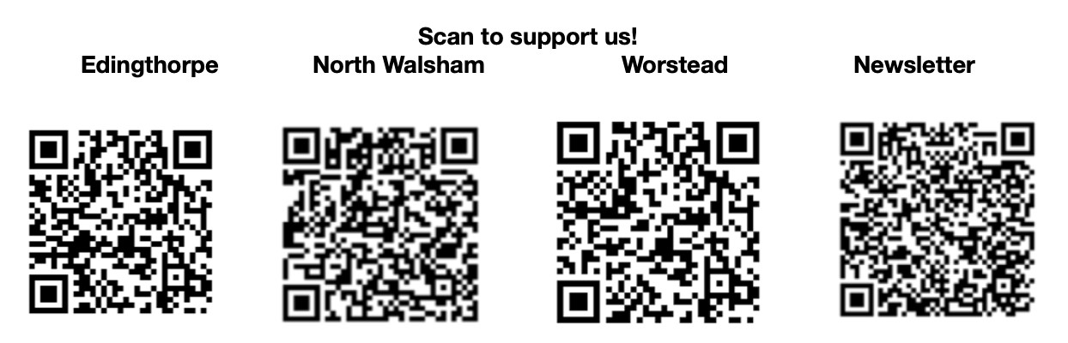


Please support the work of our Churches, by using the contactless giving point at St Nicholas or St Mary’s, leaving your gift on the offering plates or in the wall safes, or through these QR codes. Thank you.

Do you have a Business you would like to advertise in this magazine?
Whole, half or quarter page space is available.
Full Page £ 150.00
Half Page £ 75.00
Quarter Page £ 50.00
Please contact the Benefice office on 01692 408971
or email saintnicholasnw@gmail.com
for details and prices

Church Postcodes
Edingthorpe NR28 9TN, North Walsham NR28 9BT, Worstead NR28 9AL, Westwick NR10 5BW

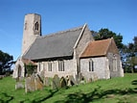
Benefice dates

All Saints’ Edingthorpe
14th December 9:15 a.m. Holy Communion
21st December 4.30 p.m.Carol Service
24th December 11:15 p.m. Midnight Mass
28th December 9:15 a.m. Morning Prayer
11th January 9:15 a.m. Holy Communion
25th January 9:15 a.m. Morning Prayer

St. Mary’s, Worstead
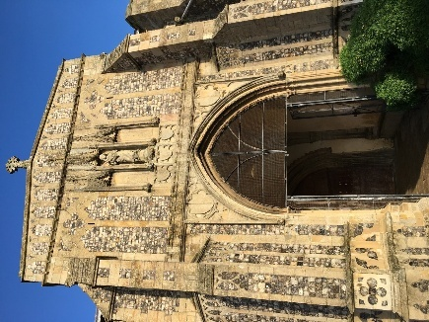
21st December 9:15 a.m. Holy Communion
3 p.m. Carol Service

24th December 4pm Crib Service

24th December 9 p.m. Bethlehem Mass

4th January 9:15 a.m. Morning Prayer

18th January 9:15 a.m. Holy Communion

1st February 9:15 a.m. Morning Prayer

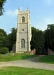
St Botolph’s Westwick

20th December 4 p.m. Carol Service

1st February 4 p.m. Choral Evensong

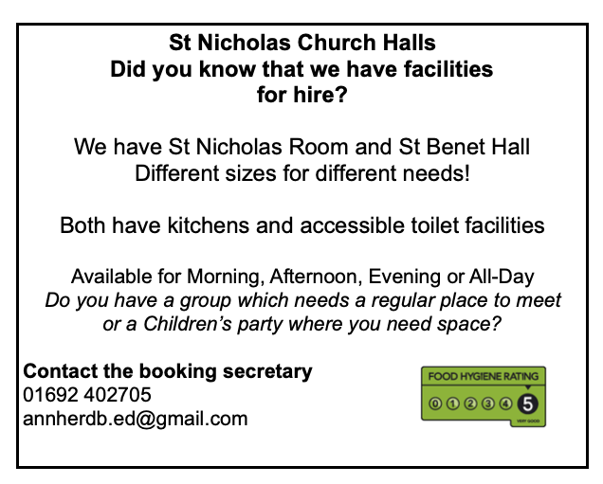
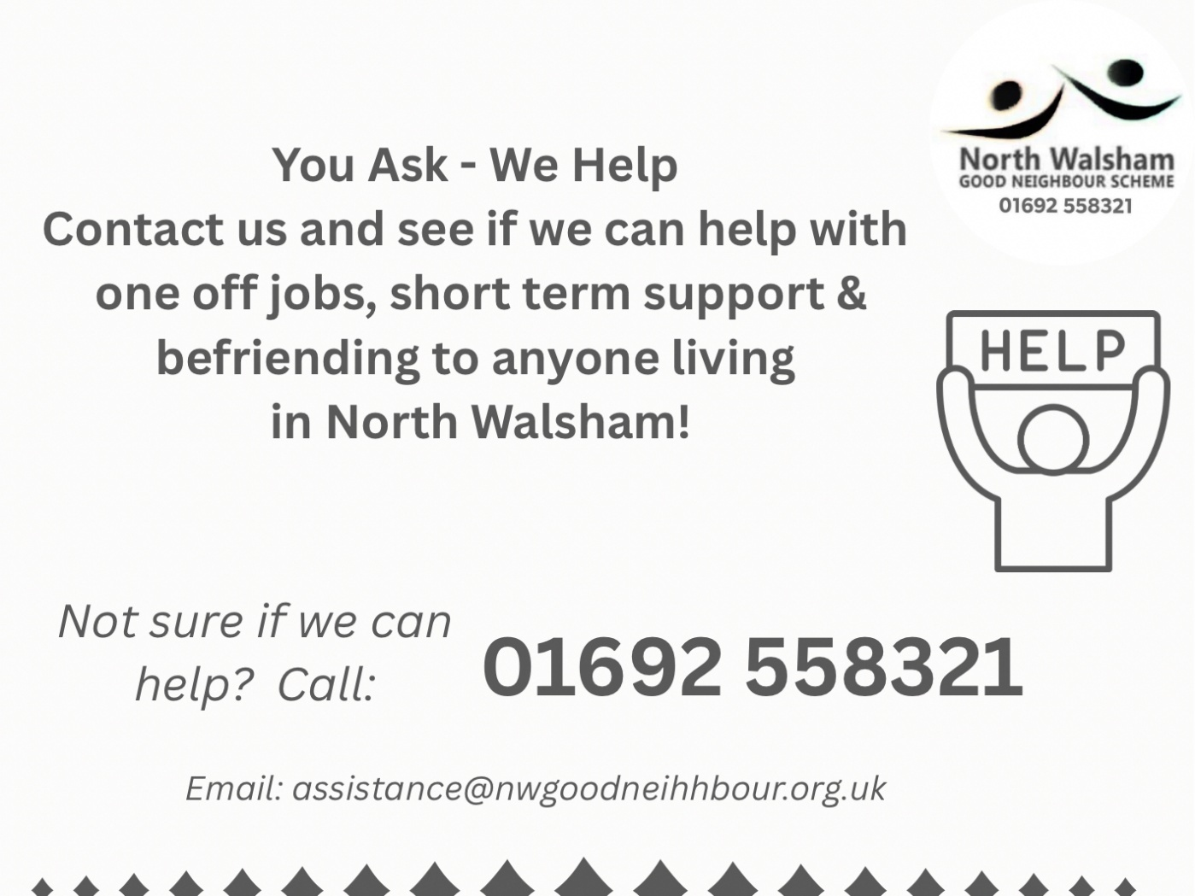

Ready to tick off your list – Will Made?
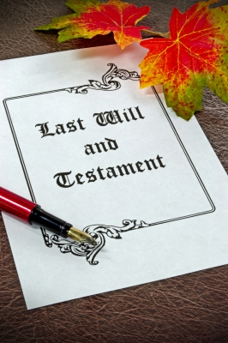
"The Church of England have teamed up with Farewills to provide a free will writing service: Online Will Writing Service | Legal Will In 15 Minutes . Anyone can use this service and it is not compulsory to leave something to your church, but it would be nice if you did. It is important for each one of us to leave our earthly matters in good order so why not take advantage of this opportunity now? It is good to remember a gift in your will to a charity is tax free. If you already have a will, you could consider leaving a legacy to the church by adding a codicil. https://farewill.com/norwich-diocese

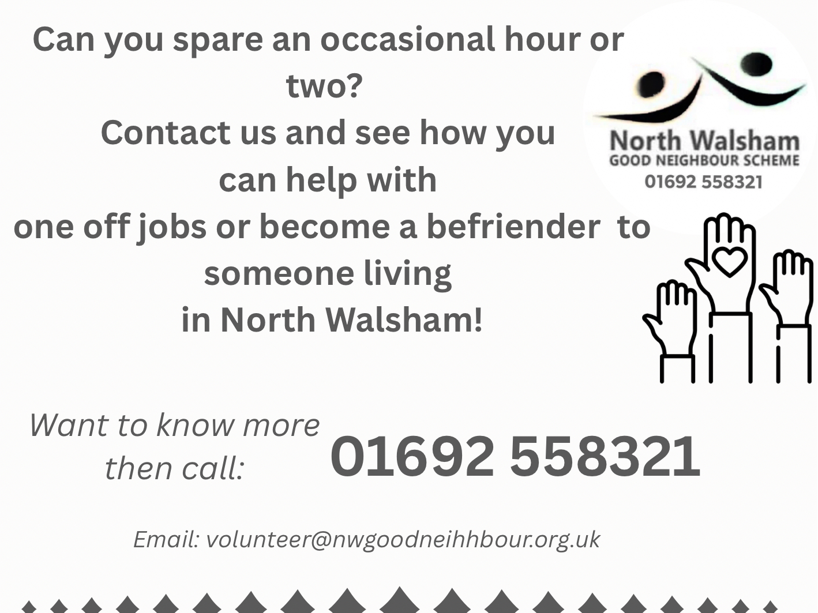

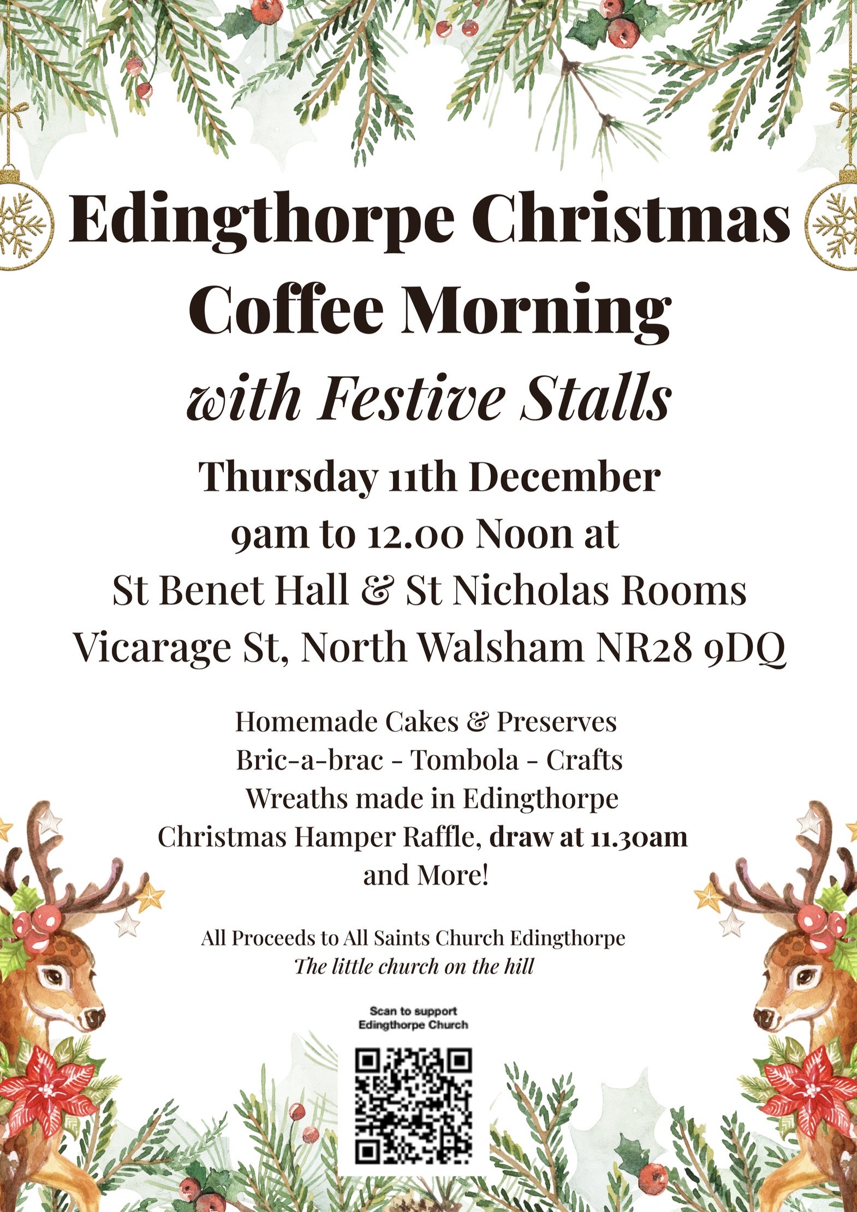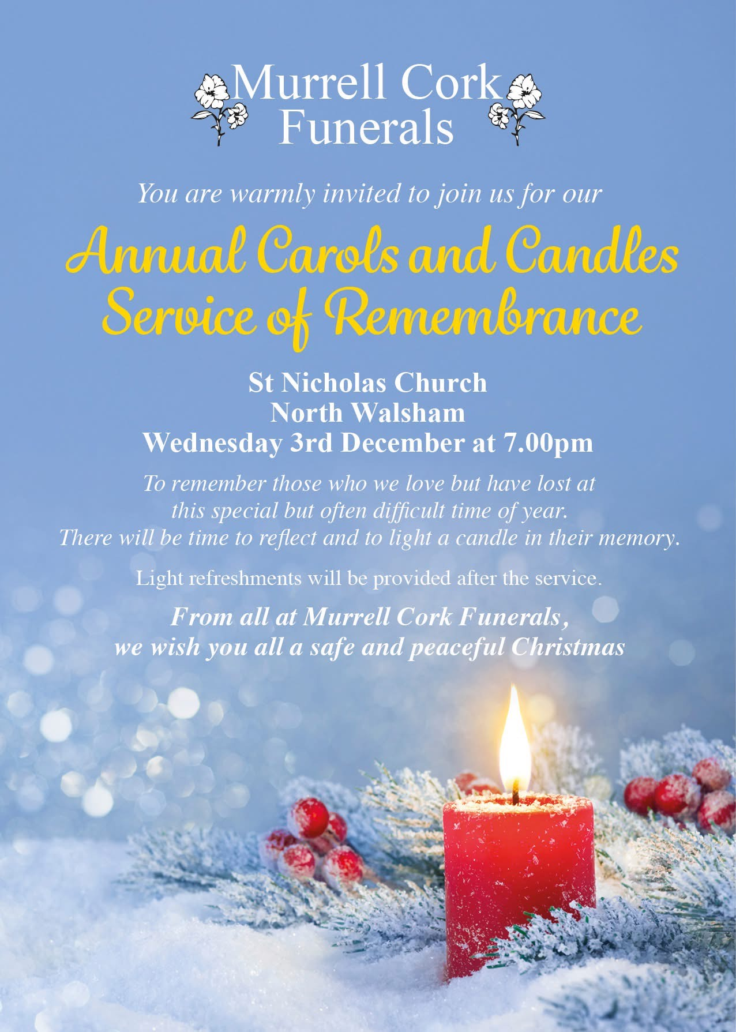

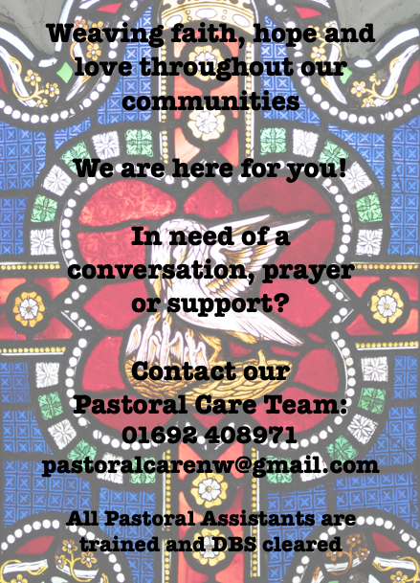

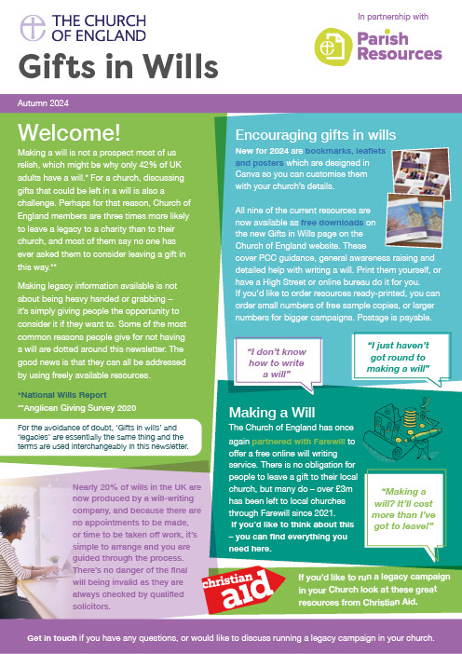
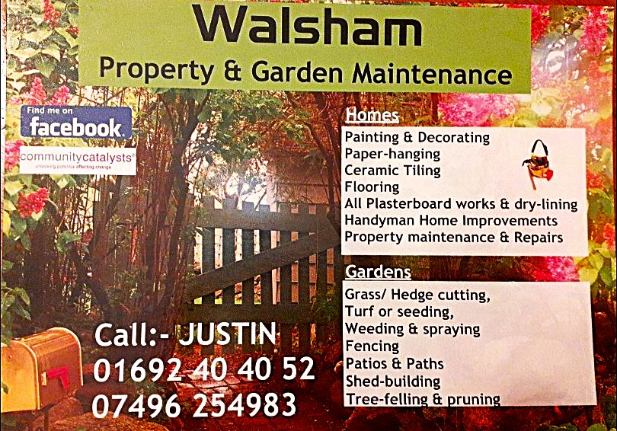

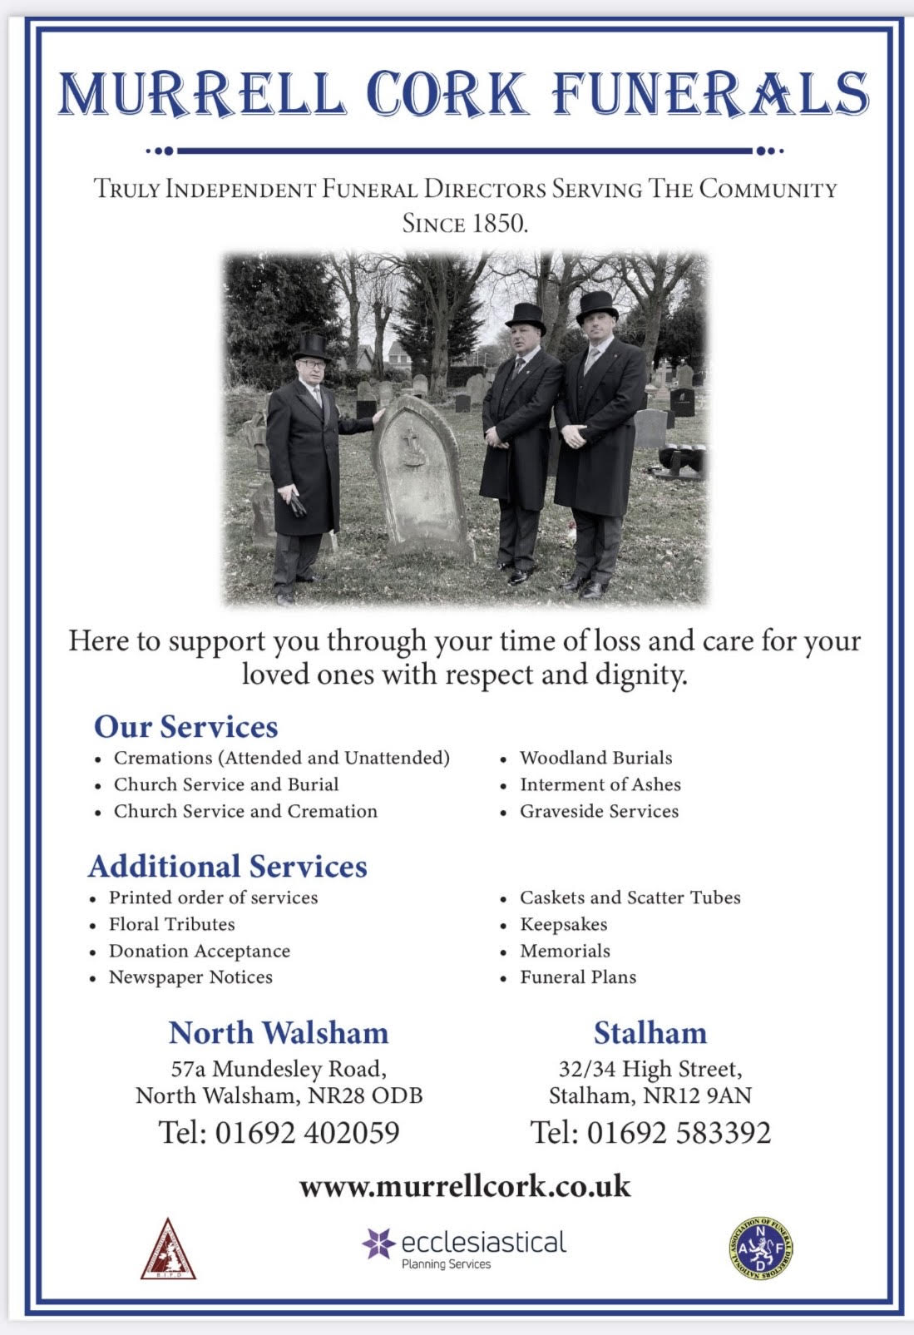
r Sale and Wants Page




Money Matters …
A regular report for our readers written by James Reginald Drake at ClearView Financial Consultants
Burgh Road, Aylsham - 01263 734859, Station Road, Hoveton - 01603 273590 and North Walsham 07773 626662

Lasting Powers of Attorney – Why are they so Important?
Lasting Powers of Attorney (LPA’s) are documents that give an individual you trust (your attorney) the legal authority to make decisions on your behalf should you either lose the mental capacity to make them, or you no longer wish to make these decisions yourself. Lasting Powers of Attorney come in 2 forms, these coming under the heading of ‘Property & Financial Affairs’ and ‘Health & Welfare’
So, how can they help?
The Property & Financial Affairs LPA covers things such as running your bank and savings accounts, making or selling investments, paying bills, buying or selling property and applying for benefits.
The Health & Welfare LPA covers things such as the type of health care and medical treatment you receive (including decisions on life sustaining treatment), where you live, as well as the type of care that you receive in areas such as diet and daily routine.
Given the wide range of areas that these documents cover, it becomes quite obvious as to why they are so important. However, according to ‘The Office of the Public Guardian’ via an article produced in 2022, less than 1% of the UK population have a Lasting Powers of Attorney in place.
So, why do so few people have them in place? One of the most commonly mentioned reasons is that people assume that their spouse will automatically have the right to make decisions for them should they ever reach the stage where they are unable to. This however is a common misconception and it is very often discovered far too late that they actually have no legal authority at all. Cost is another reason people put it off, I can assure you are costs for this type of work are minimal, in the hope this is not a reason to delay.
What should you do?
Well, the answer to this one is quite simple……. get on and set up both types of LPA as soon as you can. It is never too soon to set one up, but it certainly can be too late. By law, once your mental capacity has gone, so has your opportunity to appoint attorneys to act on your behalf. At this point your loved ones will be required to go down a different route and apply to the Court of Protection for a Deputyship order. This requires more forms, more cost and more time, which can all be easily avoided with a bit of forward planning.
So, if setting up Lasting Powers of Attorney(s) is something that you think would benefit you and your loved ones, please feel free to contact me and we can discuss how they can be put in place in a way that is best suited to your own personal requirements.
This short article in no way should be taken by readers as advice.
James can be contacted on either of the above landline numbers or via email at support@smithifa.co.uk
ClearView Financial Consultants is a trading name of Martin Smith Independent Financial Adviser Ltd, a company registered in England
under number 11439150 and authorised and regulated by the Financial Conduct Authority under number 944677.



