Psalm 17: 1 to 9
Just a reminder you can find out more that is happening and get in touch via our website
https://allsaintschurchkirkhallam.enablecomcloud.co.uk/
or A Church Near You website
www.achurchnearyou.com/church/13402/
These are our two official, authorised websites, other sites may have our name but actually are nothing to do with the church.
Please stand, if able, and join in the verses in bold

Hear a just cause, O Lord; attend to my cry;
give ear to my prayer from lips free of deceit.
From you let my vindication come;
let your eyes see the right.

If you try my heart, if you visit me by night,
if you test me, you will find no wickedness in me;
my mouth does not transgress.
As for what others do, by the word of your lips
I have avoided the ways of the violent.
My steps have held fast to your paths;
my feet have not slipped.

I call upon you, for you will answer me, O God;
incline your ear to me, hear my words.
Wondrously show your steadfast love,
O saviour of those who seek refuge
from their adversaries at your right hand.

Guard me as the apple of the eye;
hide me in the shadow of your wings,
from the wicked who despoil me,
my deadly enemies who surround me.
Distribution of Communion –currently the Priest will dip the communion wafer in the wine while we discern a safe way to bring the common cup back into worship, as we want everyone to feel included and safe. We also have gluten free wafers available.

Glory be to the Father and to the Son and to the Holy Spirit,
as it was in the beginning, is now and ever shall be,
world without end. Amen

A big ‘thank you’ to the students at Kirk Hallam Community Academy for making this Remembrance display
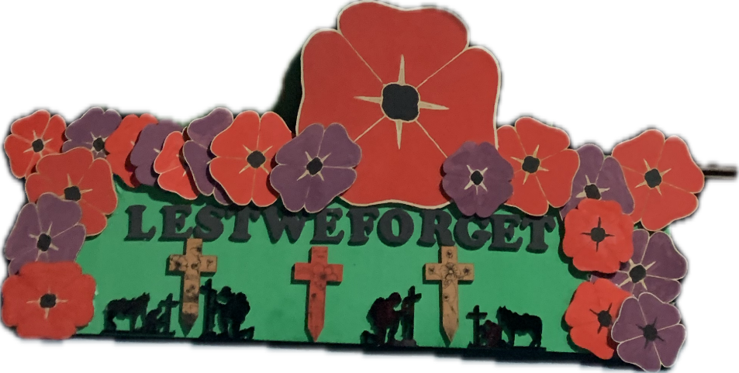
As from Sunday 16th November the 4pm service will be in Friendship House (except on 21st December for the Carol Service) until Sunday 15th February.
In our weekly prayers for our parish
This week we pray for God’s blessing on Sunningdale Drive, The Spinney and Tilton Grove.

New Testament Readings from the Lectionary

Monday 10th Matthew 4: 23 to 5:12
Tuesday 11th Matthew 5: 13 to 20
Wednesday 12th Matthew 5: 21 to 37
Thursday 13th Matthew 5: 38 to end
Friday 14th Matthew 6: 1 to 18
Saturday 15th Matthew 6: 19 to end

We are using the readings from the
Church of England’s Morning Prayer service.
All Saints Church
Refreshments After the Morning Service
Please stay seated after the service and a hot drink will be brought to you in the pews.
Church contact information
Contact: Rev’d Christine - revchristine@outlook.com
The Rectory, The Village, West Hallam, DE7 6GR
Landline 0115 646 1497
Rev’d Ailsa -revailsahunt@gmail.com
Tel - 07356064856

Churchwardens – Mrs Janet Wheeldon, -Tel: 0115 8771593
Mrs Linda Gregory – linda.gregory3@icloud.com
https://www.achurchnearyou.com/church/13402/
https://www.facebook.com/allsaintskirkhallam

Kirk Hallam
Disabled Toilet in Friendship House.
Disabled Toilet in Friendship House.

Working with God to transform lives & communities.
Please can you ensure your mobile is on silence, or off during the service, it is affecting people with hearing aids and the loop system.

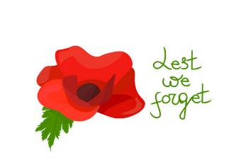
9th November – Remembrance Sunday
10.00am Iona Communion Service with Rev’d Ailsa
4.00pm Iona Evening Prayer with Rev’d Alan

Forthcoming Events
Tues 11th 6.00pm Home Group in Friendship House
Weds 12th 9.30am Morning Prayer at UCAS, Stanley Common
Weds 5th 2.00pm Mothers’ Union meeting in church
Fri 14th 6.00pm Choir Practice in Friendship House
Sat 15th 10.00am Prayer Meeting in Friendship House

16th November – Second Sunday Before Advent
10.00am CW Communion Service with Rev’d Ailsa and Julie
11.00am Interring of ashes of Mavis Harrison by Rev’d Christine
2.00pm Baptism of Knightley-Rose Llewellyn by Rev’d Christine
3.00pm Building Faith, Lego Church at Community Hallam
with Rev’d Ailsa
4.00pm BCP Holy Communion in Friendship House
with Rev’d Christine
‘You are the light of the world. A city set on a hill cannot be hidden’ Matthew 5:14
It’s Good to Talk! If you spot that someone is missing, please pop a news sheet through their door, & if you’ve time, call for a chat - just to check they’re OK & to let them know that they are not forgotten!

