MASS & SERVICE TIMES THIS WEEK

SUNDAY 30TH NOVEMBER
FIRST SUNDAY OF ADVENT

PARISH MASS
10 AM
Celebrant: Father Paul Bennett SSC

MONDAY 1ST DECEMBER Holy Hour 10 am

TUESDAY 2ND DECEMBER Christingle Service with 10am
Gill Blowers Nursery

SUNDAY 7TH DECEMBER
SECOND SUNDAY OF ADVENT
Parish Mass 4 pm
Celebrant: Father Yenda Smejkal SSC

Parish Priest
In Vacancy
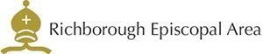



Please contact the churchwarden: Valerie Rice 07946 175105

Email: marshfarmholycross@gmail

