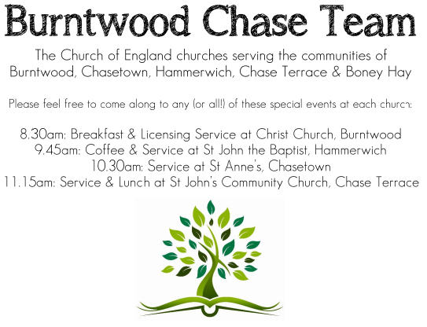 CHRIST CHURCH
SUNDAY 30th November 2025 at 10am

SERVICES:
Sunday 30th November 2025
Morning Worship
Advent Sunday

Readings:
Isaiah 2: 1-5
² In days to come
the mountain of the Lord’s house
shall be established as the highest of the mountains,
and shall be raised above the hills;
all the nations shall stream to it.
³ Many peoples shall come and say,
‘Come, let us go up to the mountain of the Lord,
to the house of the God of Jacob;
that he may teach us his ways
and that we may walk in his paths.’
For out of Zion shall go forth instruction,
and the word of the Lord from Jerusalem.
⁴ He shall judge between the nations,
and shall arbitrate for many peoples;
they shall beat their swords into ploughshares,
and their spears into pruning-hooks;
nation shall not lift up sword against nation,
neither shall they learn war any more.
⁵ O house of Jacob,
come, let us walk
in the light of the Lord!

Matthew 24: 36-44
³⁶ ‘But about that day and hour no one knows, neither the angels of heaven, nor the Son, but only the Father. ³⁷ For as the days of Noah were, so will be the coming of the Son of Man. ³⁸ For as in those days before the flood they were eating and drinking, marrying and giving in marriage, until the day Noah entered the ark, ³⁹ and they knew nothing until the flood came and swept them all away, so too will be the coming of the Son of Man. ⁴⁰ Then two will be in the field; one will be taken and one will be left. ⁴¹ Two women will be grinding meal together; one will be taken and one will be left. ⁴² Keep awake therefore, for you do not know on what day your Lord is coming. ⁴³ But understand this: if the owner of the house had known in what part of the night the thief was coming, he would have stayed awake and would not have let his house be broken into. ⁴⁴ Therefore you also must be ready, for the Son of Man is coming at an unexpected hour.

COLLECT FOR TODAY
Almighty God,
give us grace to cast away the works of darkness
and to put on the armour of light,
now in the time of this mortal life,
in which your Son Jesus Christ
came to us in great humility;
that on the last day,
when he shall come again in his glorious majesty
to judge the living and the dead,
we may rise to the life immortal;
through him who is alive and reigns with you,
in the unity of the Holy Spirit,
one God, now and for ever.

WHAT’S GOING ON
Upcoming Services

Monday 1st December Cameo Cafe 10-12noon
Wednesday 3rd December Morning Prayer 9.30am
Saturday 6th December Art Cafe 3-5pm
Sunday 7th December In Loving Memory 4pm
Wednesday 10th December Morning Prayer 9.30am

Art Cafe

Art Cafe will be on Saturday 6th December, 3-5pm.
All welcome to join us.

Cameo Cafe
Cameo Cafe will be open on Monday 1st December, 10-12 noon.
Come and join us for a cuppa and a biscuit or two.

An Evening of Christmas Music and Readings – Thursday, 11th December, 7.00pm
Time to dig out those Christmas jumpers! Come along to an informal evening of Christmas readings, carols and Christmas songs including the ever popular “White Christmas”. Bring your own drinks, if you wish, and a small amount of Christmas food to share.
Poppy Collection
Our Poppy collection amounted to £60 Thanks to all who contributed.

Christmas Fayre
Thank you to Chris and team for all their hardwork and making the
Christmas Fayre a success. We raised £1369 thank you to everyone.

FLOODLIGHTING
If you think about commemorating a special occasion by floodlighting our Church. Please contact Chris Brown on 01543 683862 for details.

PRAYER CHAIN
Christ Church is blessed with a very active prayer chain. If you, or anyone you know, feel that they would like others to pray for them, please speak to Chris Brown on 01543 683862.

HOME COMMUNION
For anyone who is unable to attend church and would like Home Communion,
Steve Morgan is able to carry this out.

VICAR CONTACT DETAILS
Stephen Morgan Tele: 07305 852152
CHURCH WARDENS CONTACT DETAILS
Judith Rogers Tele: 01543 324718
Mike Holmes Tele: 01543 672970
Church Office Tele: 01543 642187 [leave a message and we will respond]
Church Web Site:www.christchurchburntwood.org.uk
Church Email: christchurchburntwood15@gmail.com
Facebook: www.facebook.com/group/christchurchburntwood/

Other Contacts
Matt Wallace St. John’s, Chase Terrace— Tele: 01543 670078
Richard Westwood St. Anne’s, Chasetown—Tele: 01543 686111

NEXT SUNDAY SERVICE
Sunday 7th December at 4pm
In Loving Memory
Isaiah 11: 1-10
Matthew 3: 1-12
2nd Sunday of Advent

