
WELCOME!
ST STEPHEN’S CHURCH IS OPEN
10am-3pm daily
for Private Prayer and Reflection

BULLETIN
30th November 2025
The First Sunday of Advent

10.30am Family Communion

Notices for inclusion in the bulletin please
email to me by Tuesday of each week
officeststephenfradley@gmail.com

Please take Bulletin away with you
Diary Dates
November 2025

Sunday 30th 10.30am Family Communion
Refreshments are served after every service

December 2025
Monday 1st 9-12noon Fradley Park School in Church

Tuesday 2nd 7-9pm Community Choir rehearsal

Wednesday 3rd 2-4pm Wednesday Welcome

Thursday 4th 7.30-9.30pm Heritage Concert U3A Recorders
Free event
Come and enjoy seasonal music, Mulled cider and Savouries

Sunday 7th 9am Holy Communion (BCP)
10.30am A special All Age Service for Advent with The Music Group

Tuesday 9th 11.30am Funeral of Gregory Jones in Church followed by Committal at Fradley Crematorium

Friday 12th 1.45pm Fradley Park School Yr 3 Carol Service in church

Saturday 13th 7.30pm Fradley Community Choir Concert in church

Sunday 14th 10.30am Family Communion Advent 3

Wednesday 17th 2pm Wednesday Welcome Carol Service

Welcome to our Worship today
If you are visiting for the first time, please introduce yourself so that we may welcome you personally.

30th November 2025
Advent Sunday

Collect
Almighty God,
as your kingdom dawns,
turn us from the darkness of sin to the
light of holiness,
that we may be ready to meet you
in our Lord and Saviour, Jesus Christ

Readings
Isaiah 2. 1-5 Romans 13. 11-end
Matthew 24. 36-44

Post Communion Prayer
O Lord our God,
make us watchful and keep us faithful
as we await the coming of your Son our Lord;
that, when he shall appear,
he may not find us sleeping in sin
but active in his service
and joyful in his praise;
through Jesus Christ our Lord.

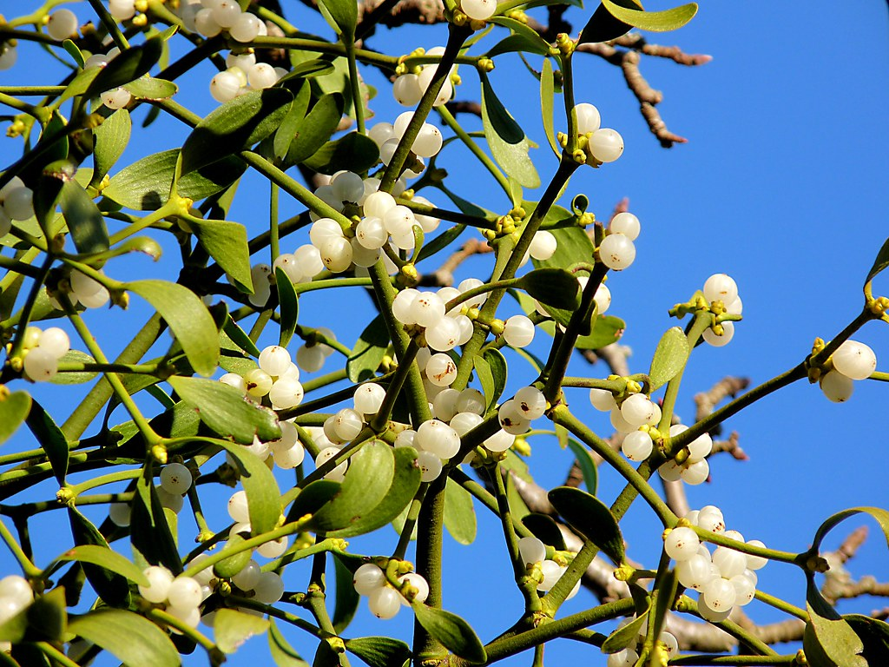
MISTLETOE
In Britain most mistletoe is found in the south and west Midlands, with particularly good populations in Herefordshire, Worcestershire, Gloucestershire, Gwent and Somerset. There is mistletoe elsewhere, but it is only regionally abundant in that core area of the south-west midlands.

Change may be happening though – new evidence from the last 20 years suggests that mistletoe is spreading faster than it used to. This is particularly noticeable in eastern areas, where established but seemingly static mistletoe populations are now spreading. Is this change due to climate or to birds? It could be subtle hints of climate change – computer modelling does suggest that mistletoe will head east with climate change. Or it could be something else. One possibility is better spread of the seeds by Blackcaps, a bird that is particularly efficient at spreading mistletoe. British Blackcaps migrate for the winter so they do not usually affect mistletoe here, but recently continental Blackcaps have started overwintering in Britain, with many thousands now spending their winters here and feeding on mistletoe and then spreading it.

Kissing beneath the mistletoe is a very old tradition indeed and although part of Christmas revels, mistletoe is rarely allowed inside a church because of its strong pagan associations. It is well known as the most sacred plant of the Druids, the priestly clan of the Celts.

If you have a young fruit tree in your churchyard, garden or elsewhere, how about encouraging mistletoe by smearing some berries onto the bark after Christmas is over. The thin bark of a young trees is easier for the mistletoe to penetrate and establish.

St Stephen’s Church Fradley Advent & Christmas Events 2025

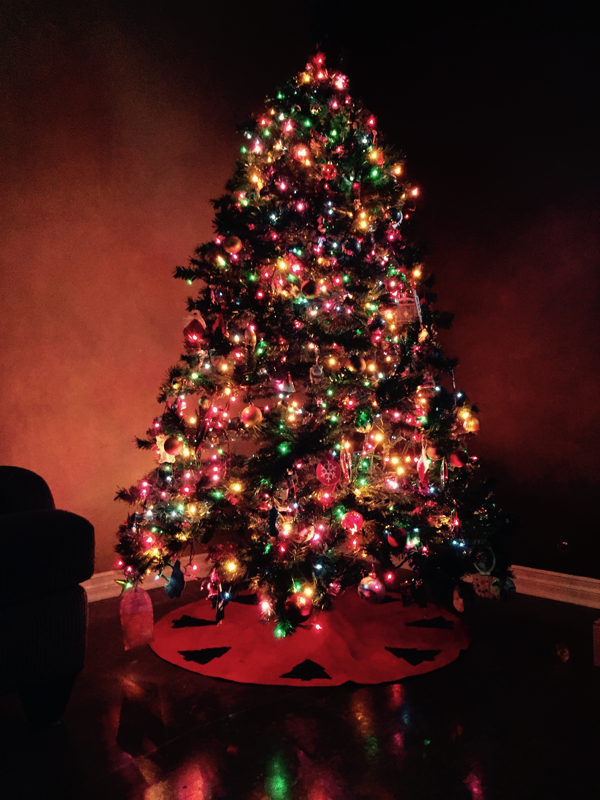
Wednesday 17th December
2pm Places of Welcome Carol Service followed by the usual places of welcome hospitality

Saturday 20th December
10am 12noon CHRISTMAS TREE FESTIVAL begins
Come and admire the wonderful Christmas Trees. Coffee and Cake served.
12noon Hamper Raffle Draw The Festival continues until 29th December

Sunday 21st December
4pm LESSONS &CAROLS by CANDLELIGHT Mulled Cider and Mince Pies
will be served

Wednesday 24th December
4pm Birthday Service Children are invited to come dressed as a character from the Nativity Scene as we retell the age old story of The Birth of Christ.
11.30pm Midnight Service by Candlelight
The first Communion of Christmas with Traditional carols and music led by our Music Group

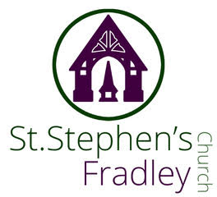
Heritage Concert by U3A Recorder Group


Music for the Season
Thursday 4th December
7.30pm
Light refreshments will be served after the concert
Free Event
Donations welcomed


Christmas Tree Festival
20th-29th December
Free Entry
Refreshments available on
Saturday 20th December
10am-12 noon
Grand Hamper Raffle Draw at 12noon
Coffee, Cakes, Mince Pies
and Chocolate treats
Can you help to support St Stephens Church?
St Stephen’s Church is heavily dependent on voluntary donations and income from events in order to fulfil its ministry to the local and wider communities.
If you would like to support us at this time,
donations can be made via our Just Giving page.
We are grateful for any donation, large or small.

https://www.justgiving.com/fundraising/ststephensfradley

Contact us
Revd. Elizabeth Wall
01543 254891
Email: ayton265@gmail.com

Churchwarden
Marian Derry
01283 791573

St Stephen’s Administrator: Di Cooper
07930162991
officeststephenfradley@gmail.com

Find us on
ACNY https://www.achurchnearyou.com/church/4123/
Face bookwww.facebook.comststephensfradley

DC 26/11/25

