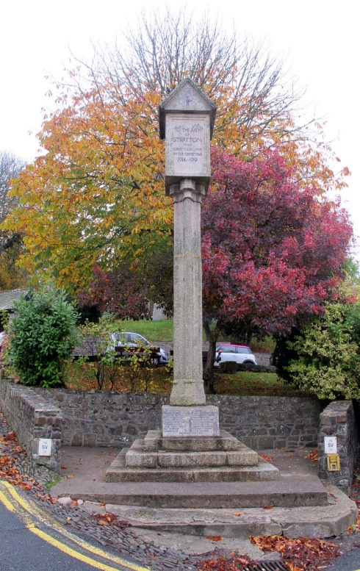
The Parish Church
of St Andrew, Stratton

Priest in Charge
The Revd Teresa Folland
Tel: 01288 352599
e-mail: teresa.folland@gmail.com
Churchwarden
Mrs Diana Ohlson
Tel: 01288 354441
e-mail: dohlson24@gmail.com

NOVEMBER and DECEMBER 2025

Times of Change

Comfort us Lord, when we feel overwhelmed and insecure
Help us through the challenges we face
Although we feel safe with familiar ways
Never let us become resistant to new ways
Give us grace to be open and receptive
Entrusting us to work to your praise and glory. Amen

Services at St Andrew’s November 2025

2nd Nov 4th Sunday before Advent All Saints Sunday
Readings: Daniel 7:1-3; 15-18; Psalm 149; Ephesians 1:11-end; Luke 6:20-31. Morning Worship 9.30am – LWLs Sheila Waring and Val Barker
3.00pm Launcells ALL SOULS SERVICE Benefice service
Evensong 6pm. Officiant: Revd Jane Bradbury
Cantor: Jane Bradbury
Psalm: 145: 1-9

Readings: Lamentations 3:22-33 John 11(1-31) 32-44 Reader: Sheila Waring
5th Nov Christian Meditation 9.30am
Midweek Mass Wed.10.30am - Officiant: Rev Teresa
9th Nov 3rd Sunday before Advent REMEMBRANCE SUNDAY
Readings: Job: 19:23-27a; Psalm 17:1-9 [or 1-8]; 2 Thessalonians 2:1-5, 13- end; Luke 20:27-38.
Parish Mass 9.30am – Officiant: Rev Teresa Folland
Please note the service begins in Church Square at 9.30am
12thNov Christian Meditation 9.30am
Midweek Mass Wed. 10.30am – Officiant: Rev Doug Adams
16th Nov 2nd Sunday before Advent
Readings: Malachi 4:1-2a; Psalm 98; 2 Thessalonians 3:6-13; Luke 21:5
Morning Worship 9.30am LWLs Judy Dunne & Val H
19th Nov Christian Meditation 9.30am
Midweek Mass Wed.10.30am - Officiant: Rev Richard WS
23rd Nov Sunday next before Advent CHRIST the KING
Readings: Jeremiah 23:1-6; Psalm 46; Colossians 1:11-20; Luke 23:33-43.
Parish Mass 9.30am – Officiant: Rev Teresa Folland
26th Nov Christian Meditation 9.30am
Midweek Mass Wed. 10.30am – Officiant: Rev Jane Bradbury
30th Nov First Sunday in Advent ST ANDREW’S DAY
Readings: Isaiah 2:1-5; Psalm 122; Romans 13:11-14; Matthew 24: 36-44
11.00am Kilkhampton Benefice Service – Officiant: Teresa
with Local Worship Readers
4pm Songs of Praise at St Andrew’s
with LWLs Judy Dunne and Val Hopper

Services at St Andrew’s December 2025

1st Dec OCS Carols of the Stratton 100 7pm – Rev Teresa
3rd Dec Christian Meditation 9.30am
Midweek Mass Wed. 10.30am – Officiant: Rev Teresa
7th Dec 2nd Sunday of Advent
Readings: Isaiah 11:1-10; Ps 72:1-7, 18-19; Romans 15:4-13; Matt 3:1-12.
Morning Worship 9.30am - LWLs Val H & Judy Dunne
Evensong 6pm – LWL Val Barker
Cantor: Dafydd Thomas
Psalm: 11 or 28
Readings: 1 Kings 18: 17-39 John 1: 19-28 Reader: Ian Barker
10th Dec Christian Meditation 9.30am
Midweek Mass Wed. 10.30am – Officiant: Rev Doug Adams
14th Dec 3rd Sunday of Advent
Readings: Isaiah 35:1-10; Psalm 146:4-10; James 5:7-10; Matthew 11:2- 11.
Parish Mass 9.30am – Officiant: Rev Jane Bradbury
17th Dec Christian Meditation 9.30am
Midweek Mass Wed. 10.30am – Officiant: Rev Doug Adams
21st Dec 4th Sunday of Advent
Readings: Isaiah 7:10-16; Ps 80:1-8, 18-20; Romans 1:1-7; Matt 1:18-end.
Morning Worship 9.30am - LWLs Val H & Judy Dunne
24th Dec Christmas Eve
Readings: Isaiah 52:7-10; Psalm 98; Hebrews 1:1-4 [5-12]; John 1:1-14
No Christian Meditation today or Midweek Mass today
Christingle Service 4pm – LWL Judy Dunne & Val Hopper
Midnight Mass 11.30pm – Officiant: Rev Teresa Folland
25th Dec Christmas Day
Readings: Isaiah 9:2-7; Psalm 96; Titus 2:11-14; Luke 2:1-14, [15—20].
Parish Mass 9.30am – Officiant: Rev Teresa Folland
28th Dec 1st Sunday of Christmas HOLY INNOCENTS
Readings: Isaiah 63:7-9; Psalm 148; Hebrews 2:10-end; Matthew 2:13-
end.
Parish Mass 9.30am – Officiant: Rev Jane Bradbury
31st Dec New Year’s Eve
No Christian Meditation or Midweek Mass today
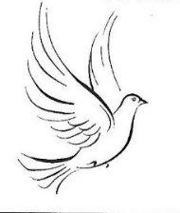
FROM THE PARISH REGISTERS 2025

Burial of Ashes
11th September Jean S S Jennings

Funerals
11th September Oliver Gittins followed by burial in the churchyard

23rd October Henry John Pearse followed by burial in the churchyard

THANKGIVING SERVICE for the Life of
Robert Saxton 18th October followed by cremation on 22nd October
~~~~~~~~~~~~~~~~~~~~~~~~~~~~~~~~~~~~~~~~~~~~~~~~~~~~~~~~~
Dates for your Diary
Tues 11th Nov – PCC Meeting 2pm at Stamford House
Fri 28th Nov – Hot Lunch in the Church St Andrew’s Patronal Weekend
Sat 29th Nov – GIFT DAY and CRAFT FAYRE
Mon 1st Dec – MU Advent Carol Service at St Andrew’s 2pm
Fri 12th – Sun 14th Christmas Tree Festival
Sat 20th Dec – Supper Party at Crossways Carols and Canapés 7pm
Sun 21st Dec - 9 Lessons and Carols 6pm
Thurs 1st Jan 2026 – New Year’s Day Lunch in church
Sat 24th Jan – Burns Night Supper at Crossways 7pm

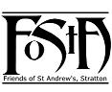


CHRISTMAS CAROLS & CANAPÉS
On Saturday 20th December 2025 at 7pm at Crossways, New Road, Stratton
by kind invitation of Anne and Geoff Day

Ticket £15 available from Val Barker
Creative gifts for the new care home.
Members and friends of St Andrew’s have been very busy in many ways. They have knitted lap blankets, sewn patchwork knee quilts, created ‘twiddle muffs’ for patients suffering dementia and are now creating angels! On Monday 13th October some members went to the Open Day for Deer Park Care home in Holsworthy and gave them some of their creations as gifts for their new residents.
Deer Park has reopened under new management and is now registered to give residential care, nursing care & dementia care as well as the very important respite and palliative care.

St Andrew’s 100 Club - WATCH THIS SPACE!
This very important fundraiser for your church has been running for a long time. Huge thanks are due to Rob and Deirdre Varley for starting it and continuing to make it happen. Everyone deserves a rest from chores and so do they, we offer them our thanks for many years service. Our 100 Club is going to have a relaunch in January. Watch this space for further details of bigger prizes and how to join. Existing members will be contacted in due course. A really good way to support St Andrew’s and have a little flutter at the same time.

St Andrew’s Donation Boxes
More than 20 donation boxes were given out to supporters of our Church last November on our Gift Day. If you are one of these people, could I ask you please to return the box on our next Gift Day on Sat 29th Nov, so that this money can be included in the gifts given that day. These donations are greatly appreciated by the church community, who find it hard to meet the ever increasing costs of keeping our wonderful Church open.

Hot Lunches
The days are drawing in and a hot lunch in the middle of the day sounds ever more inviting!!! Do please join us for one of ours!! There will be a lunch on Nov 28th and Jan 1st as in previous years, to bring some warmth and good company from our dedicated band of volunteers. We will have 4 choices of main meal and pudding, with a cup of tea or coffee, for £8 per head. You can’t get a better priced meal anywhere!!!! Please either sign up on the list in church or let me know if you want to come, on 01288 359108. Judy

Creationtide

On Sunday August 31st a Benefice service of Holy Communion was celebrated for Creationtide. At this service the St Andrew’s Creation Chapel was dedicated and the new Creationtide flag blessed. The guest speaker was Dr Sharon Willoughby who has recently taken up the post of Diocesan Environment Officer.
At St Andrew’s there is an awareness of conservation needs thanks to our own Creation Champion, Sheila Waring, who has encouraged the PCC, congregation and wider church family to be involved and proactive with many of these issues over the last few years. Her latest project has been making a few subtle changes to make one of the side chapels into an area which will highlight many of the conservation needs but most importantly dedicated to the One who is God the Creator and Sustainer of Life.
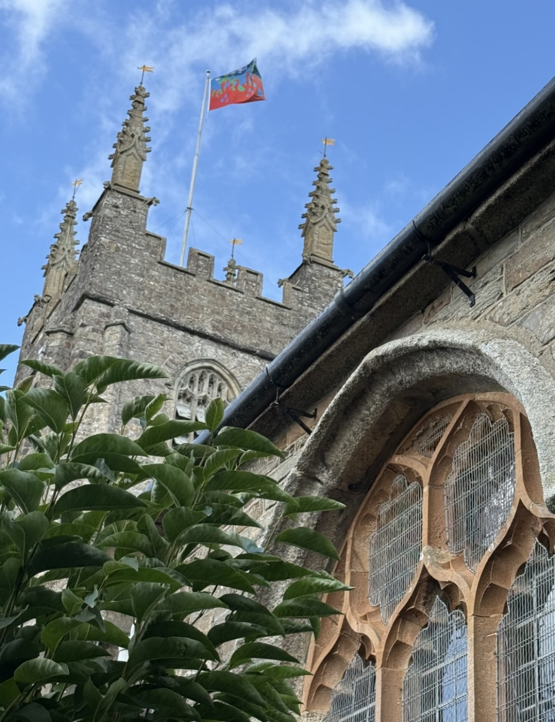
The winning flag design by Mrs Christina Ball, from a competition run by the Friends of St Andrew’s Church, was presented to the Rector Revd Teresa Folland, and placed on the Altar. The flag itself was then shown to the congregation after which it was taken, by Mr Paul and Mrs Christine Davy, to St Andrew’s Creation Chapel where it was blessed by the Rector and the Chapel dedicated. The production and costs of the flag had been arranged by Paul Davy and then generously gifted to the church.
During the service Sharon Willoughby gave a very interesting address touching on her career progression, her new post as Diocesan Environment Officer and some of her hopes and aspirations for the Diocese and its people, all based on her chosen text from the Letter to the Hebrews Chapter 13.
After the service and Revd Teresa had given the final blessing, everyone went outside to watch as the flag was hoisted on the Tower flagpole on a very blustery day. All then returned to the church for light refreshments.
75 people, including children, had shared together in worship, fellowship and hospitality.
The Rector and people of St Andrew’s would like to thank, in particular, the DAC Secretary and the Chancellor for all their help and encouragement with the flag competition and its final production.
~~~~~~~~~~~~~~~~~~~~~~~~~~~~~~~~~~~~~~~~~~~~~~~~~~~~~~~~~~~~~


Christmas Tree Festival
December Friday 12th – Sunday 14th
St Andrew’s Church is once again holding a Christmas Tree Festival in December. We are inviting as many individuals, churches, businesses and societies as possible in the area to be involved.
There is no set theme for the tree decorations and either real or artificial trees up to 5 feet in height are welcome. Any tree lights will have to be battery operated.
The festival will take place over three days from Friday 12th December to Sunday 14th inclusive. Setting up and preparations for the festival will take place over the preceding two days, beginning on Wednesday 10th December at 11.30 am. And from 9.30 am. on Thursday 11th December.
If you would like to be part of the festival, could you please let us know by November 30^{th.}
Contact :01288 714338: or email: waring626@btinternet.com

St Andrew’s Bells Restoration Project

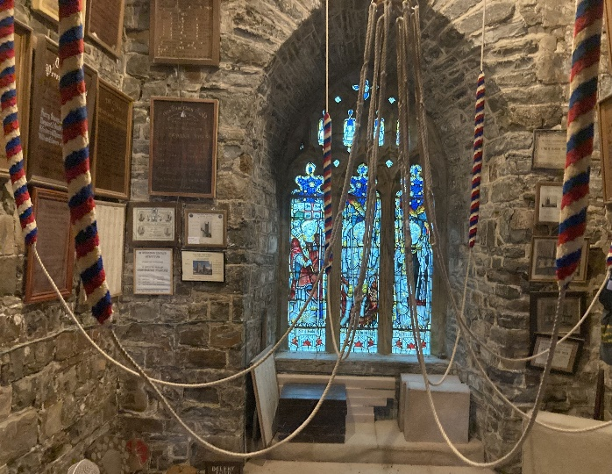
You may have noticed that only five bells have been ringing on Sunday mornings since the middle of April. This is due to major restoration work being needed in the belfry before we can ring all eight again. The bells of St Andrew’s are amongst the finest cast by John Taylor & Co of Loughborough. They are highly regarded amongst bellringers, both locally and nationally, for their fine tone and are the second heaviest peal of eight bells in the county of Cornwall.
The damage in brief: the 6th bell’s cast iron bell frame is cracked, so it cannot be rung and the frame castings of the six heaviest bells have been pushed up and out of position by the effects of RSJ rusting expansion. Fortunately, all the necessary work can be carried out in the belfry, thus avoiding the entire bell installation having to be removed from the Tower, the cost of which would be astronomical.
Whilst undertaking this work, it makes sense to check all the main bearings for wear and fit them with fresh lubricant and seals. Also, the first seven bells’ clappers will be removed from the bells and sent away for rebushing, refacing and annealing, allowing them to strike more evenly.
Bottom line: we need to raise £32,000 (inc VAT) to complete this work. Fortunately, we have some money in the Tower Sangwin Fund and I will be applying to various organisations for funding. However, if you would like to contribute to our Bells Restoration Project do please get in touch either with myself or our PCC Treasurer, Simon Waring.
We cannot wait to get this beautiful peal of eight bells ringing again!

Jo Barnes, Tower Captain

Mothers’ Union – Kledh Kernow Branch

Last month members came together to celebrate the beauty of creation and the time of harvest. We held a service with traditional harvest hymns, readings and prayers. Items were donated for the work of the local Foodbank. Following the service there was time to catch up with MU news and to celebrate the 90th birthday of member Ann Fairbrother. The branch gave Ann a bouquet of flowers to mark the occasion.

16 Days of Activism
The Mothers’ Union supports the 16 Days of Activism campaign which runs from 25th November to 10th December. Throughout this campaign, MU joins with 6000 organisations from over 185 countries to raise awareness of and call for an end to gender-based violence and abuse in all forms and in all societies. In Britain and Ireland our members offer support from providing essential items for refuges, organising workshops on gender-based issues in schools and prisons to support families of survivors to heal and rebuild important family bonds. Look out for the Red Chair initiative in some local churches during the 16 days as a focus on this important issue.

Future Meetings
Monday 3rd November Branch meeting: Christmas Crafts 2pm Stamford House, Stamford Hill EX23 9EY
Thursday 20th November: Members Day St Endellion’s Church Hall 10am – 3.30pm Please bring a packed lunch.
Monday 8th December: Advent service with hymns and reflections 2pm St Andrew’s Church, Stratton.
~~~~~~~~~~~~~~~~~~~~~~~~~~~~~~~~~~~~~~~~~~~~~~~~~~~~~~~~~~~~~~

Christingle Service

Our annual service will take place at 4pm on Christmas Eve and we look forward to a church full of families and friends. We celebrate by using the Christingle orange during the service and a collection will be taken to support the work of the Children’s Society.
Children’s Society Donation Boxes

During November, would all holders of these donations boxes please return them to church, so that they can be emptied and reused? As is the case with all charities, it is becoming ever more difficult to raise money for their good causes, with the change from using cash to cards. However, notes or cheques made out to The Children’s Society, are also very welcome, as the need for protection for children across our country remains a high priority. Please do give generously to make a difference to sad children’s lives. If you can’t get to church, I am very happy to collect from your home. Just give me a call on 01288 359108 Judy.

Stratton School

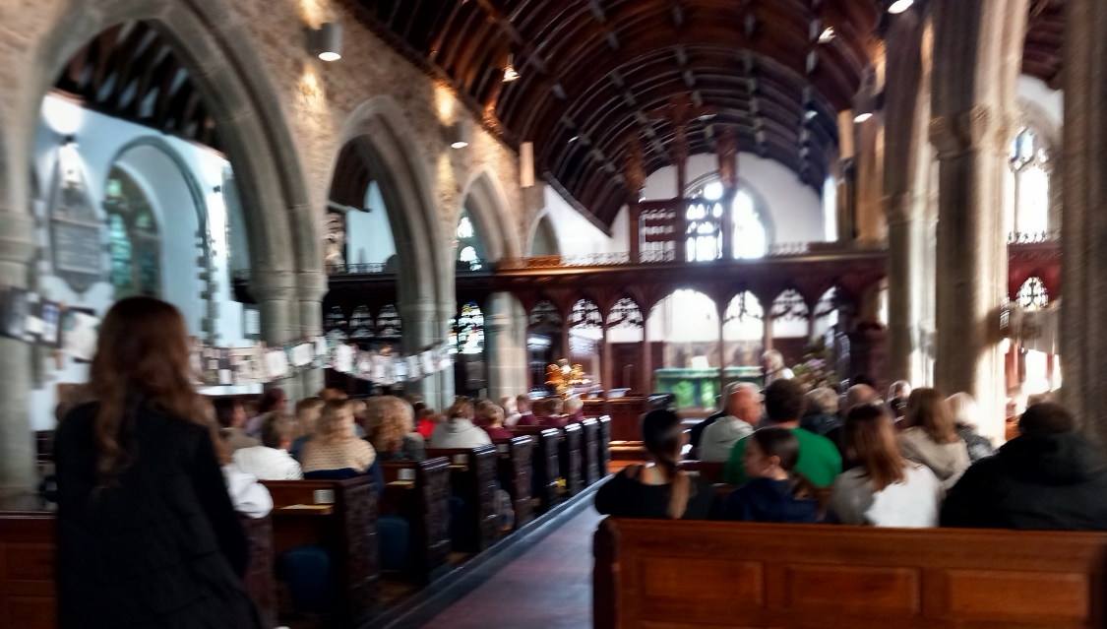
In September the Year r children and staff from Stratton School held their Harvest Festival in St Andrew's. The children sang beautifully the Harvest songs they had learnt and gave readings, thoughts and prayers about Harvest. They had also created some delightful art work which had been strung between the pillars and were admired by parents and visitors to the service. Thank you, children and staff, for a wonderful reminder of how lucky we all are.
In the month of November we remember in our prayers all those living in:

Sunday 2nd Spicers Lane, Huntfield Close, Treworden Close, Gibraltar Square, Church Square
Sunday 9th Corner Gardens, Fore Street, Old Post Office Hill
Sunday 16th Howells Road, Holsworthy Road, The Leat
Sunday 23rd Howard Lane, Parc Fer Close, Barnfield Park
Sunday 30th Those living outside the Parish for whom St Andrew’s is their spiritual home.

In the month of December we remember in our prayers all those living in:

Sunday 7th Bridge Street, Union Hill, Bowden
Sunday 14th Poundfield Lane, Hospital Road, Ward Close
Sunday 21st St Martin’s Rd, St Peter’s Rd, Gladwell Gardens and the Binhamy Estate
Sunday 28th Those in the Parish who have friends and relations who cannot be with them at this time of the year.

Those who have asked for our prayers:
Allan Gouldson, Bella, Molly Hooper, Pam Kemp, Lyzette Bevan, Karen Hunting and Baby Henry and family.
We bring before God, especially at this time, all who work in our local hospitals, the inpatients and all undergoing investigations and outpatient treatment. We remember too those of our church family who are ill at home or housebound.
The recently departed: Robert Saxton, Henry Pearse and Yvonne Bishop. May they rest in peace and rise in glory.

Those in our Year’s Mind in November the week beginning:

Sunday 2nd Eva Ford, Ada Morwenna Cobbledick, Christopher Allin, Norah Snow, Sylvia Wilcox, Jennifer Piedot, Clive Curtis, Philip Evans, Leonard Fox
Sunday 9th Patrick Sweet, William Brown, William Bond, Margaret Price, Brenda Sharp, Lawrence Middle, Colin Fewster, Daphne Cox,
Michael Boorer, Irene Kennard, John Street, Mary Wickett,
Philip Wilcox, Joan Golesworthy, Clara Haynes,
Rosaleen McQuiggan, Alice Davy

Sunday 16th Doris Hockin, Patricia Long, Irene Nash, Leonard Nash,
Dorothy Stickler, Flossie Buckingham
Sunday 23rd William McQuiggan, Anne Cobbledick, Angus Macdonald,
Colin Heard, John Daniels, Frederick Miles Smith (Priest),
William Young, Percy Curtis, Douglas Davey, Arthur Steedman, Barry Ferries Grand, Janet Standen
Sunday 30th Arthur Dymond, Trevor Martin, John Heard, Gertrude Abbott

Those in our Year’s Mind in December the week beginning:

Sunday 7th Geoff Tinker, Frederick Sleeman, Roger Dossett,
Leonard Westlake, Bertha Barton, Percy Barton,
Stephen Cornish, Alan Barlow, Hilda Etheridge, John Franks,
Paul Durston, Margaret McCabe, Robert Bennett, John Davey,
Charles Bryant
Sunday 14th Anthony Blatchford, Anthony Pulsford, Mary Peardon,
Elizabeth Thorp, Michael Crowell, Albert Bissat,
Jennifer Sleeman
Sunday 21st Irene Mears, George Heard, Francis Campbell, Sandra Cook, Nora Pulsford, Edward Stickler, Maurice Colwill, Gordon Bickle,
Charles Varley, Wallace Pearce, Arthur Shearer, Michael Garner,
James Howard, Frank Saltern, W.E. Knight
Sunday 28th Michael Worden, Trevor Cox, Helen Dickerson, Brian Philp, Barbara Bailey, John Richardson, Prudence Baker,
Kenneth Standen, Phyllis Leonard, Jocelyn Johnston, Pamela Bryant, Anthony Edwards, Pamela Eastwood, Helen Pearce

All those in our own special remembrance.

News Sheet Editors: Val Barker Tel: 353435 and Sheila Waring Tel: 714338

If you have anything for inclusion in the News Sheet for January and / or February please send it to the editors by Wednesday 10th December. It would be a kindness if you could send all documents in Calibri (Body) Font, Size 12. Thank you.

