
ST. ANN’S, BELFIELD NEWS LETTER
WORSHIP

Church open
St Ann’s is open for public worship on Sundays and Wednesdays at 10.30am

Streamed service
On-line via twitch.tv/revdgill and for 1 week after. Downloads available on request.

Prayers for the sick
Ghislaine Glover, Cath Boon, Roger and Addy.

Prayers for home members
Bob (in Mona Cliffe Care Home), Dorothy (in Braeside)

The anniversary of the dearly departed Mary Pilling, Eveline Butterworth, Harold Elsdon and Thomas Schofield

Scan this with your phone to contribute to St Ann’s mission and ministry

Art Exhibition and Craft Fayre
Great time was had by all. We raised £282 +Digi giving £6=£288( Festive Cakes £24,Refreshments £110, Raffle £94, Bric-a-brac £44+ £10 donation) and people are really looking forward to doing something similar again! Thank you, all!

Help needed again please to set up for joint lunch from 10.30 am
Sat.29th November 2025
Joint Benefice Service
30th November, 10.30am. Preacher Reggie van Dinter, GM Community Chaplain. Lunch in the hall after. All welcome.

ADVANCE NOTICES Rev Duke’s final service at St Thomas’, Kirkholt Sunday 28th December, 3pm. +Mark will preach. There will be NO morning services in the benefice that day.

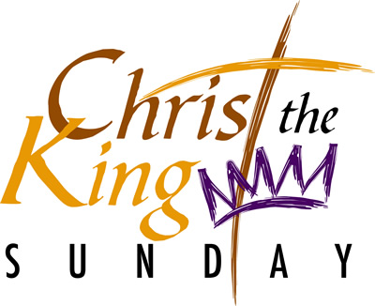

Sunday 23rd November 2025, 10.30am
Rev. Richard McEwan
Eucharist

Hymns :- All NEH
391 King of glory, King of peace
457 The King of love, my shepherd is.
443 Rejoice the Lord is King.
295 Comm: Let all mortal flesh
490 Judge eternal,

Organist : Mr. John Keate

NOTICES
School Visits
Please pray for our visits to/from schools during Advent. Experience Christmas 9th Dec at Christ Church and Nativity with Moorhouse at St Ann’s on 10th Dec.

Lives Cut Short
A service of remembrance for those who have died too soon. Monday 24th November, 7.30pm, Manchester Cathedral.

Senior Social Christmas Lunch
Monday 8th Dec 2025 3pm start Healey Hotel £25. Pre-booking required.

Advent and Christmas Services - flyers and posters out this week.

