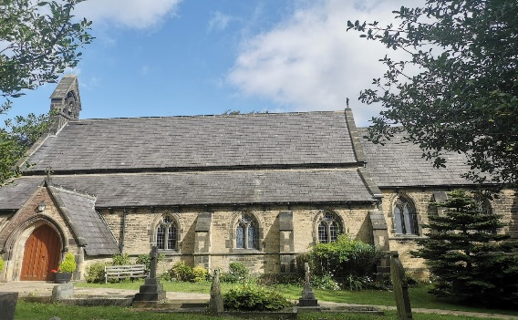

Welcome to Christ Church Barkisland.
We hope you enjoy your visit in this beautiful Church. The Church is a listed building and its upkeep is the responsibility of the Church Wardens supported by members of the Parochial Church Council [PCC]
You may be surprised to learn that all the running expenses including building repairs are funded by the church congregation. This is made possible by Regular Giving [Standing Orders], Collections at Services, Fund Raising and Legacies.
To give you some idea as to what this entails in 2024 the total expenditure was £43,882.
Included in this was Insurance £2355, Organ Tuning £320, Heating £3127 Water £395 Church Maintenance £12952 Decorating £850, and paying the Parish Share to the Diocese £14081.
It is a major concern that eventually our finances will reduce to a point that we are unable to maintain this wonderful building for future generations.
Last year we were able to have all the electrics checked and upgraded. All the old Halogen lights were replaced with energy efficient LCDs.
Next years challenge is to fund work in the Church Yard to ensure all the trees are made safe by removal or lopping.
If you feel you can support our work in keeping the Church maintained a Standing Order Mandate and a Gift Aid Declaration are available on the table near the entrance.
A copy of last years Accounts is always available in the Porch. If you would like more in depth information about the church, please ask the Church Wardens or any member of the PCC
Church Wardens – Jane Haigh, Craig Drummond
PCC Secretary Elizabeth Gregory
PCC Treasurer Margaret Bridgman
PCC members Julie Raven, Anne Szlachich, Judith Denham, Stephanie Drummond

