St Silas Church Blackburn
Preston New Road, BB2 6PS
Saturday Morning Café Concerts
Season 2026
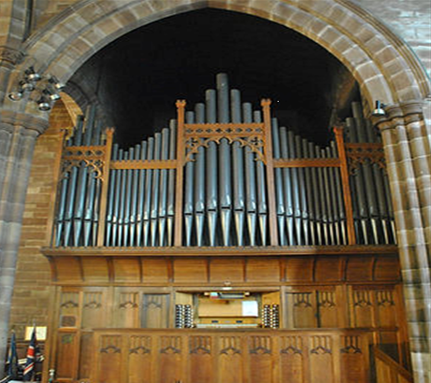
ALL CONCERTS @ 11.00am
(refreshments from 10.15am)
Admission £5 Under 16s Free
2026
- March 14th ELCB Brass Ensemble
- April 18th John Hosking, Organ
- May 16th Ian Pattinson, Organ
- June 13th Dunelm Duo
Lynne Williams, Flute/Saxophone
Robert Rainford, Piano
- July 18th
Alan Winstanley & Elizabeth Bowman, Organ
- September 12th Nigel Spooner, Organ
- October 17th Robin Stopford, Organ

