
SPIRE & LIGHT United Churches
United Benefice of St Keverne, St Ruan with St Grade & St.Wynwallow (The Lizard)

*If you do not wish to receive these notices, please let your Churchwarden know*

9th November 2025
Remembrance Sunday

Readings
Job 19:23-27a
Psalm 17:1-9
2 Thessalonians 2:1-5, 13-end
Luke 20:27-38
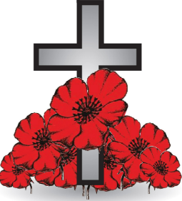
10.40am – St.Keverne
10.45am – St.Ruan
10.45am – St.Wynwallow
12.30pm – St.Peter’s
3pm – Evensong – St.Grade

16th November
9.30am –– Holy Communion - St.Peter’s, Coverack
9.30am – Holy Communion – St.Wynwallow, The Lizard
11.15am – Family Service – St.Ruan, Ruan Minor
3pm – Cornish Evensong – St.Keverne




Tickets also available at Tregullas Farm Shop, The Lizard


The Prayer Spot
Lord Jesus Christ, as we pray today, please be with us and guide us in all we do and say in your wonderful name.
Help us to remember that you are a God who cares, who understands and who meets all our needs. We pray for the benefice and Deanery we belong to and we thank you for the faithful people you have brought together.
Remind us that we have been brought to faith by our saviour Jesus Christ to enjoy our time together. We thank you Lord Jesus for your presence in our lives and the love you have given us to share with others. Keep us strong in our faith and close to you. Help us to be always there for others in their time of need.
You have given us gifts to use, to reach out to give comfort to those around us who are in need.
Heavenly Father we live in a world that is slowly destroying itself, through greed, hatred and with no care or concern for others. Remind us that we can bring love, care and understanding into the world by reaching out into our communities and showing our love to all. We pray for those in our communities who need Gods help as they care for others, for those in need of hospital care but also those who look after them.
Loving God, be with us always. Remind us daily we are brothers and sisters in Christ, that God is ever present in our lives, through his wonderful Holy Spirit that he gives us freely. God Bless you all
O Lord our rock and Redeemer, guide our thoughts and our words in our discussions today. Let our hearts be filled with your praise. Let us never forget the good things you do for us. You have forgiven our sins. You have rescued us from death. You have crowned us with love and tender mercies. Renew our strength and refresh our souls. Through Jesus Christ our Lord, Amen
Sam Buchanan

The Diocese of Truro’s Prayer Diary for this week

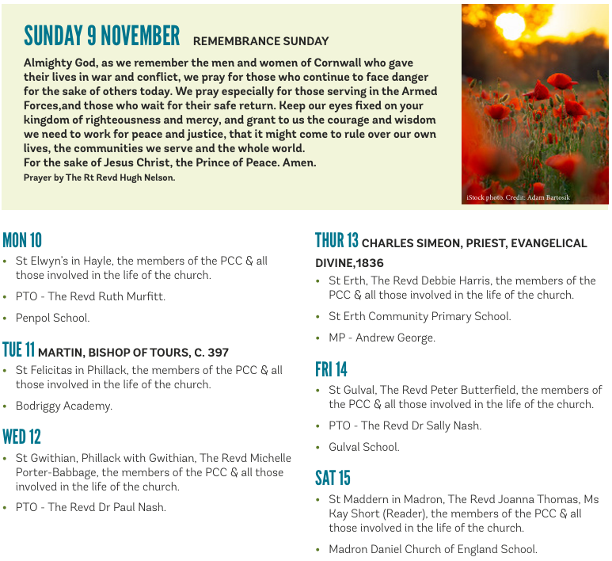

On the Way Prayers

They shall grow not old, as we that are left grow old; age shall not weary them, nor the years condemn. We will all be preparing for special services to be held in our churches this coming Remembrance Sunday. So first of all let’s just have a moment of quiet to think about anything we have to do and to pray that you will be with us every step of the way.

We know that Remembrance is a time when we can reach out to our communities, to bring them into our churches. We pray that their experience will be positive and that it may even make them wonder about joining us again. As we all meet in our churches and at our war memorials this weekend to remember those who laid down their lives for us, to lay our wreaths and to say those famous words of the Act of Remembrance, let us pray for each one of our churches in Kerrier Deanery, that we will continue to be a focal point for our communities in times of need, in times of stress and in times of peace. We give thanks for the work of the British Legion and Help for Heroes and we pray particularly for all those currently based at Culdrose.

We that are left are growing old – and we know Lord that one of the tasks you have set us, is to pass our faith onto those who are younger than ourselves – and we know that we are struggling with this task. So we ask for your help – we pray that in Kerrier Deanery, you will show us the way to appeal to younger people, to get them involved in our churches, to help us spread your gospel to different generations and to adapt our services and practises to inspire and enlighten them.

We remember all those who have done so much to build our churches and keep them going – those people in the early medieval times who brought Christianity to this part of Cornwall and then those who were so moved to build the churches in our towns and villages. We give thanks for our Deanery Team Heidi, Susie, for all our PTOs, for Ann our administrator, Martin our finance officer and we pray that as we advertise for a third stipendiary priest that you are calling someone to lead our pastoral provision

In our prayers now we remember all those who need to feel the comfort of your healing touch dear Lord at this time – whether they are sick in mind, body, soul or spirit.

Remembrance is a time to pray for peace – peace throughout your world; that all may learn the futility of war and that peace and reconciliation are the only way. We particularly pray for the fragile peace in the Holy Land – that it can hold and that a lasting solution can be found. We pray for the people of Ukraine: that all may be kept safe from harm in the winter that they are dreading. And we pray for the people of Sudan, where apparently terrible atrocities are taking place. Lord, make us all channels of your peace, that where there is hatred we may bring your love, where there is injury we ask for your pardon, and wherever there’s doubt, let us always have true faith in you. Where there is despair may we bring hope, where there is darkness, may we bring your light and where there is sadness help us to spread joy. Master grant that we may never seek so much to be consoled as to console, to be understood as to understand and to be loved as to love with all our souls. For it is in pardoning that we are pardoned, in giving of ourselves that we receive and in dying that we are raised to eternal life.
And we pray that during this period of Remembrance these words will resonate throughout our land and be said by people of all ages, all races and all creeds : at the going down of the sun and in the morning we will remember them. Amen

