Prayers

Please pray for the sick, particularly George Hall, Chloe French, Gail Calder, Andrew Watson, Revd Sam Quilty. We pray for the family and friends of those who have recently died. We remember all whose anniversaries of death fall at this time of year: Anne Hogg.
We pray for all preparing to be confirmed by Bishop Mark next Sunday, especially from our parishes, Liam and Amber McTague.

This week and beyond

- Monday 10th November, Deanery Development Group meets at 1.30pm, Holy Island Vicarage
- Tuesday 11th November Remembrance Services:
9.30am Ford Church Collective Worship with Ford School
Ancroft War Memorial 10.45am
Lowick War Memorial 10.45am (with Lowick School)
- Saturday 22nd November Revd Canon Nick Sagovsky leads a morning on
‘Walking Together the Augustinian Way’ in Berwick Parish Centre from 10am-2pm. Details on poster at back of church. Booking essential.
- St Cuthbert’s Norham, daily until Friday 14th November, an exhibition ‘Silenced Bells – Distant Voices’ will include a recording of John Casken’s choral work ‘Memorial’ played on the hour from 10am to 3pm each day. 4pm by candlelight. See poster for details.

Parish Contacts
Ancroft Leigh Yorke 07716116739
Etal Andrew Joicey 01890 820540
Ford Kathleen Holmes 07951099668
Lowick Niall Cartlidge 07850876246

Websites: www.achurchnearyou.com
Instagram: https://www.instagram.com/the_flake_churches/
Facebook: the_flake_churches

Other licensed clergy
Revd Margaret Sentamu 077871 204745 m.sentamu@gmail.com
Canon Nick Sagovsky, Revd Marion Penfold 01289 305664
The Parishes of Ford & Etal, Ancroft, Lowick with Kyloe

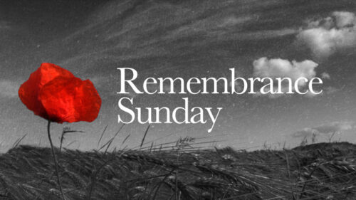

A very warm welcome to you, especially if you are visiting
and do stay for refreshments afterwards.
Please take this sheet home with you and use it as a basis for prayer.
Children are welcome in all our services.

Sunday 9th November – Remembrance Sunday
3rd Before Advent
Lowick 9.15am Holy Communion
Revd Alex Firman/Revd Charlotte Osborn
Ford 10.50am Remembrance with Holy Communion
Revd Alex Firman/Revd Charlotte Osborn
Lowick 2pm Kyloe Remembrance, 2.30 War Memorial, 3.15 Barmoor

Sunday 16th November 2025
2nd Before Advent
Lowick 9.15am Holy Communion
Revd Charlotte Osborn/Revd Margaret Sentamu
Ford 11am Holy Communion
Revd Charlotte Osborn/Revd Margaret Sentamu
Tweedmouth 5pm Deanery Confirmation Service

Licensed Clergy
Revd Charlotte Osborn (Vicar) 01289 388591
ceosborn@mail.com 07957 367457
Revd Alex Firman (Assistant Curate) 07935 732811 alex_firman@hotmail.co.uk

