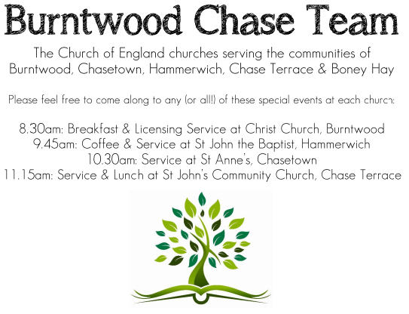 CHRIST CHURCH
SUNDAY 16th November 2025 at 10am

SERVICES:
Sunday 16th November 2025
Holy Communion
2nd Sunday before Advent

Readings:
Malachi 4: 1-2a
⁴ See, the day is coming, burning like an oven, when all the arrogant and all evildoers will be stubble; the day that comes shall burn them up, says the Lord of hosts, so that it will leave them neither root nor branch. ² But for you who revere my name the sun of righteousness shall rise, with healing in its wings. You shall go out leaping like calves from the stall.

Luke 21: 5-19
⁵ When some were speaking about the temple, how it was adorned with beautiful stones and gifts dedicated to God, he said, ⁶ ‘As for these things that you see, the days will come when not one stone will be left upon another; all will be thrown down.’
⁷ They asked him, ‘Teacher, when will this be, and what will be the sign that this is about to take place?’ ⁸ And he said, ‘Beware that you are not led astray; for many will come in my name and say, “I am he!”and, “The time is near!” Do not go after them.
⁹ ‘When you hear of wars and insurrections, do not be terrified; for these things must take place first, but the end will not follow immediately.’ ¹⁰ Then he said to them, ‘Nation will rise against nation, and kingdom against kingdom; ¹¹ there will be great earthquakes, and in various places famines and plagues; and there will be dreadful portents and great signs from heaven.
¹² ‘But before all this occurs, they will arrest you and persecute you; they will hand you over to synagogues and prisons, and you will be brought before kings and governors because of my name. ¹³ This will give you an opportunity to testify. ¹⁴ So make up your minds not to prepare your defence in advance; ¹⁵ for I will give you words and a wisdom that none of your opponents will be able to withstand or contradict. ¹⁶ You will be betrayed even by parents and brothers, by relatives and friends; and they will put some of you to death. ¹⁷ You will be hated by all because of my name. ¹⁸ But not a hair of your head will perish. ¹⁹ By your endurance you will gain your souls.

COLLECT FOR TODAY
Heavenly Father,
whose blessed Son was revealed
to destroy the works of the devil
and to make us the children of God
and heirs of eternal life:
grant that we, having this hope,
may purify ourselves even as he is pure;
that when he shall appear in power and great glory
we may be made like him
in his eternal and glorious kingdom;
when he is alive and reigns with you,
in the unity of the Holy Spirit,
one God, now and for ever.

WHAT’S GOING ON
Upcoming Services
Wednesday 19th November Morning Prayer 9.30am
Sunday 23rd November Holy Communion 10am
Wednesday 26th November Morning Prayer 9.30am
Sunday 30th November Morning Worship 10am

DEANERY PRAYER AND PRAISE EVENING WITH BISHOP TIMOTHY,
in Church at 7pm on Thursday 20th November 2025.
ALL ARE WELCOME TO ATTEND.

An Evening of Christmas Music and Readings – Thursday, 11th December, 7.00pm
Time to dig out those Christmas jumpers! Come along to an informal evening of Christmas readings, carols and Christmas songs including the ever popular “White Christmas”. Bring your own drinks, if you wish, and a small amount of Christmas food to share.
FLOODLIGHTING
If you think about commemorating a special occasion by floodlighting our Church. Please contact Chris Brown on 01543 683862 for details.

PRAYER CHAIN
Christ Church is blessed with a very active prayer chain. If you, or anyone you know, feel that they would like others to pray for them, please speak to Chris Brown on 01543 683862.

HOME COMMUNION
For anyone who is unable to attend church and would like Home Communion,
Steve Morgan is able to carry this out.

VICAR CONTACT DETAILS
Stephen Morgan Tele: 07305 852152
CHURCH WARDENS CONTACT DETAILS
Judith Rogers Tele: 01543 324718
Mike Holmes Tele: 01543 672970
Church Office Tele: 01543 642187 [leave a message and we will respond]
Church Web Site:www.christchurchburntwood.org.uk
Church Email: christchurchburntwood15@gmail.com
Facebook: www.facebook.com/group/christchurchburntwood/

Other Contacts
Matt Wallace St. John’s, Chase Terrace— Tele: 01543 670078
Richard Westwood St. Anne’s, Chasetown—Tele: 01543 686111

NEXT SUNDAY SERVICE
Sunday 23rd November at 10am
Holy Communion
Colossians 1: 11-20
Luke 23: 33-43

