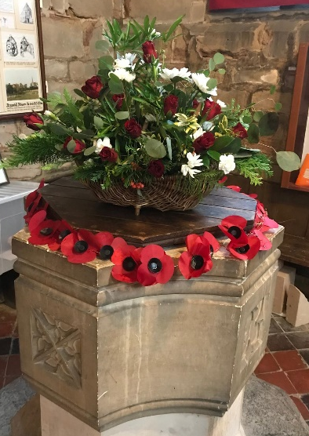
ST MICHAEL AND ALL ANGELS,
HAMSTALL RIDWARE

In the United Benefice of King’s Bromley, the Ridwares
and Yoxall

November 9th 2025
Remembrance Sunday
PARISH NOTICES

UNITED BENEFICE SERVICE ROTA
 | Hamstall Ridware  St Michael and All Angels | Yoxall  St Peter | King’s Bromley  All Saints | Mavesyn Ridware  St Nicholas
November 9th  Remembrance Sunday | 3.00 pm  Remembrance Service | 10.30 am  Remembrance Service | 10.45 am  Remembrance Service | 10.45 am  Act of Remembrance at Hill Ridware
November 16th  Trinity 22 | 10.30 am  Holy Communion | 4.00 pm  Holy Communion | 9.00 am  Holy Communion | 10.30 am  Holy Communion
November 23rd  Christ the King | 10.30 am  Service of the Word | 9.00 am  Holy Communion | 10.30 am  Holy Communion
November 30th  Advent Sunday | 10.30 am  United Benefice Holy Communion Service at St Peter’s, Yoxall
December 7th  Advent 2 | 10.30 am  United Benefice Holy Communion Service at St Nicholas, Mavesyn Ridware
Please note that services of Holy Communion at 9 am follow the Book of Common Prayer and are said. Services at 10.30 will include hymns and other singing.
There are services of Holy Communion at 10.00 every Wednesday at St Peter’s, Yoxall and on the first Thursday of each month at All Saints, King’s Bromley.
*******************
Rugeley Food Bank. Please do remember those who depend on Food Banks. They are needed now just as ever. If you wish to donate directly to Rugeley Foodbank at Rugeley Community Centre the Centre is open everyday to receive contributions. Alternatively, the Rugeley Food Bank welcomes financial contributions – see https://rugeley.foodbank.org.uk. Gifts can also be brought to St Michael’s and left in the box at the back of church near the font. If that is not convenient please contact Liz Carter on 07751 068181.
****************
Contact details: If you wish to contact the Rector, Jeremy Brading you can do so on revd@kbhmy.co.uk and Glenis Turner, the PCC Secretary and Benefice Administrator is on admin@kbhmy.co.uk. The churchwardens are Michael Elsom michael.elsom@btopenworld.com and John Ferguson clan.member1954@gmail.com Information about events at church can be found at our webpages at https://www.achurchnearyou.com/church/4451/ and https://kbhmy.co.uk/hamstall/
St Michael’s will continue to be open everyday (weather permitting) between 10.00 am until 4.00 pm. We will revert to shutting the church at 6.00 pm on March 29th 2026
St Michael’s encourages donations by means of this QR code and it will appear (all being well) on all our publications as an invitation to contribute to the important work of the church both
as a place of worship and a community asset where all can share in the wonderful place we have inherited and wish to pass down to those who come after.
PLEASE REMEMBER IN YOUR PRAYERS:
Those who are sick: Mary Mycock, Brenda, Angela Perkin, Doug, David and Barbara Rudge, May Windley, Pam Payne, Rev’d Frank Finch, Chris Poole, Les Woods, Pat Lomax, Alison Scott and any known personally to you.
Those who live and work in the Nursing, Care and Retirement homes in the villages both in and near the parishes of the United Benefice.
Using the Archbishops’ prayer for Ukraine at this time let us remember the people of that war-torn land:
God of peace and justice, we pray for the people of Ukraine today. We pray for peace and the laying down of weapons. We pray for all those who fear for tomorrow, that your Spirit of comfort would draw near to them. We pray for those with power over war or peace, for wisdom, discernment and compassion to guide their decisions. Above all, we pray for all your precious children, at risk and in fear, that you would hold and protect them. We pray in the name of Jesus, the Prince of Peace. Amen
The situation in the Middle East where hopes for a peaceful resolution sometimes appear irretrievably bleak:
O God of all justice and peace, we cry out to you in the midst of the pain and trauma of violence and fear which prevails in the Holy Land. Be with those who need you in these days of suffering; we pray for people of all faiths - Jews, Muslims and Christians and for all people of the land. While we pray to you, O Lord, for an end to violence and the establishment of peace, we also call to you to bring justice and equity to the peoples. Guide us into your kingdom where all people are treated with dignity and honour as your children - for to all of us you are our Heavenly Father. In Jesus' name we pray. Amen.
At this Remembrance time we recall the sacrifices made on behalf of us all – and give thanks for the example those provide both in peace and war. We give thanks for those who even today are prepared to risk their own lives to protect others.
From the Diocesan Prayer Diary:
Sunday 9th November: (Margery Kempe, Mystic, c.1440)
On Remembrance Sunday, the C of E's 'prayer of commemoration for the fallen';
Father of all, remember your holy promise, and look with love on all your people, living and departed. On this day we especially ask that you would hold forever all who have suffered during war, those who returned scarred by warfare, those who waited anxiously at home, and those who returned wounded, and disillusioned; those who mourned, and those communities that were diminished and suffered loss. Remember too those who acted with kindly compassion, those who bravely risked their own lives for their comrades, and those who in the aftermath of war, worked tirelessly for a more peaceful world. And as you remember them, remember us, O Lord; grant us peace in our time and a longing for the day when people of every language, race, and nation will be brought into the unity of Christ’s kingdom. This we ask in the name of the same Jesus Christ our Lord. Amen.
Tuesday 11th: (Martin, Bishop of Tours, c.397)
On Armistice Day, another prayer from the national church;
Almighty and eternal God, from whose love in Christ we cannot be parted, either by death or life: hear our prayers and thanksgivings for all whom we remember this day; fulfil in them the purpose of your love; and bring us all, with them, to your eternal joy; through Jesus Christ our Lord. Amen.
COMMUNITY CAFÉ
All who come to these events obviously enjoy themselves tremendously – so why not come along to the next ones with your family and friends. Who knows, you might meet some new folks and show them what a friendly place Hamstall – and St Michael’s - in particular is. Once again Jo and her team look forward to welcoming you. The next events will be on Thursday November 27th from 10.30 to 12.30 and on Tuesday December 16th in the afternoon – the significance of that date will not be lost on the Jane Austen fraternity!
DEANERY MISSIONAL PRAYER EVENT
The Bishop of Wolverhampton, the Right Reverend Timothy Wambunya, will be leading this event on Thursday 17th November at 7pm at Christ Church, Burntwood WS7 9EA. All are welcome – further details from Rev’d Jeremy.
Safeguarding of children and vulnerable adults. If you have any concerns please speak in complete confidence to the Parish Safeguarding Officer, Dr Paul Carter 01889 504347 or the Diocesan Safeguarding Officer Mr Neil Spiring 01543 306 030.

