Westfield Church Notices Sunday 9th November

Valerie writes:

We Will Remember Them
This week we remember all those who gave their lives in the World Wars and other conflicts and those who have been injured and traumatised.

My brother and I recently found our Danda's (Granddad's) diary from 1942 when he heard news of his eldest son Arthur's death. Arthur died in August 1942 aged 22, when the ship he was on was torpedoed.

Here is an excerpt from Danda's diary:

'We realised with anguish that we should never again see his broad frame, his high forehead, his blue eyes and fair hair and the red healthy glow of his cheeks. No more should we hear his sunny rippling laughter, nor receive his vibrant and delightful letters, nor listen to his rattling talk. Never again should we bask in his easy pleasantry, his urbanity, his ever-cheerful good nature.

Gone for ever were the days when we took delight in seeing him swing a woodman's axe, dig a garden, tear the heart out of a book, prepare a talk or organise a play.'

During the war my Grandparents had to leave their home and business in Folkestone as the coastal town was too dangerous, instead they lived in a cabin in woods near Canterbury.

Here is a second extract from Danda's diary describing how the power of nature helped in their healing process.

'The craters caused by repeated air bombardment presented very ugly scars in the little Kentish wood in which we lived as evacuees. In the peaceful lapse of time, Nature silently healed the wounds. Primroses, bluebells, moss and willow herb beautified the enemy's gashes in this sweet English earth.

To me this symbolised the work of the great Healer in the grief rent heart. Into the holes made by the bombs from France my wife scattered foxglove seed and soon the craters were alive again and bright with lovely colour. My son planted larch seedlings, and now we are gladdened by their beauty. So I am persuaded that, although in periods of bereavement the universe appears tormentingly inscrutable, it is still comforting and friendly.

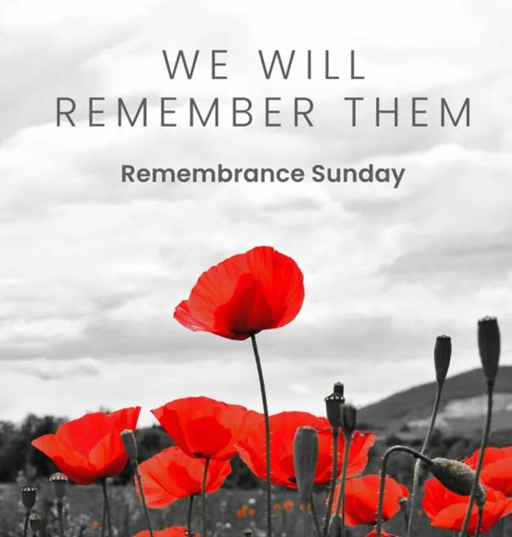

What’s on:

Sunday 9th November
8.00am: Prayer Book Communion
10.00am: Remembrance Sunday Service

Wednesday 12th November
9.30am: Holy Communion
10.30am: Warm Space Community Hub
Bible Study Groups NOT running this week

Upcoming at St John the Baptist Church
15th November: Wedding at 1.30pm

Messages:

Purple Poppies

Kate wearing her poppy collar to remember all the animals who are killed during wars.

Purple poppies for all equine animals and blue for dogs, pigeons and all others.
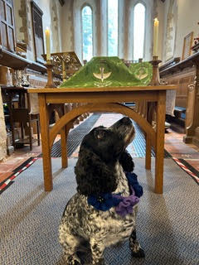

The Friends Christmas Fair

This year, The Friends Christmas Fair will be held in the Community Hall on Saturday 29th November from 2-00pm -----4-00pm. There would be room for a few extra stalls if anyone would be interested.
Anne & Jim

Prayer:

If you would like a situation prayed about urgently, please contact the church Prayer Share. Contact Dawn 01424 255423 / 0750 7745 159

If you know anyone who would like to be added to the notices, please send me an email with their details. If you don’t want to receive this email each week, or would rather receive it in a different format, please let me know.
Please give information for notices to me by Thursday morning (contact details below).
Have a good week everyone,

