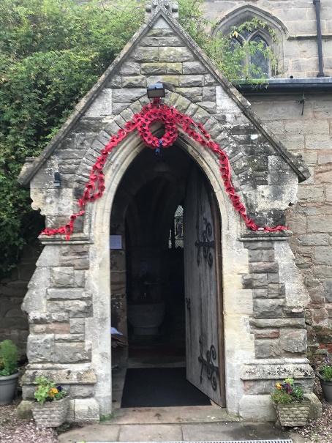
ST MICHAEL AND ALL ANGELS,
HAMSTALL RIDWARE

In the United Benefice of King’s Bromley, the Ridwares
and Yoxall

November 16th 2025
Trinity 22
PARISH NOTICES

UNITED BENEFICE SERVICE ROTA
 | Hamstall Ridware  St Michael and All Angels | Yoxall  St Peter | King’s Bromley  All Saints | Mavesyn Ridware  St Nicholas
November 16th  Trinity 22 | 10.30 am  Holy Communion | 4.00 pm  Holy Communion | 9.00 am  Holy Communion | 10.30 am  Holy Communion
November 23rd  Christ the King | 10.30 am  Service of the Word |  | 10.30 am  Holy Communion
November 30th  Advent Sunday | 10.30 am  United Benefice Holy Communion Service at St Peter’s, Yoxall
December 7th  Advent 2 | 10.30 am  United Benefice Holy Communion Service at St Nicholas, Mavesyn Ridware
December 14th  Advent 3 | 9.00 am  Holy Communion | 10.30 am  Holy Communion | 10.30 am  Holy Communion | 4.00 pm  Christingle
Please note that services of Holy Communion at 9 am follow the Book of Common Prayer and are said. Services at 10.30 will include hymns and other singing.
There are services of Holy Communion at 10.00 every Wednesday at St Peter’s, Yoxall and on the first Thursday of each month at All Saints, King’s Bromley.
*******************
Rugeley Food Bank. Please do remember those who depend on Food Banks. They are needed now just as ever. If you wish to donate directly to Rugeley Foodbank at Rugeley Community Centre the Centre is open everyday to receive contributions. Alternatively, the Rugeley Food Bank welcomes financial contributions – see https://rugeley.foodbank.org.uk. Gifts can also be brought to St Michael’s and left in the box at the back of church near the font. If that is not convenient please contact Liz Carter on 07751 068181.
****************
Contact details: If you wish to contact the Rector, Jeremy Brading you can do so on revd@kbhmy.co.uk and Glenis Turner, the PCC Secretary and Benefice Administrator is on admin@kbhmy.co.uk. The churchwardens are Michael Elsom michael.elsom@btopenworld.com and John Ferguson clan.member1954@gmail.com Information about events at church can be found at our webpages at https://www.achurchnearyou.com/church/4451/ and https://kbhmy.co.uk/hamstall/
St Michael’s will continue to be open everyday (weather permitting) between 10.00 am until 4.00 pm. We will revert to shutting the church at 6.00 pm on March 29th 2026
St Michael’s encourages donations by means of this QR code and it will appear (all being well) on all our publications as an invitation to contribute to the important work of the church both
as a place of worship and a community asset where all can share in the wonderful place we have inherited and wish to pass down to those who come after.
PLEASE REMEMBER IN YOUR PRAYERS:
Those who are sick: Mary Mycock, Brenda, Angela Perkin, Doug, David and Barbara Rudge, May Windley, Pam Payne, Rev’d Frank Finch, Chris Poole, Les Woods, Pat Lomax, Alison Scott and any known personally to you.
Those who live and work in the Nursing, Care and Retirement homes in the villages both in and near the parishes of the United Benefice.
Using the Archbishops’ prayer for Ukraine at this time let us remember the people of that war-torn land:
God of peace and justice, we pray for the people of Ukraine today. We pray for peace and the laying down of weapons. We pray for all those who fear for tomorrow, that your Spirit of comfort would draw near to them. We pray for those with power over war or peace, for wisdom, discernment and compassion to guide their decisions. Above all, we pray for all your precious children, at risk and in fear, that you would hold and protect them. We pray in the name of Jesus, the Prince of Peace. Amen
The situation in the Middle East where hopes for a peaceful resolution sometimes appear irretrievably bleak:
O God of all justice and peace, we cry out to you in the midst of the pain and trauma of violence and fear which prevails in the Holy Land. Be with those who need you in these days of suffering; we pray for people of all faiths - Jews, Muslims and Christians and for all people of the land. While we pray to you, O Lord, for an end to violence and the establishment of peace, we also call to you to bring justice and equity to the peoples. Guide us into your kingdom where all people are treated with dignity and honour as your children - for to all of us you are our Heavenly Father. In Jesus' name we pray. Amen.
From the Diocesan Prayer Diary:
Sunday 16th November: (Margaret, Queen of Scotland, Philanthropist, Reformer of the Church, 1093, Edmund Rich of Abingdon, Archbishop of Canterbury, 1240)
Lord, today we thank you for the ministry of one of your servants in the former Archbishop of Canterbury Edmund Rich. So too we pray for the next person called to serve in that role in Bishop Sarah Mullally;
Almighty and everlasting God, the only worker of great marvels, send down upon your servant Sarah, called to be Archbishop of Canterbury and all who are committed to her care, the spirit of your saving grace, and that they may truly please you, pour upon them the continual dew of your blessing. Grant this, O Lord, for the honour of our advocate and mediator, Jesus Christ. Amen.
Wednesday 19th: (Hilda, Abbess of Whitby, 680. Mechtild, Béguine of Magdeburg, Mystic, 1280)
Lord, we lift before you the Education Team's training day on developing subject knowledge of Abrahamic Faiths and World Views, for a constructive and informative time for all those taking part. We thank you for the shared heritage of following you between Christianity, Islam, and Judaism, and pray you will guide us more to embrace what connects us rather than focus on what may divide us. We also pray for this morning's FAM Committee, for wisdom and your guidance in all the decisions they have to make.
Finally today, we pray for today's final gathering of this iteration of the Soul Food Course. Thank you for the efforts made in leading it by Charles, Sue, and Ursula; and we pray that all those that have taken part will leave with a greater measure of inspiration of the many wonderful ways that we can talk to you - and the confidence that you will always listen.
Thursday 20th: (Edmund, King of the East Angles, Martyr, 870;
Priscilla Lydia Sellon, a Restorer of the Religious Life in the Church of England, 1876)
Lord, we bring before you today's Refresher of Canon Law, for clear guidance for all those that need it to stay within the law and learn how it may affect us. We thank you for all those who serve the diocese in legal areas, for Mark who is taking today's session, and Andrew, Pauline, and Rosie in the Registry team.
COMMUNITY CAFÉ
All who come to these events obviously enjoy themselves tremendously – so why not come along to the next ones with your family and friends. Who knows, you might meet some new folks and show them what a friendly place Hamstall – and St Michael’s - in particular is. Once again Jo and her team look forward to welcoming you. The next events will be on Thursday November 27th from 10.30 to 12.30 and on Tuesday December 16th in the afternoon – the significance of that date will not be lost on the Jane Austen fraternity!
.
Safeguarding of children and vulnerable adults. If you have any concerns please speak in complete confidence to the Parish Safeguarding Officer, Dr Paul Carter 01889 504347 or the Diocesan Safeguarding Officer Mr Neil Spiring 01543 306 030.

