St Olaf’s Church Poughill
NOTICES FOR WEEK BEGINNING SUNDAY 23rd November 2025
“All of you together are Christ’s body, and each of you is a part of it.”
1 Corinthians 12: 27 (Church verse for 2025)

Rector: Rev Teresa Folland contact 01288 352599 (home)
Churchwarden: Howard Emmens contact 07769 188858 (mobile)
Churchwarden: Kathy Emmens contact 07795 909054 (mobile)
Note: If in any danger on church premises ring 999

Sunday 23rd November 10.00am Morning Praise Tim Symonds
6.00pm Informal Prayer and Praise in The Old School
Sunday 30th November 11.00am* Benefice Service Rev Teresa Folland with Hilbre and Ian
*Note the later start time
Sunday 7th December 10.00am Morning Praise Mark Sinden
Sunday 14th December 10.00am Holy Communion Rev Richard Ward-Smith
Church Prayer Meeting: Fridays 7.00pm meeting in The Old School.
Saturday Prayer Breakfast : Saturday 22nd November is the ladies’ prayer breakfast at 8.30am in the Old School.
Hollabury Fellowship: Wednesday 26th November: Tim Symonds will be leading.
ALPHA: Please continue to pray for those who took part in the ALPHA course as they consider what they will do next.
Revel Thank You Evening
Next Thursday, 27th November, at 7 pm in THE VILLAGE HALL, there will be Poughill Revel’s Thank You evening. During the evening there will be refreshments, entertainment from the Ukulele Band, and the presentations to local organisations of donations from the money raised at this year’s Revel (St Olaf’s will be one of those recipients).
This is an invitation to everyone who helped at Poughill Revel and in particular in the Tea Tent to come along and join in.
Late Night Shopping Carols
On Friday 5th December the Christians Together in Bude and Stratton will be gathering to sing carols during Bude’s Late Night Shopping Evening. We shall gather outside The Ark Angel (venue TBC next week), meeting first to pray together from 5.30pm, and the singing will start at 6pm. Wrap up to keep warm and dry, and come and join in.
Fish and Chips
There will be no second Friday fish and chips lunch get together in December. But, owing to popular demand this event will make a comeback in 2026. Hooray!
Crown of Life School – Note from Alison
Crown of Life Vocational training: Eighteen former students have now been sponsored for a one-year Vocational course at the Crown of Life School for 2026. Several individuals in the congregation, and the church as a whole, have made financial contributions towards this. Thank you so much
Saturday Zoom Quiz 7.30pm: Join with others in the benefice via Zoom: Meeting ID 874 2385 3298 Passcode 564 786.
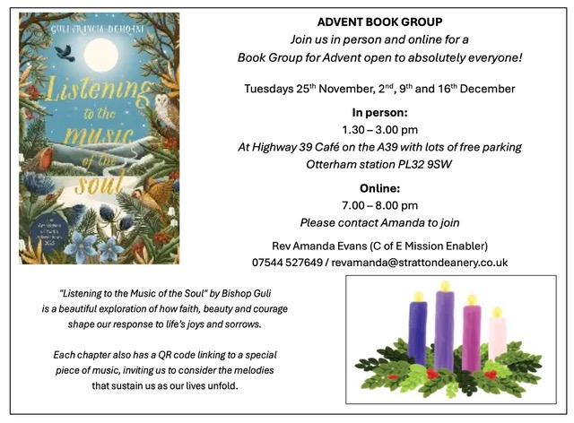
Would you like to know more about how to welcome everyone into our churches?

What? A series of 4 informal sessions to explore and equip, encourage and embrace becoming an inviting and welcoming church to all, and for all.

Where? The Old School, Poughill Road, Poughill, Bude EX23 9ER

When? Thurs 2-4pm: 27 November, 4,11 &18 December (last session in church)

Who? Everyone welcome – tea and coffee and biscuits on tap!

Come to all or as many sessions as you are able!
Open to everyone in Stratton Deanery. No need to book.

Any questions, please contact
Rev Amanda Evans: 07544527649 or Hannah Wicks email: hcfwicks@gmail.com

Morning Prayer: 9.00am Monday to Friday Via Zoom: Meeting ID 818 0754 3068 passcode 342 493 or you can join by phone on 0203 051 2874 or 0203 051 5237.
Daily Bread notes for December to February are available at the back of the church.
SOCKS (St Olaf's Children's Klub) Fridays 5.30–6.30pm in The Old School and Pants (Youth Group for those 11+): Contact Rachel on 353842.

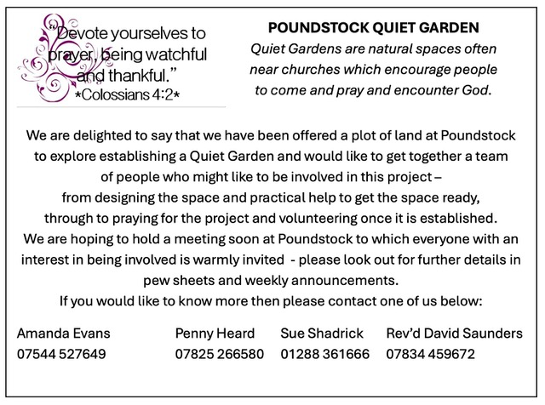
Recordings of sermons: Sound recordings of sermons are now available from Rich. Tel 07772 775591 or email docrichpage@hotmail.com.
House Groups meet on various days during the week. If you are interested in joining one, please contact Kathy or Howard. There are vacancies just waiting for YOU!
Communion at home: Rev Douglas Adams and Rev Teresa Folland can arrange for communion in your home when you find yourself unwell and unable to attend services for a period. Please phone if this is something you would like: Rev Teresa Folland 01288 352599 or Rev Douglas Adams 01288 353842.
Sermon: Rev Douglas Adams
When I was a child and in my growing up years, I listened to many a sermon that was full of doom and gloom and forecasted worse things to come
They were about the END TIMES when it seemed like the whole world would become a molten mess and swallow up humankind.
At this time of the year the lectionary uses passages that use apocalyptic language
The Apocalyptic Theology of the end times.
There’s plenty of fuel for this in some of the ninth century prophets
Our first Bible reading was a good example of this Malachi 4.1-2a
See, the day is coming, burning like an oven, when all the arrogant and all evildoers will be stubble; the day that comes shall burn them up, says the Lord of hosts, so that it will leave them neither root nor branch.
Makes you shudder when you try to imagine what it means
The origin of this sort of prophecy is to be found in the fact that Israel constantly turned its face away from God’s holiness and righteousness and worshipped other gods instead
But it’s not limited to the Old Testament prophets
The teaching of Jesus in our gospel reading of today seems to be taking a similar line
Jesus was present in the Jerusalem temple when someone is praising all the beautiful stones and gifts of gold.
Jesus says in Luke 21: 6 “As for these things that you see, the days will come when not one stone will be left upon another; all will be thrown down.”
He is referring to the destruction of the Jerusalem temple which was built to glorify God and lead Israel in its worship.
The theme is about God bringing judgement on his sinful people
They have continued to be sinful and self seeking
It was the Achilles heel of the Jews
God called them to be faithful and they did exactly the opposite and were unfaithful and disobedient to his laws.
In the two thousand years since Jesus walked this earth little has changed for the Jewish people but even more sadly for the Christian world of which we are part.
God calls us to be a righteous and holy people and we turn away and make excuses and do our own thing instead.
BUT
And there is a but in Jesus’ teaching
For those who walk with God in their lives something much better is promised
It’s found from verse 13 onwards. This will give you an opportunity to testify.
So make up your minds not to prepare your defence in advance; for I will give you words and a wisdom that none of your opponents will be able to withstand or contradict.
You will be betrayed even by parents and brothers, by relatives and friends; and they will put some of you to death.
You will be hated by all because of my name. But not a hair of your head will perish.
By your endurance you will gain your souls.
I’ll summarise what the main points are
We are to be active and TESTIFY about Jesus and our faith in him. We won’t need to worry about what we will say because God himself will give us the words to say.
When others betray us and let us down and speak against us we are not to be afraid. God has our back and we will be protected from evil people.
Jesus says “But not a hair of your head will perish.”
In other words when we meet opposition and all seems to be lost, we will have God by our side protecting us from the arrows aimed at us.
We know the outcome will be victory. Verse 19 says By your endurance you will gain life.
The Greek word used here can have different meanings.
The NIV choose the word “win life” to translate it rather than “souls”
Jesus isn’t saying that we will be saved by our own efforts but that we will see victory over evil and sin in our own experience. We will be “over-comers”
We will see God at work in changing peoples lives.
It will be exciting and stimulate our worship and praise.
Yes, Jesus will one day return in triumph
We don’t know when or what the run up to it will be like
But God will be there for you and me and usher us into his everlasting kingdom.
One more thing.
Our present national and international situation has begun to look worrying
Russia’s attack on the Ukraine have destabilised Europe and there is unrest in several other countries.
Climate change seems to be triggering natural disasters like flooding and mass damage
It looks very worrying to us in the UK.
As Christians we will find political instability and political unrest a big concern.
People are turning their backs on Bible truth and turning to violence.
As Christian people we need to recognise that things are changing but also remember we have a Saviour who will walk with us during worrying times.
The Church is beginning to grow again and the young, gen X, are beginning to seek God in a new way.
We have a ministry to confess Jesus and make him known to others in distress
We need to be ready for possible rejection and persecution
We need to know that God has our back and won’t forsake us or desert us in times of trouble. Amen
************************************************
Intercessory Prayers:
Anchor our hearts in Your promises, not in the noise of unanswered questions. While we wait, let Your peace guard our hearts and renew hope, for we know that even in Your silence, You are present and working

Our Father, we come before you, we bless your name and we are thankful for all we have and are and have been given by you. Compassionate God, as we enjoy your bounty on our tables, we remember those whose cupboards are bare. We pray for every family worried about their next meal. For parents struggling to feed their children, and for anyone facing isolation and hunger on their own, we ask and pray that you will provide for them and bring them hope.
Thank you for your grace and mercy that we are forgiven and can enter into your kingdom. We praise you for your deep love and for empowering us to live a new life in your Spirit. Help us to never forget the sacrifice of Jesus. Because our sins are covered, we dare to come into your presence with our prayers.
We give thanks for St Olaf’s, this community of believers that serves as a beacon of your love and truth in our area. We thank you for the people who serve, the teaching that nourishes us, and the opportunities to share your goodness with those around us. We pray for continued growth, wisdom, and unity as we strive to be a blessing to you and a light to the world. May your Holy Spirit fill us, empowering us to serve faithfully and reach out to others with your grace sharing the light of Christ.
We pray for the Church of England, Archbishop-designate Sarah. Archbishop Stephen, Bishop David, and our rector Teresa. May they know the strength and power of your Spirit.
We ask for your hand on the Alpha Course participants as they think about what comes next for them.
We pray for our suffering world. So many countries at war: Ukraine continues to suffer and now President Zelensky must consider an American peace plan which would mean a loss of territory. We pray for wisdom for all sides in discussion that peace may be achieved.
In Sudan families are running out of time as hunger spreads: twenty-one million people are not getting enough to eat. The population are enduring malaria, Dengue fever, cholera and typhoid outbreaks and famine and the diseases are overwhelming the Khartoum hospitals. Bless your suffering people and may the warring leaders have compassion for the suffering they are causing.
We give thanks for the fragile peace that has come to Gaza and Israel and for the release of prisoners and hostages. But Israel is continuing to use weapons against the people of Gaza. We continue to pray for the damage and hurt that has been caused. May there be rebuilding of the land and the lives. We think of the six thousand amputees trying to rebuild their lives in Gaza without proper prosthetics. Bring healing of the mind we pray to those who have seen atrocities and cannot forget, and those who have been tortured.
We pray for persecuted Christians throughout the world. Violent chaos continues to be a cover for persecution in countries like Myanmar, Yemen, Nigeria and Sudan; civil wars have become places for targeted attacks against Christians. Bless your suffering people. We know you said that you did not come to bring peace but a sword, but we still pray for peace and your kingdom to come and your will to be done.
We pray for the sick in our own community. Continue to heal and sustain Pam Kemp, Bella, Sandra Shepherd, Paul Whybrow, Molly Hooper, Peter Harrison, Mary, Debbie, Denise, Liz, Rich, Irene Webster, Ferg and Tim. We continue to pray for Remy, eight and suffering with a serious cancer, and for his family too. We pray for Sue Dickinson with serious injuries. We ask that all these we have named may receive a touch from you. May they know your peace and hope in their situations.
We pray too for those who mourn, that they will be comforted.
We pray for children in our community, that they will be protected from all the temptations that surround them, and that they will understand what is good and choose that. We pray for the schools, that they will look after the children in their care and that the teachers will have the energy and compassion needed. We especially pray for protection from the harm that can befall children through social media, on-line grooming, drugs and other harmful internet platforms that target the innocent.
We pray for those at college or university, that they will keep their faith and find good friends, and for those looking for work that they will find something useful and fulfilling to do.
This week we pray from our electoral roll for Bernadette Knott and her family and Keith Makin and his family. We thank you them and the part they play in this fellowship. Thank you for the contribution they each make in their different ways.
The charities we are especially praying for this week are OMF International and Oriel Ministries: for OMF International as they share the gospel with the people of East Asia as well as providing medical aid; and for Oriel Ministries as they take the gospel to young people who do not know it.

We think of King Charles as he has had to deal with family problems. We ask for the King’s health to remain good. For the government we pray for stability and moral leadership, honesty and truthfulness in all they do, as they face so many problems both in this country and in dealing with other countries, and especially for the upcoming budget. We ask for your hand on the Assisted Dying Bill as it continues its passage through the House of Lords and pray that your will may be done.
We pray for the armed services and the intelligence services and are grateful that they work to keep us safe in these troubled times, and are helping deter suspected Russian drones from flying over Belgium.
We pray that we may we stay true to you our Saviour and Lord through all the challenges and difficulties of life, knowing that you are always with us and never forsake us.
Breathe in me, O Holy Spirit, That my thoughts may all be holy. Act in me, O Holy Spirit, That my work, too, may be holy. Draw my heart, O Holy Spirit, That I love but what is holy.
Accept these prayers for the sake of your Son, our Saviour Jesus Christ. Amen.
***********************************************************************************************Please Contact Kathy Emmens by Friday noon if you have an item you wish to be included in the notice sheet: kathyemmens@gmail.com

