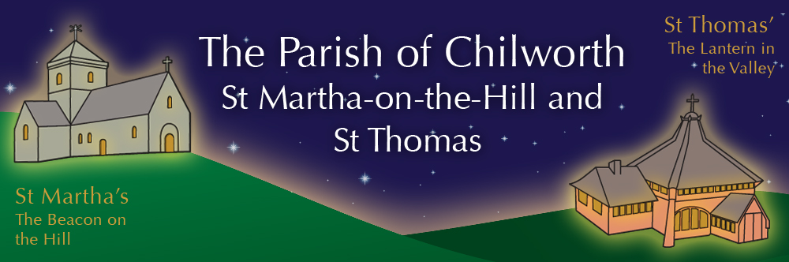

NOTICES: - 30th NOVEMBER 2025
Priest David Oakden – Revdavid@parishofchilworth.org.uk - 01483 534293 (day off Friday)
Do let me know of anybody or anything that you would like to be prayed for.
www.parishofchilworth.org.uk and find us on https://www.achurchnearyou.com

**********Hebrews 12:28 (NLT)***********
Since we are receiving a Kingdom that is unshakable, let us be thankful and please God by worshipping him with holy fear and awe.
***********************************

Opportunities to pray together: -
Ecumenical Prayer Breakfast 1st Saturday of the month at the Vicarage, from 9am, prayer, coffee and croissant. Next is the 6th December – Thursday evening at St Thomas at 7:30 pm for an hour every other week. **4th & 18th December.

This Sunday Services: – 1st of Advent
9:30 St. Thomas. Family Worship inc. Posada
11:15 St. Martha’s – Fifth Sunday inc. Baptism

Next Sunday Services: - 7th December
9:30 St. Thomas. Holy Communion
11:15 St. Martha’s – BCP Morning Prayer

Looking further ahead: -
Chilworth Tinies and Toddler Group: St T’s Monday 9:15 – 10:30am
Advent Art +Lunch: 1st Dec Midday St T’s
Xmas Tree Lighting: 1st Dec St T’s 3:30pm
Benefice Autumn Course: 1st Dec 7:30pm Albury Village Hall

Food & Hygiene Bank: -
The Foodbank Larder box is located in the porch of St Thomas Church. Suggested items: - Long life milk /tins tuna/ tins meat/ sachets microwaveable rice /pasta sauces/curry sauces/cereal/spreads/ tea/ coffee/ hot chocolate/ tins soup/ baked beans. Please assist, especially as the autumn is now upon us.

Chilworth Tinies and Toddler Group: -
Mondays from 9:15 -10:30 meet in St Thomas, play chat, pray and support.

Benefice Autumn Study Course: -
7:30pm Monday evenings at Albury Village Hall
Can simply being with God, being with each other and being with our community really form the heart of our mission and ministry as a church? Join us to explore together how the concept of “being with” rather than “doing for” or “working for” can guide us as individuals as well as churches.

Benefice News - David Oakden: -
He will be licenced to this additional role by Archdeacon Catherine on December 9th at 2.30pm at Albury Parish Church – St Peter & St Paul, Church Lane, Albury.

Advent Bring and Share Lunch 30th Nov: -
This year's Bring and Share Advent Lunch (with a curry theme) will be held at St Thomas' @ 12.00pm for 12.30 sit down. A sign up sheet will be available shortly (curry, rice, chutneys, pickles, poppadum’s, wine, soft drinks etc) but please bring mince pies for desserts as this is when we begin to 'collect' our mince pies for refreshments following the Christmas Tree Lighting at the beginning of December and other special Christmas Services during December. Many thanks.

Advent Art + Lunch 1st, 8th, 15th of Dec: -
Simple lunch of cup a soup, and a discussion on paintings with an Advent theme in St T’s from midday.

XMAS Tree Lighting 1st Dec St T’s 3:30pm: -
Annual outside of St T’s service, with the Salvation Army band, where we sing carols, and light the tree, with refreshments after.

Christmas Highlights: -
14th Dec 4:30pm Candlelit Carols – St T’s
20th Dec 1:30pm & 3pm Coromarta Carols – St M’s
21st Dec 11:15am 9lessons & Carols – St M’s
21st Dec 5:00pm Candlelit Carols – Old Saxon Church
23rd Dec 6:30pm Carols at Drummond Arms
24th Dec 4:00pm Crib/ Christingle – St P & St P’s
24th Dec 11:00pm Midnight Communion – St M’s

