FOR YOUR PRAYERS THIS WEEK:
Des, Jo, Kim Roberts, Nicky Carter, Mary Brenchley, Ted, Julie Amass, Luke Inglis, Joy Cox, Georgie Mayes, Seema Dehad, Tom Scullion, Learie Eversley, Paul Mackenzie, Sally, Chris and Angela, Philip Rutt, Margaret White, Rachel Merrill, Nicholas Slack, Valerie Rounden, Helen, Anne, Chris Ackroyd.

NOTICES:

Please send notices for inclusion in the next bulletin to Nick Whiteley – nwhiteley@gmail.com - 5 days before the service.

ST FAITH’S PARISH CHURCH
HITCHIN
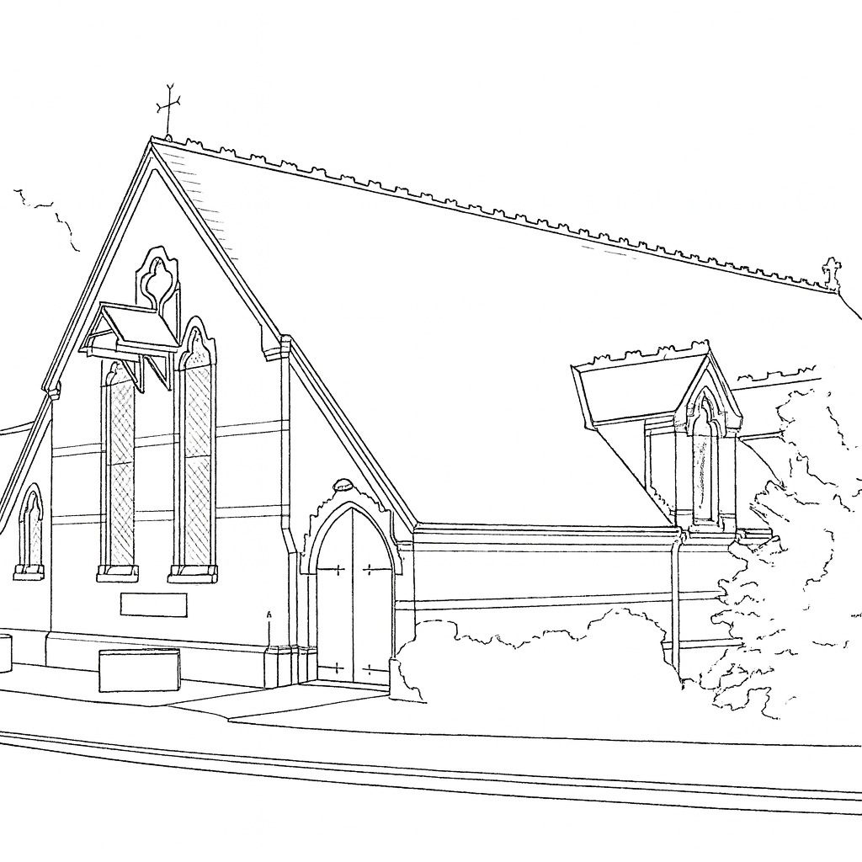
REMEMBERANCE SUNDAY
9th of November 2025
Third Sunday before Advent
Welcome to St Faith’s. Children of all ages are welcome. For the very young there is a small crèche area on the lectern side of the church near the front.
COLLECT
Almighty Father, whose will is to restore all things
in your beloved Son, the King of all:
govern the hearts and minds of those in authority,
and bring the families of the nations,
divided and torn apart by the ravages of sin,
to be subject to his just and gentle rule;
who is alive and reigns with you,
in the unity of the Holy Spirit,
one God, now and for ever.

2 Thessalonians 2:1-5, 13-17
Concerning the coming of our Lord Jesus Christ and our being gathered to him, we ask you, brothers and sisters, ² not to become easily unsettled or alarmed by the teaching allegedly from us—whether by a prophecy or by word of mouth or by letter—asserting that the day of the Lord has already come. ³ Don’t let anyone deceive you in any way, for that day will not come until the rebellion occurs and the man of lawlessness^{[a]} is revealed, the man doomed to destruction. ⁴ He will oppose and will exalt himself over everything that is called God or is worshiped, so that he sets himself up in God’s temple, proclaiming himself to be God.
⁵ Don’t you remember that when I was with you I used to tell you these things?
¹³ But we ought always to thank God for you, brothers and sisters loved by the Lord, because God chose you as firstfruits to be saved through the sanctifying work of the Spirit and through belief in the truth.
¹⁴ He called you to this through our gospel, that you might share in the glory of our Lord Jesus Christ.
¹⁵ So then, brothers and sisters, stand firm and hold fast to the teachings we passed on to you, whether by word of mouth or by letter.
¹⁶ May our Lord Jesus Christ himself and God our Father, who loved us and by his grace gave us eternal encouragement and good hope,
¹⁷ encourage your hearts and strengthen you in every good deed and word.
Luke 20: 27-38
²⁷ Some of the Sadducees, who say there is no resurrection, came to Jesus with a question. ²⁸ “Teacher,” they said, “Moses wrote for us that if a man’s brother dies and leaves a wife but no children, the man must marry the widow and raise up offspring for his brother. ²⁹ Now there were seven brothers. The first one married a woman and died childless. ³⁰ The second ³¹ and then the third married her, and in the same way the seven died, leaving no children. ³² Finally, the woman died too. ³³ Now then, at the resurrection whose wife will she be, since the seven were married to her?”
³⁴ Jesus replied, “The people of this age marry and are given in marriage. ³⁵ But those who are considered worthy of taking part in the age to come and in the resurrection from the dead will neither marry nor be given in marriage, ³⁶ and they can no longer die; for they are like the angels. They are God’s children, since they are children of the resurrection. ³⁷ But in the account of the burning bush, even Moses showed that the dead rise, for he calls the Lord ‘the God of Abraham, and the God of Isaac, and the God of Jacob.’ ³⁸ He is not the God of the dead, but of the living, for to him all are alive.”

