Westfield Church Notices Sunday 23rd November

Valerie writes:
Change
Everything around us is constantly changing, as the autumn turns into winter the weather gets cooler, the garden rests, the trees shed their leaves, the moon waxes and wanes.
Every time we see our grandchildren they've grown and changed week by week, a new tooth, a size bigger shoes, a new experience to share.
Change in our lives is expected, but sometimes if it happens suddenly or unexpectedly it can be unsettling, moving house, coping with a new health issue or the sad passing of a loved one.
It's reassuring to know that God never changes. He's the one sure thing we know is constant. God's promises remain the same yesterday, today and forever.
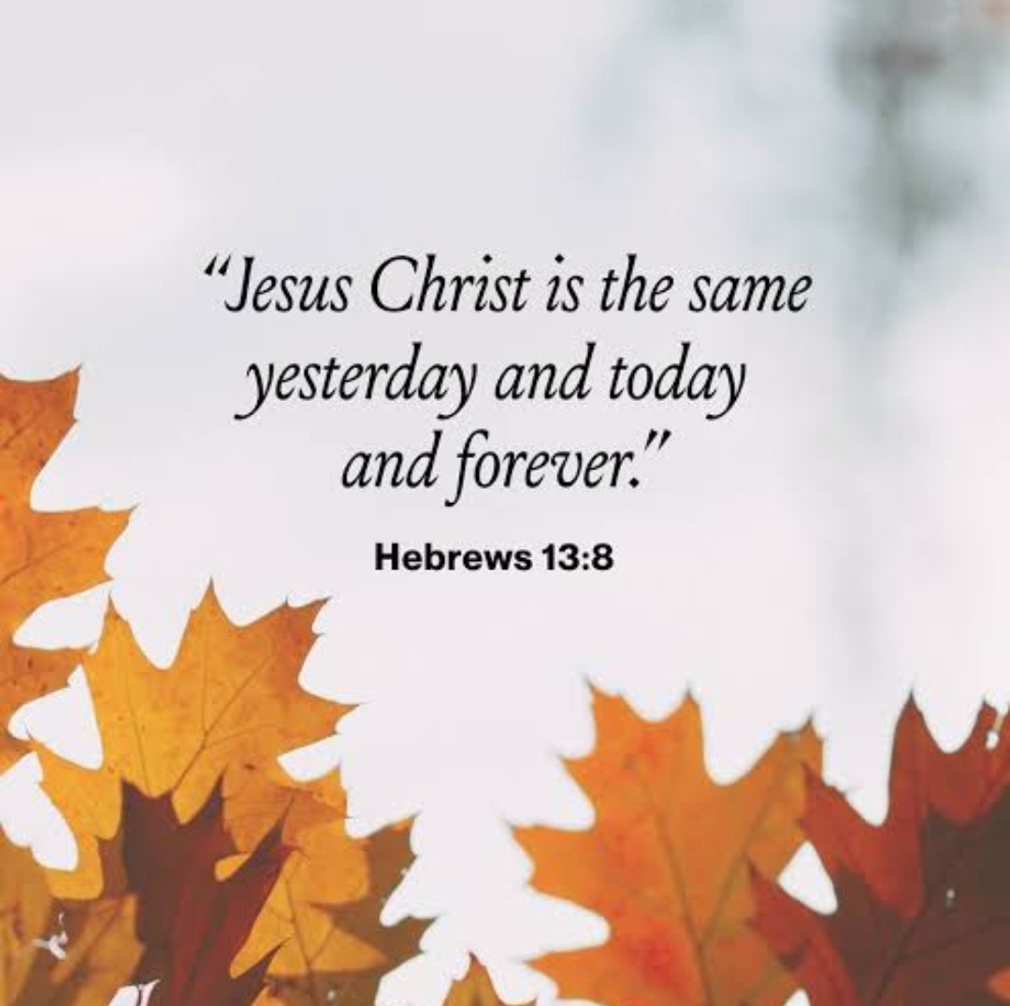

What’s on:

Sunday 23rd November
8.00am: Prayer Book Communion
9.30am: Holly Communion
Wednesday 26th November
9.30am: Holy Communion
10.30am: Warm Space Community Hub
7.30pm: Home Groups at Dawn and Jess’ and Cathy and Howard’s

Messages:

FSW

The FSW collection this month is on Sunday 23rd November.
This will be our final collection this year so food for Christmas would be welcome.
In addition, this year FSW are requesting presents (not gift wrapped).
Let's make this a bumper collection this month.


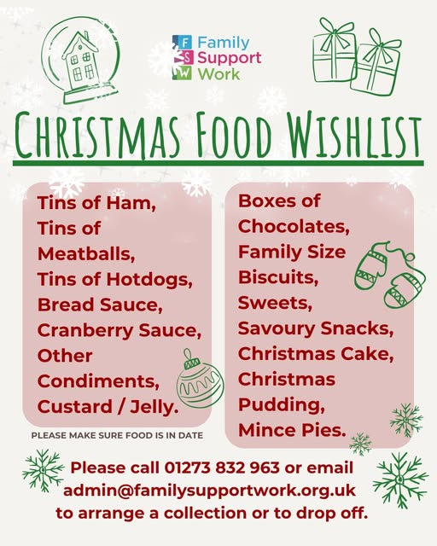

Also, Tina Puttick from FSW will be coming to talk to us on Sunday 25th January
Many thanks for all your other contributions during the year.

Kathy and Eric Darvill

Friends of Westfield

The Christmas Fair is on Saturday 29th November from 2-00 p.m. until 4-00 p.m. in the Community Hall. We'd appreciate gifts of raffle and tombola prizes as well as the usual cakes, etc. We would also be grateful for a few offers of help in putting out tables and chairs from 1-00p.m. and also running stalls.

This year, any money raised will be donated to the PCC to go towards the Church Hall ceiling repair. Jim

Confirmation Service

A very big Thank You to everyone who helped to make Wednesday evening’s Confirmation Service so special. I had many lovely comments from visitors remarking how lovely Westfield church people and the building are - well done everyone.

And very big Congratulations to Charlotte, Ellie, Felicity and Leo on their Confirmation. We love you, are proud of you, have promised to encourage you in your faith and are privileged to be part of your church family.

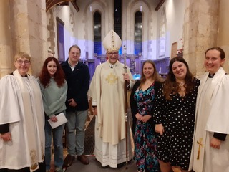

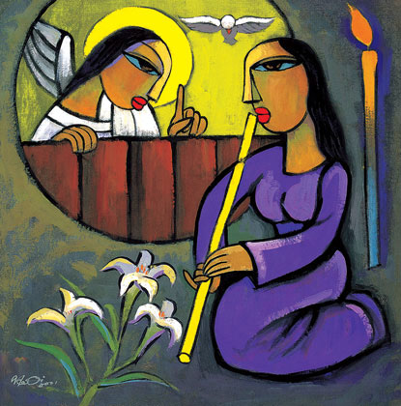
Pregnant with Hope
(Reflections for Advent)

Join us for an evening of reflections for Advent, along with poetry and music. The evening will be led by Professor Tina Beattie.

Tina is Professor Emerita of Catholic Studies at the University of Roehampton in London and a well-known Roman Catholic theologian. She has published extensively on sacramentality, desire, embodiment and gender, engaging with psychoanalytical theory and art history as well as theology. She has a particular interest in Marian theology, art and devotion. She now works as an independent researcher and writer. In addition to her academic publications, Tina is also a published novelist and a regular contributor to the media, including BBC Radio 4’s “Thought for the Day”.

Please join us for what will undoubtedly be an interesting, thought-provoking and stimulating evening.

Date: Wednesday December 10th, 2025

Time: 7.00 pm

Venue: St Thomas the Apostle Church, Camber, New Lydd Rd, TN31 7RJ

Wine and cheese will be served after the talk.

There’s plenty of parking in both the church grounds and the neighbouring street.
For more details, please contact The Revd. Jacques Desrosiers, on 07931 217458 (including WhatsApp) or email jtmdesrosiers@gmail.com.

Carols by Candlelight 14th December 6pm

Sandi would like to have a robed choir for this lovely service, so we need the help of singers from the congregation. We hope to sing two anthems (not too difficult) as well as two or three descants. There will be two or three practices, probably on Thursdays (TBC) from 27th November. Please let Janice know if you can help.

Church Christmas Dinner

7.00pm Thursday 16th December at Fairligh Lodge Hotel, see attached for details

Benefice Reorganisation

Sandi has asked me to bring your attention to the proposed Benefice Reorganisation. You’ll find a copy of the draft proposal, and the full document explaining the proposed reorganisation of Fairlight, Guestling and Westfield into a single Benefice in the New Year, attached to this email. Paper copies have also been displayed in all our churches, for your review. Please note that the draft proposal contains details of where to write should you wish to comment at this stage of the consultation. The closing date is 1st December.
Sarah Parish Administrator

Prayer:

If you would like a situation prayed about urgently, please contact the church Prayer Share. Contact Dawn 01424 255423 / 0750 7745 159

If you know anyone who would like to be added to the notices, please send me an email with their details. If you don’t want to receive this email each week, or would rather receive it in a different format, please let me know.
Please give information for notices to me by Thursday morning (contact details below).
Have a good week everyone,
Tony Demarco tonydemarcohastings@gmail.com

