MASS & SERVICE TIMES THIS WEEK

SUNDAY 23RD NOVEMBER
OUR LORD JESUS CHRIST,
KING OF THE UNIVERSE

PARISH MASS
10 AM
Celebrant: Father Chris Burrows

MONDAY 24TH NOVEMBER Holy Hour 10 am

TUESDAY 25TH NOVEMBER Mass 11 am
Celebrant: Father Yenda Smejkal SSC

FRIDAY 28TH NOVEMBER Community Health Walk 10 am
followed by refreshments

SUNDAY 30TH NOVEMBER
FIRST SUNDAY OF ADVENT
Parish Mass 10 am
Celebrant: Father Paul Bennett SSC

Parish Priest
In Vacancy
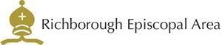


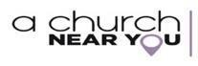
Please contact the churchwarden: Valerie Rice 07946 175105

Email: marshfarmholycross@gmail

