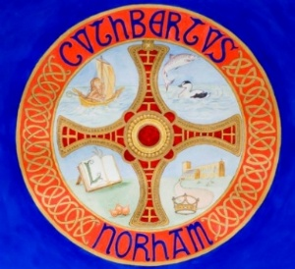 | The St Cuthbert’s Project  Bulletin No. 4, June 2025

The Standing Committee of the Parochial Church Council (PCC) continue to meet every month or so, with more work being done between meetings.

Our Funding Adviser, Katherine Williams, is helping us through the complex process of applying to the National Lottery Heritage Fund for a grant in the region of about £240,000. We recently had a preliminary meeting with a representative of the Fund, who was very positive about our project.

The PCC’s Architect, Ninette Edwards, has made a preliminary submission to the Diocesan Advisory Committee (DAC), who offer advice and guidance on church projects, and oversee the equivalent of planning permission for work on church buildings. In her submission, Ninette put the case for improved heating along the following lines:

In order to make the church more hospitable, the PCC would like to improve the heating. They are keen to respond to the Net Zero 2030 targets, and have explored a few electric heating options, bearing in mind that the church is not in continual use.

The options reviewed have included ground source and air source heating; the capital costs for each of these is very high, and they would be expensive to run. Biomass has also been explored, and dismissed for the same reasons. The position of radiators would be problematic, due to most of the seating being in the nave away from walls, and underfloor heating would require new flooring throughout.

A Herschel Halo far infrared heating system, with lights, is therefore proposed, at a cost of about £90,000. The church at one time had chandelier lighting, so the concept of this type of suspended fitting is not new for the building.

To find out more about the Herschel heating system, see: https://www.herschel-infrared.co.uk/heating-heritage-buildings/churches.

If you have any comments or questions, please contact:
- The Vicar, the Revd Rob Kelsey, (01289) 382325
- PCC Treasurer, Mr William Jackson, (01289) 382028

