St Peter and the Holy Apostles, Plymouth- Sunday 19th October 2025
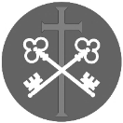
The Thirtieth Week in Ordinary Time (Year C)
Welcome to the Parish Mass
Welcome to St Peters Church. This sheet provides all that you will need for today’s Mass. If you need any assistance before, during or after the service or need a large print copy of this order of service please speak to one of our welcome team. (identifiable by a lanyard)
Please respond to the words in non-italic Bold, The Hymns are sung by all. Please inform the people on the door when you enter if you require a Gluten Free Host
…………………………………………………………………………………
We Stand for The Entrance Hymn

1. Holy God, we praise Thy name;
Lord of all, we bow before Thee.
All on earth Thy scepter claim,
All in heav'n above adore Thee.
Infinite Thy vast domain,
Everlasting is Thy reign.
2. Hark! the glad celestial hymn
Angel choirs above are raising;
Cherubim and seraphim,
In unceasing chorus praising,
Fill the heav'ns with sweet accord:
"Holy, holy, holy Lord!"
3. Holy Father, holy Son,
Holy Spirit, three we name Thee,
Though in essence only one;
Undivided God we claim Thee
And, adoring, bend the knee
While we own the mystery.
4. Spare Thy people, Lord, we pray,
By a thousand snares surrounded;
Keep us without sin today,
Never let us be confounded.
Lo, I put my trust in Thee;
Never, Lord, abandon me.

The Introductory Rite
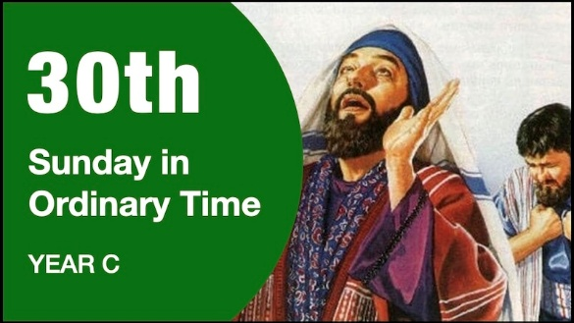
In the name of the Father and of the Son and of the Holy Spirit. Amen.

Following the greeting we respond.
And with your spirit.

The Priest introduces the Mass
The Penitential Rite
Brothers and sisters, let us acknowledge our sins,
and so prepare ourselves to celebrate the sacred mysteries.

I confess to almighty God and to you, my brothers and sisters, that I have greatly sinned, in my thoughts and in my words, in what I have done and in what I have failed to do, through my fault, through my fault, through my most grievous fault; therefore I ask blessed Mary ever-Virgin, all the Angels and Saints, and you, my brothers and sisters, to pray for me to the Lord our God.

May almighty God have mercy on us, forgive us our sins, and bring us to everlasting life. Amen.

Either:
Lord, have mercy. Lord, have mercy.
Christ, have mercy. Christ, have mercy.
Lord, have mercy. Lord, have mercy.
Or:
Kyrie, eleison. Kyrie, eleison.
Christe, eleison. Christe, eleison.
Kyrie, eleison. Kyrie, eleison.

The Gloria
Glory to God in the highest, and on earth peace to people of good will.
We praise you, we bless you, we adore you, we glorify you, we give you thanks for your great glory, Lord God, heavenly King, O God, almighty Father.
Lord Jesus Christ, Only Begotten Son, Lord God, Lamb of God, Son of the Father, you take away the sins of the world, have mercy on us; you take away the sins of the world, receive our prayer; you are seated at the right hand of the Father, have mercy on us.
For you alone are the Holy One, you alone are the Lord, you alone are the Most High, Jesus Christ, with the Holy Spirit, in the glory of God the Father. Amen.

The Collect
Let us pray.

Almighty ever-living God, increase our faith, hope and charity, and make us love what you command, so that we may merit what you promise. Through our Lord Jesus Christ, your Son, who lives and reigns with you in the unity of the Holy Spirit, God, for ever and ever. Amen.

We sit for The First Reading- Sirach 35:15b-17, 20-22b

The Lord is the judge, and with him is no partiality. He will not show partiality in the case of a poor man; and he will listen to the prayer of one who is wronged. He will not ignore the supplication of the orphan or the widow when she pours out her story. He whose service is pleasing to the Lord will be accepted, and his prayer will reach to the clouds. The prayer of the humble pierces the clouds, and he will not be consoled until it reaches the Lord; he will not desist until the Most High visits him and does justice for the righteous and executes judgement. And the Lord will not delay.

The word of the Lord. Thanks be to God.

The Responsorial Psalm- Ps 34(33):2-3. 17-18. 19, 23. ℟7a

Response- The lowly one called, and the Lord heard him.

I will bless the Lord at all times, praise of him is always in my mouth.
In the Lord my soul shall make its boast; the humble shall hear and be glad. R

The Lord turns his face against the wicked to cut off their remembrance from the earth.
When the just one cries out, the Lord hears, and rescues him in all his distress. R

The Lord is close to the broken-hearted; those whose spirit is crushed he will save.
The Lord ransoms the souls of his servants. All who trust in him shall not be condemned. R

The Second reading- 2 Timothy 4:6-8, 16-18

Beloved: I am already being poured out as a drink offering, and the time of my departure has come. I have fought the good fight, I have finished the race, I have kept the faith. Henceforth there is laid up for me the crown of righteousness, which the Lord, the righteous judge, will award to me on that day, and not only to me, but also to all who have loved his appearing.
At my first defence no one came to stand by me, but all deserted me. May it not be charged against them! But the Lord stood by me and strengthened me, so that through me the message might be fully proclaimed and all the Gentiles might hear it. So I was rescued from the lion’s mouth. The Lord will rescue me from every evil deed and bring me safely into his heavenly kingdom. To him be the glory for ever and ever. Amen.

The word of the Lord. Thanks be to God

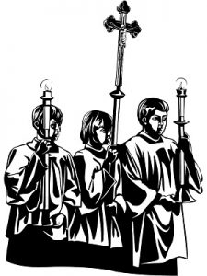
We stand for-

The Gospel Procession and Acclamation- 2 Corinthians 5:19

Alleluia, alleluia.
God was in Christ reconciling the world to himself,
and entrusting to us the message of reconciliation.
Alleluia.

The Gospel- Luke 18:9-14

The Lord be with you. And with your spirit.
A reading from the holy Gospel according to N. Glory to you, O Lord.
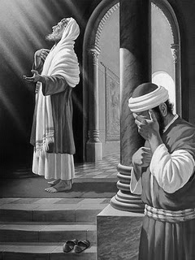
At that time: Jesus told this parable to some who trusted in themselves that they were righteous, and treated others with contempt: ‘Two men went up into the Temple to pray, one a Pharisee and the other a tax collector. The Pharisee, standing by himself, prayed thus: “God, I thank you that I am not like other men, extortioners, unjust, adulterers, or even like this tax collector. I fast twice a week; I give tithes of all that I get.” But the tax collector, standing far off, would not even lift up his eyes to heaven, but beat his breast, saying, “God, be merciful to me, a sinner!” I tell you, this man went down to his house justified, rather than the other. For everyone who exalts himself will be humbled, but the one who humbles himself will be exalted.’
The Gospel of the Lord. Praise to you, Lord Jesus Christ.

We sit for The Homily

We stand The Creed
I believe in one God, the Father almighty, maker of heaven and earth, of all things visible and invisible.
I believe in one Lord Jesus Christ, the Only Begotten Son of God, born of the Father before all ages. God from God, Light from Light, true God from true God, begotten, not made, consubstantial with the Father; through him all things were made. For us men and for our salvation he came down from heaven,
At the words that follow, up to and including ‘and became man’, all bow.
and by the Holy Spirit was incarnate of the Virgin Mary, and became man.
For our sake he was crucified under Pontius Pilate, he suffered death and was buried, and rose again on the third day in accordance with the Scriptures.
He ascended into heaven and is seated at the right hand of the Father. He will come again in glory to judge the living and the dead and his kingdom will have no end.
I believe in the Holy Spirit, the Lord, the giver of life, who proceeds from the Father and the Son, who with the Father and the Son is adored and glorified, who has spoken through the prophets.
I believe in one, holy, catholic and apostolic Church. I confess one Baptism for the forgiveness of sins and I look forward to the resurrection of the dead and the life of the world to come. Amen.

We remain standing for The Prayers of the Faithful

Each biding concludes with the following said or sung-

We pray to the Lord. Lord in your Mercy hear our prayer.

The Priest Concludes the Prayers of the Faithful
……………………………………………………………………………..
No collection is taken during the Mass, but there is a collection box at the back of church for you to give your financial contribution. All money collected helps towards the mission and ministry of our churches. If you would prefer, a card reading machine is available at the back of the church for your contribution.
The Offertory Hymn


1. O worship the King,all glorious above;
O gratefully sing his power and his love;
our shield and defender, the Ancient of Days,
pavilioned in splendour and girded with praise.
2. O tell of his might, O sing of his grace,
whose robe is the light, whose canopy space;
his chariots of wrath the deep thunder clouds form,
and dark is his path on the wings of the storm.
3. The earth with its store of wonders untold,
Almighty, thy power hath founded of old;
hath stablished it fast by a changeless decree,
and round it hath cast, like a mantle, the sea.
4. Thy bountiful care what tongue can recite?
It breathes in the air, it shines in the light;
it streams from the hills, it descends to the plain,
and sweetly distils in the dew and the rain.
5. Frail children of dust, and feeble as frail,
in thee do we trust, nor find thee to fail;
thy mercies how tender, how firm to the end,
Our Maker, Defender, Redeemer, and Friend.
6. O measureless might, ineffable love,
while angels delight to hymn thee above,
thy humbler creation, though feeble their lays,
with true adoration shall sing to thy praise.
The Liturgy of the Eucharist
Pray, brethren (brothers and sisters), that my sacrifice and yours may be acceptable to God, the almighty Father.
May the Lord accept the sacrifice at your hands for the praise and glory of his
name, for our good and the good of all his holy Church.

The Lord be with you. And with your spirit.
Lift up your hearts. We lift them up to the Lord.
Let us give thanks to the Lord our God. It is right and just.
The Priest continues with the Preface. The Sanctus is the said or sung:
Holy, Holy, Holy Lord God of hosts.
Heaven and earth are full of your glory. Hosanna in the highest.
Blessed is he who comes in the name of the Lord. Hosanna in the highest.

The Priest continues the Eucharistic prayer. The following is said or sung
The mystery of faith…. We proclaim your Death, O Lord, and profess your Resurrection until you come again.

The Priest concludes the Eucharistic prayer.
Through him, and with him, and in him, O God, almighty Father, in the unity of the Holy Spirit, all glory and honour is yours, for ever and ever. Amen.

The Lord’s Prayer
At the Saviour’s command and formed by divine teaching, we dare to say:
Our Father, who art in heaven, hallowed be thy name; thy kingdom come, thy will be done on earth as it is in heaven. Give us this day our daily bread, and forgive us our trespasses, as we forgive those who trespass against us; and lead us not into temptation, but deliver us from evil.
Deliver us, Lord, we pray… and the coming of our Saviour, Jesus Christ.
For the kingdom, the power and the glory are yours now and for ever.

The Peace
Lord Jesus Christ, who said to your Apostles: Peace I leave you, my peace I give you,
look not on our sins, but on the faith of your Church, and graciously grant her peace and unity in accordance with your will. Who live and reign for ever and ever. Amen.
The peace of the Lord be with you always: And with your spirit.
Let us offer each other the sign of peace.
All are invited to make an acknowledgement to each other to mark the sign of the peace.

The Agnus Dei
All say or sing:
Lamb of God, you take away the sins of the world, have mercy on us.
Lamb of God, you take away the sins of the world, have mercy on us.
Lamb of God, you take away the sins of the world, grant us peace.

The Invitation to Communion
Behold the Lamb of God, behold him who takes away the sins of the world. Blessed are those called to the supper of the Lamb.
Lord, I am not worthy that you should enter under my roof, but only say the word and my soul shall be healed.

All who are regular communicants in their own tradition are welcome to receive the sacrament if you are not a communicant you are welcome to come forward at this point in the service to receive a blessing To indicate that it is just a blessing you require, please take this service sheet up with you. We have returned to offering the chalice at the time of communion but please do not feel any pressure to receive from the common cup as the church teaches that the sacrament is received fully in one kind. We request that you do not intinct (dip) your host in the Chalice but either take a sip from the cup or return directly to your seat. This is for reasons of good hygiene
The Communion Hymn
1. Father of heaven, whose love profound
a ransom for our souls hath found,
before thy throne we sinners bend,
to us thy pardoning love extend.
2. Almighty Son, incarnate Word,
our Prophet, Priest, Redeemer, Lord,
before thy throne we sinners bend,
to us thy saving grace extend.
3. Eternal Spirit, by whose breath
the soul is raised from sin and death,
before thy throne we sinners bend,
to us thy quickening power extend.
4. Thrice Holy! Father, Spirit, Son;
mysterious Godhead, Three in One,
before thy throne we sinners bend,
grace, pardon, life to us extend.

We stand for The Prayer After Communion
May your Sacraments, O Lord, we pray, perfect in us what lies within them, that what we now celebrate in signs we may one day possess in truth. Through Christ our Lord. Amen
We remain standing for Our Mission Prayer for 2025
Lord Jesus, you call us to be your missionary disciples.
Guide and strengthen us to share your love with all we meet.
Give us courage to reach out to help others.
Give us wisdom to know how best to care,
And give us hope to believe we can make a difference.
Bless us all who bring your compassion and mercy to the poor and marginalised.
Together, may we make known your love on earth.
We make our prayer through Christ Our Lord. Amen.

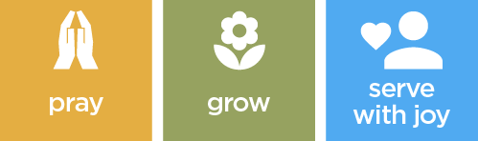

The priest may give some brief notices
The Concluding Rites
The Lord be with you. And with your spirit.

May almighty God bless you, the Father, and the Son, ✠ and the Holy Spirit. Amen.
The Dismissal
Go forth, the Mass is ended. Thanks be to God

The Final Hymn

1. Jesus, humble was your birth
when you came from heaven to earth;
Every day in all we do,
make us humble, Lord, like you.
2. Jesus, strong to help and heal,
showing that your love is real;
Every day in all we do,
make us strong and kind like you.
3. Jesus, when you were betrayed,
still you trusted God and prayed;
Every day in all we do,
Help us trust and pray like you.
4. Jesus, risen from the dead,
with us always, as you said;
Every day in all we do,
Help us live and love like you.

The Angelus
The Angel of the Lord declared unto Mary.
And she conceived of the Holy Spirit.

Hail Mary, full of grace, The Lord is with Thee; Blessed art thou among women,
And blessed is the fruit of thy womb, Jesus.
Holy Mary, Mother of God, Pray for us sinners,
Now and at the hour of our death.

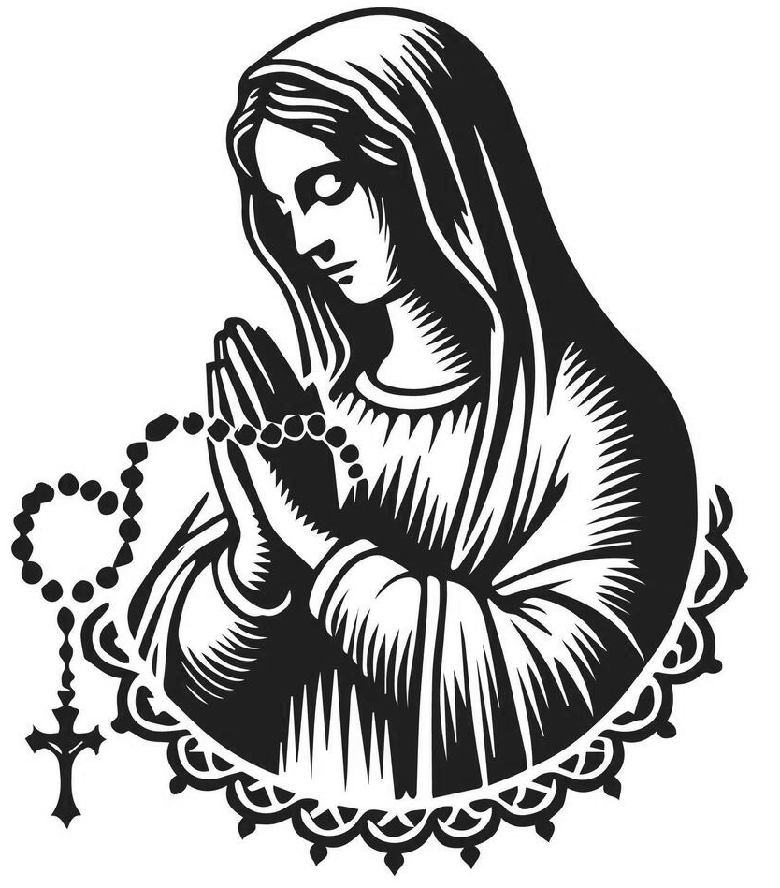
Behold the handmaid of the Lord.
Be it done to me according to thy word. Hail Mary. . .

And the Word was made flesh.
And dwelt among us.
Hail Mary…

Pray for us, O holy Mother of God.
That we may be made worthy of the promises of Christ.

Let us pray:

Pour forth, we beseech Thee, O Lord, Thy grace into our hearts, that we to whom the Incarnation of Christ Thy Son was made known by the message of an angel, may by His Passion and Cross be brought to the glory of His Resurrection. Through the same Christ Our Lord. Amen.

For Prayer

Those who have asked for our prayers…. Denise, Janice Allin, Leslie Porch,
Sheila Tucker, Tina Smart, Kathy Haydon, Bobby Lilicrap, June Brock,
Emma Addison, Georgie Maher, Ian Craggs, Brenda Alderson, Lois Tobin, Brenda Steed, Anne Lewis, Jenny Harvey, Jackie Morrison,
Fr Roger Beck, Anna, Gwen Lamb, Anna Lynch, Jackie Fisher, Helen Lewis,
Val Bradden, Cynthia Way, Pauleen Stewart, Amelia Coughlan, Roger Lewis, Shaun Carrie, Fr Jon Bielawski, Catherine Samuel’s

Recently Departed- Michael Olver, Sarah Cavey, Oliver Colvile

Anniversaries of Death
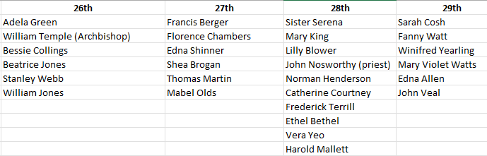
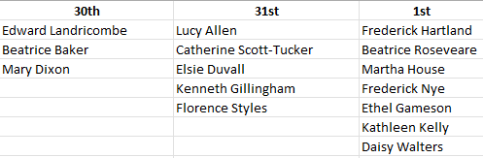

The Notices

PCC Meeting Wednesday 29th October 7.00pm at St Peter’s

Skittles and Pasty Evening- Saturday 1st November 7pm- at St Francis-
Adults £5, Children £2- please book via Jenie Sturdy- 07952954319

Annual Memorial Service will be held on Sunday 9th November at 6.00pm. To order a candle please sign the sheets in various locations.

Christmas in Stonehouse is returning again this year and will be held on the 13th December. This year we hope to gather a Dementia friendly choir, which will meet on the three Thursdays prior to the event and then sing at the event, if you know somebody who could benefit from singing in this choir please contact Fr David.

Our warmest wishes and prayers to Bishop Nicholas Hudson on his appointment as RC Bishop of Plymouth.

Thank you to everyone who helped or supported our Autumn Fayer yesterday

The Mission Community of St Peter and the Holy Apostles
St Peter, Wyndham Square + St Thomas, Royal Navy Avenue + St James-the-Less, Ham Drive
A Church of England Parish in the care of the Bishop of Oswestry
Parish Priest Fr. David Way SSC: 01752 240119 fr.davidway@gmail.com
.com
Mission Development Minister/ LLM/ Parish Ordinand: Ben Otley 07939800544 benotley.mission.plym@gmail.com

Parish Website: plymouthstpeter.co.uk ~ FOR MUCH MORE INFORMATION ON EVENTS, ETC.

This week’s services
Sunday 26th-  The Thirtieth Sunday  in Ordinary Time  (Psalter Week 2) | 8.30am St Thomas Fr DCW  10.00am St Peter Fr MB | Mass with Hymns  Sung Mass
Monday 27th- Weekday in OT | St Peter 10.00am Fr PL | Mass
Tuesday 28th- St Simon and St Jude | St Peter 10.00am Fr DCW | Mass
Wednesday 29th- Weekday in OT | St Peter 10.00am Fr DCW | Mass
Thursday 30th Weekday in OT | St Peter 10.00am Fr DCW | Mass
Friday 31st- Weekday in OT | St Peter 10.00am Fr DCW | Mass
Saturday 1st November-  Weekday in OT | St Peter 10.00am Fr DCW | Mass
Sunday 2nd  All Saints Day (Transferred)  (Psalter Week 3) | 8.30am St Thomas Fr DCW  10.00am St Peter Fr DCW  6.00pm St Peter Fr DCW | Mass with Hymns  Sung Mass with Baptism  Evening Prayer and Benediction
St Peters is open daily 8.30am- 12noon- Place of Welcome, Place of Prayer, food larder etc.

Safeguarding: If you have any concerns regarding the safety of children and others who are vulnerable, regardless of age, you must tell the Duty Priest or our parish Lay Safeguarding Representative- Jackie Morrison- email randj49@gmail.com Tel 07848859124.
For online donations please scan the QR code

