Acrise Church News: October 2025
Church Services for October (all at 9.30am)
Sunday 5th October Holy Communion Carol
Sunday 12th October Matins BCP Paul
Sunday 19th October Morning Prayer Bill
Sunday 26th October Service of the Word Diana
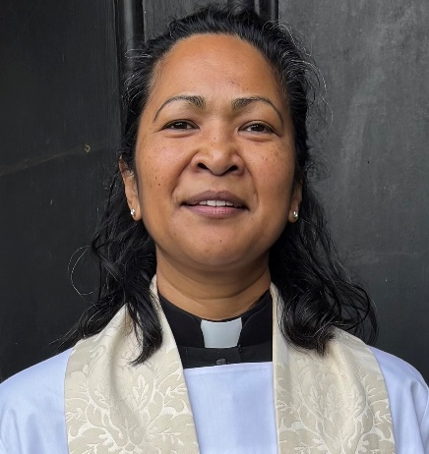
The Rector’s Message
’The Parable of The Lost Sheep is one of my favourites. It is a reminder of the extent that God will go to seek and to save those who are lost, those who are the least and those left out.
Why?
Because no one is to be lost from God’s love.
Nothing can separate us from the love of God - not even death. There is no place that Jesus will not go in order to find us and bring us safely home.
Dear Lord, help me to respond to your love and mercy upon my life by choosing to show your love and mercy to others, rejoicing with you whenever lost souls are found by you. Amen

Harvest Family Service on Sunday 28th September
This was a varied and active event enjoyed by a congregation of 37, which included 10 children. Thanks to Janet for leading the service, to Irene for playing the organ, and to the adults and children who read the scripture passages and prayers. It was good to see some of the younger children having the confidence to read. As well as the traditional harvest hymns the Harvest Samba enlivened the proceedings. Thanks also to Alison and others who provided the refreshments.
The theme of the service was giving thanks for God’s gift of creation, the natural world and the sun, rain and soil which enable crops to be grown to provide us with food.
Activities included writing thank you messages on golden leaves which were displayed on a small tree at the back of the church. The children then made autumn lanterns which reflected the colours of the season. Everyone was invited to help Janet create ‘grace’ prayers and boxes, to be used to give thanks at mealtimes.
After the prayers generous donations for Shepway Foodbank were taken up to the altar and blessed. These will be added to at our Harvest Holy Communion on 5th October.
At the end of the service everyone went out to the green where a plaque commemorating the planting of a hedge for Queen Elizabeth 2nd’s Platinum Jubilee in 2022 was erected and Janet gave a blessing. Finally, the children, and some adults, took great delight in throwing biodegradable confetti from a recent wedding over the hedge. You can see in the photo how well the hedge has grown.

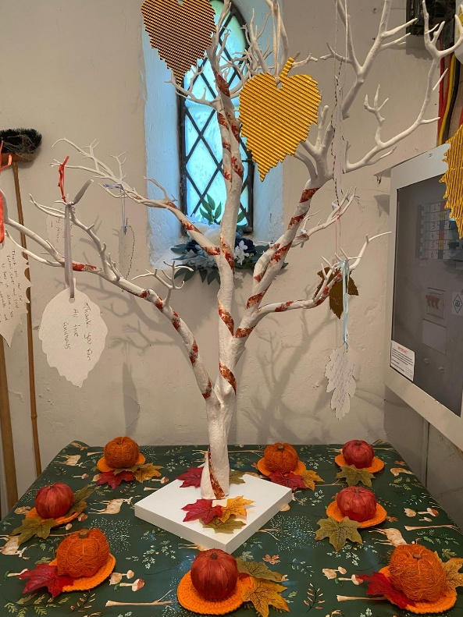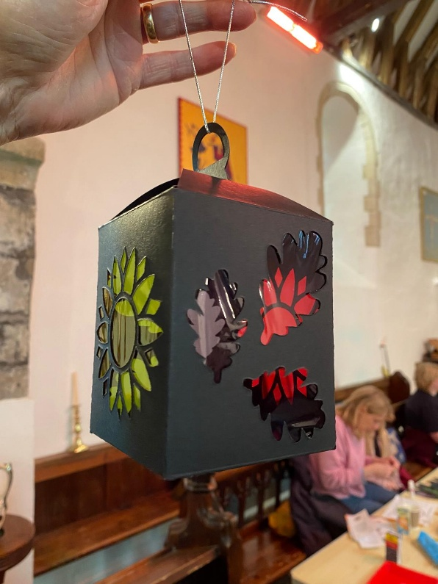

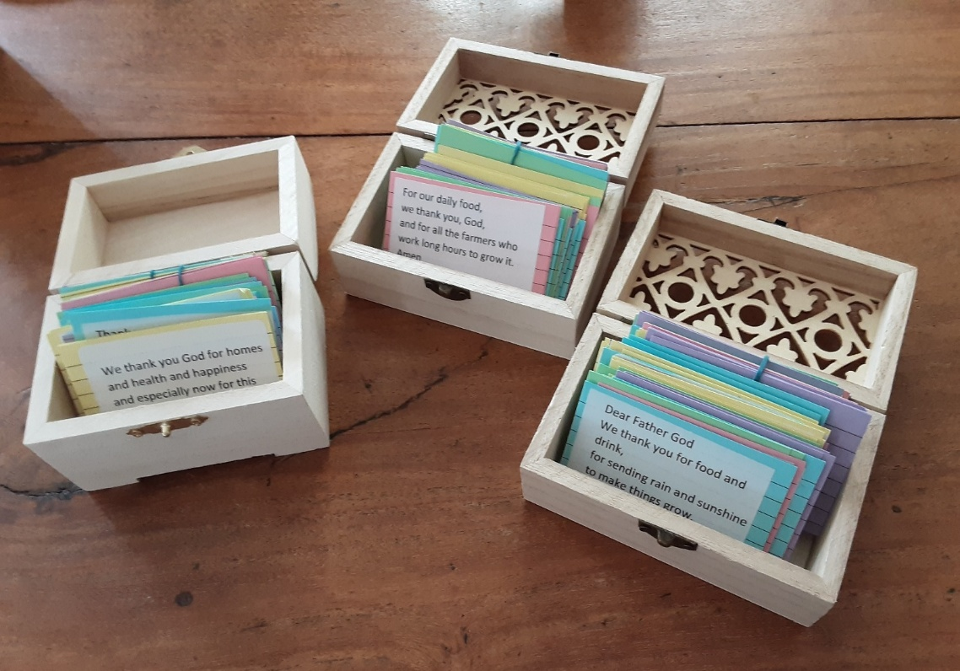
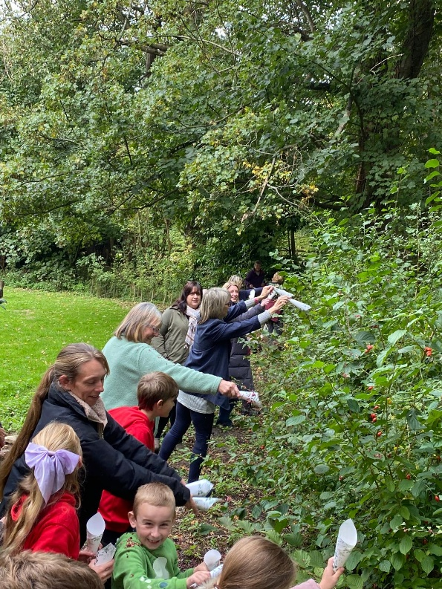
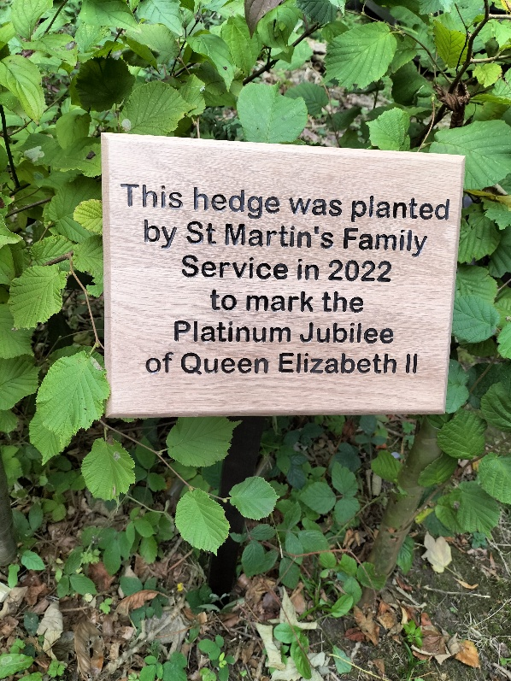
Ride and Stride for Kent Churches
This took place on Saturday 13th September and was the 40th Anniversary of the event. Unfortunately, the weather was wet and stormy in the morning with showers continuing in the afternoon, but it did clear up later in the day.
For St Martin’s Richard walked around the Canterbury churches and Sue and Mike went to the Folkestone and Cheriton churches. Between us all we visited 31 churches and raised £325. Many thanks to all who sponsored us. Thanks also to those who volunteered to sit in the church to welcome visitors though this became impossible to do in the afternoon because of the rain and a wedding. We haven’t yet applied for a grant from Friends of Kent Churches but may need to in future. Because our church has supported the Ride and Stride since it began, we should be in a strong position.
Half the money raised will come back to church funds.
Flower and Cleaning Rota
If anyone could spare a few hours every few months to join the flower and/or cleaning rota this would be welcome. You will be shown what to do and do not need to be a flower arranger. Please contact Sue on sue1954prebble@gmail.com or ring 01303844640 if you could help.
Christmas Fair at Elham Village Hall on Saturday 29th November
Note that the Christmas Fair is a week earlier than usual.
10.00 am until 2.00 pm. There will be the usual stalls, raffle and tombola, Father Christmas and festive refreshments.
To book a table please phone 01303 892364 (answer phone)
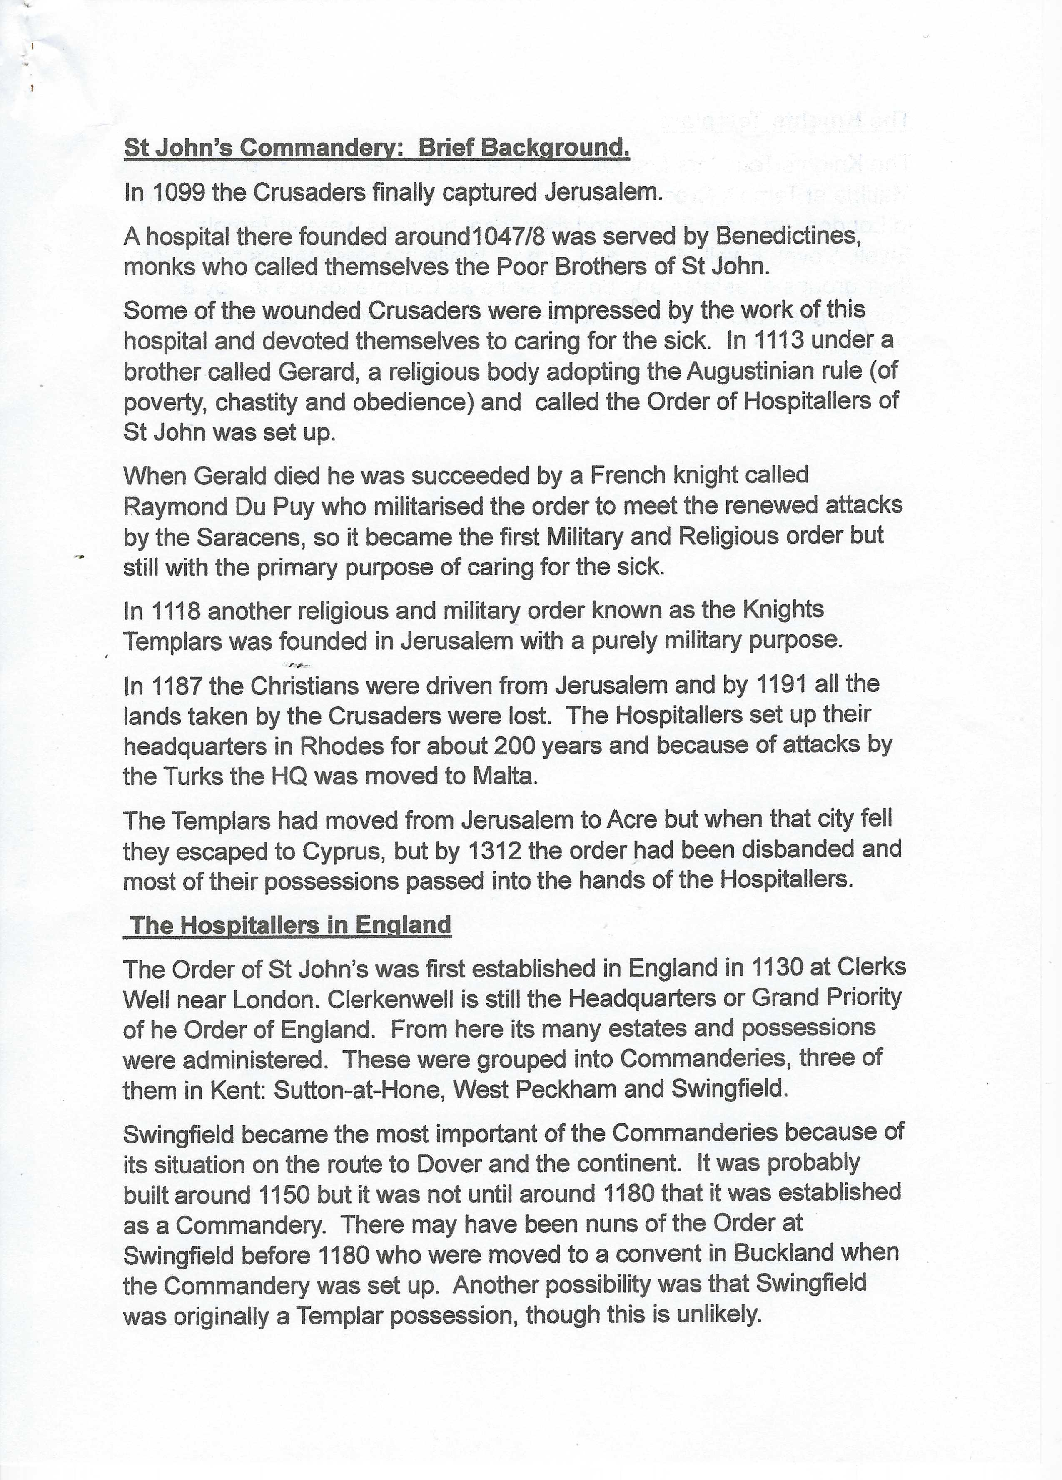

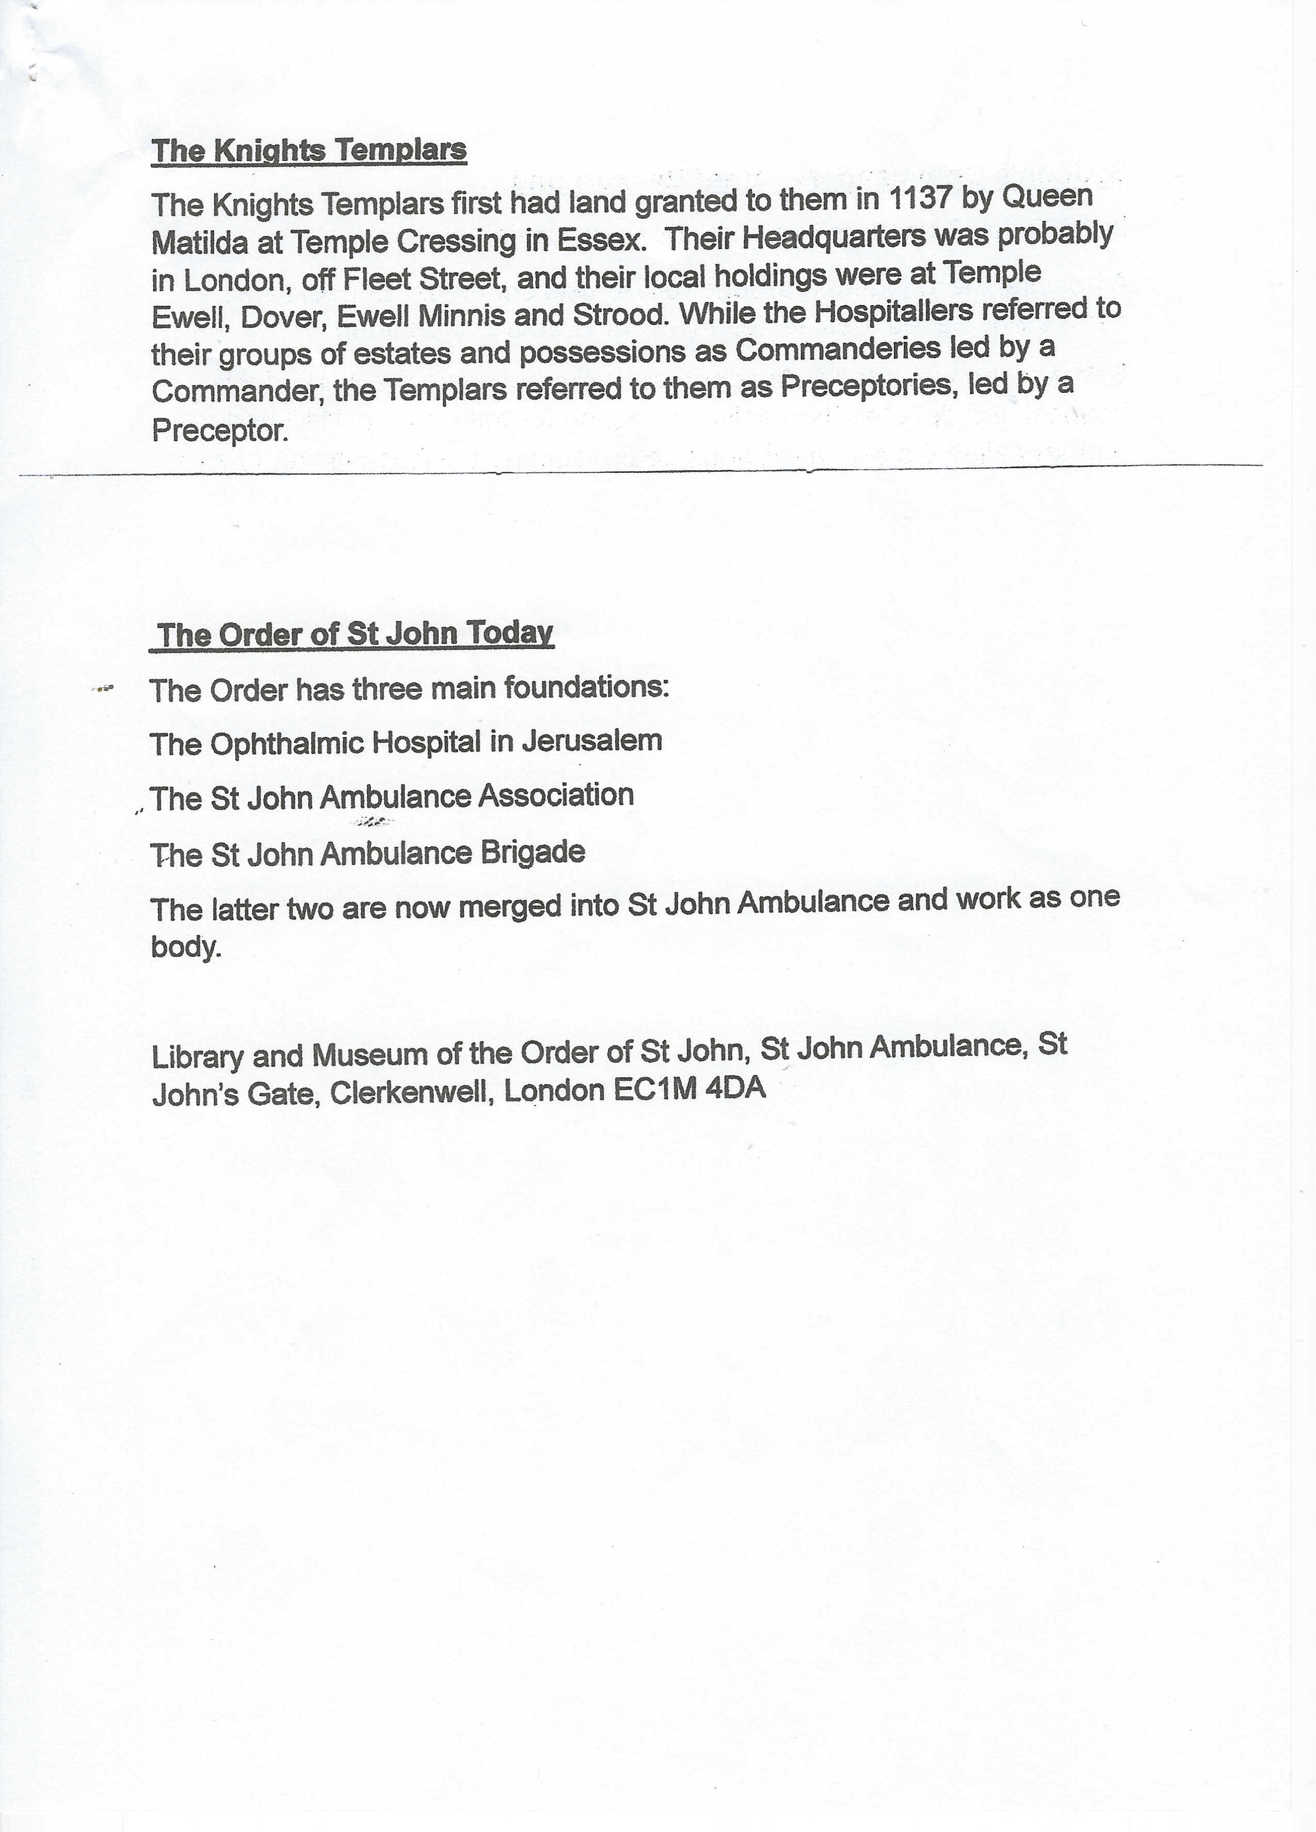
Very brief history above. A Timeline for the Commandery from 1150 until 1950 will be in next month’s Acrise Church News.

