** SPIRE & LIGHT United Churches**

United Benefice of St Keverne, St Ruan with St Grade & St.Wynwallow (The Lizard)

**\*If you do not wish to receive these notices, please let your Churchwarden know\***

**19th October 2025**

***Trinity 18***

**Readings**

**Genesis 32:22-31**

**Psalm 121**

**2 Timothy 3:14 - 4:5**

**Luke 18:1-8**

9.30am –– Holy Communion - St.Peter’s, Coverack

9.30am – Morning Prayer – St.Wynwallow, The Lizard

11am – Morning Prayer - St.Keverne

11.15am – Family Service – St.Ruan, Ruan Minor

3pm – St.Mary’s, Cadgwith – Sea Harvest

Next week – Sunday October 26th

9.30am – Morning Prayer – St.Peter’s, Coverack

9.30am – Holy Communion - St.Ruan, Ruan Minor

11am – Holy Communion – St.Keverne

11.15am – Café Church – St.Wynwallow, The Lizard



**The Prayer Spot**

We belong to a Benefice of six churches of The Lizard, Ruan, Grade, Cadgwith, Coverack, St Keverne. We have a duty of care to all those in our churches to be together in all we do in the name of Jesus Christ our saviour. God has given us this great gift of prayer - to pray for God's help and guidance in our lives and the lives of others and to ask God to be with us all in all we do in God's name.

Please pray for –

* those in our community who need God's help in their lives which can sometimes can be difficult.
* the people of the Ukraine who need God's help in these difficult times - we pray they will have God's presence in their lives.
* for all those who need hospital treatment, that God will be present with them and their family and will meet their needs.
* the churches in our Benefice - that God will be with us all, giving us the gifts of love to share with all our church members.
* for our Clergy, that God will guide them in all they do for us. Give them the gifts they need. We thank you heavenly Father for those gifts given to us of forgiveness, kindness, justice, generosity and peace - all gifts to share with others.

Remember God is ever present in your life and will answer your prayers in Jesus Christs wonderful name. Be blessed in all you do.

*Faithful Father, we begin today by giving you thanks. Your love endures for ever, it never fails. Though there are many ways in which we have failed we have not exceeded the supply of your mercy and grace. We thank you for revealing yourself to us through your word. As we open the Bible today, we pray we would hear your voice. We ask that your Holy Spirit would be at work, in opening our ears to hear and our hearts to receive your word. May we be transformed into your likeness. Through Jesus Christ our Lord, Amen*

Sam Buchanan

***The Diocese of Truro’s Prayer Diary for this week***

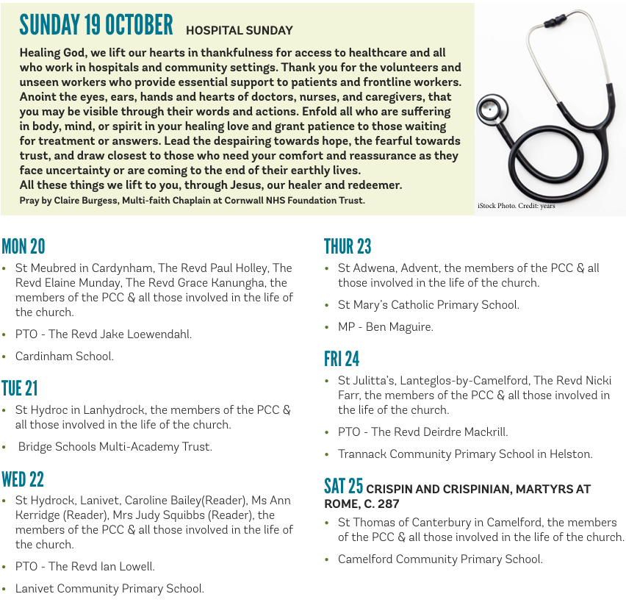

**On the Way Prayers**

“Let nothing disturb you. Let nothing frighten you. All things are passing away: God never changes. Patience obtains all things. Whoever has God lacks nothing; God alone suffices.” (St Teresa of Avila)

Dear Lord we ask that you will make us all more patient. Help us not to get frustrated in our daily lives when things don’t move as quickly as we’d like; when we have to wait on the phone for ages to actually get to talk to someone, when we’re queuing in the supermarket, or waiting for traffic to move. Give us more patience when, in our Deanery and Diocese, appointments to key posts seem to take forever or we can’t get to talk to people when it’s convenient for us. Give us more patience in our own churches – with the people and the things that frustrate us. Help us always to remember that “patience obtains all things”!

Let us also keep remembering that God never changes, but that he will always be with us through change, through troubled or tough times, and as we change and evolve to respond to the world around us, he will still be constant – always there, always caring and always listening to our prayers. Lord help us to remember this.

This week has seen jubilant scenes in both Israel and Gaza. Prince of Peace we pray that this really is the start of a lasting peace. We give thanks for all the hostages and prisoners who have been released back to their families, but we feel the sadness of those Palestinians who realise they have nothing to go back to. We pray too for all the world leaders meeting to plan for the rebuild of Gaza. Let us pray too for peace in Ukraine and it’s people still scattered throughout the world as refugees.

Now let’s pray for anything or anyone who needs the comfort of our collective prayers right now. And we give thanks that Kirsten and Jamie have a new baby boy, praying for the whole family and for all families who have recently welcomed a new addition.

Finally we pray for each other, for the problems that we each harbour in our hearts, for the things that keep us each awake at night and for the strength to keep going, to keep our own churches alive and our communities drawn to both the vibrancy and the peace and tranquillity that can be found in the walls of our beautiful buildings.