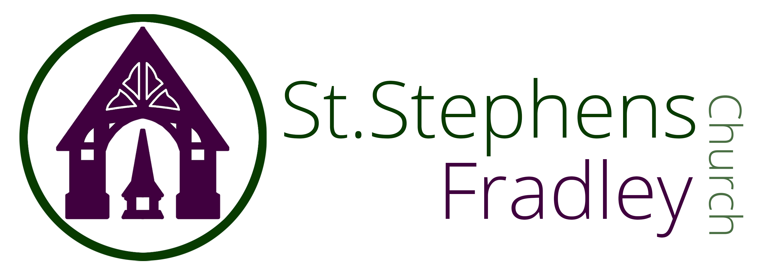
WELCOME!
ST STEPHEN’S CHURCH IS OPEN
10am-3pm daily
for Private Prayer and Reflection

BULLETIN
19th October 2025
Eighteenth Sunday after Trinity
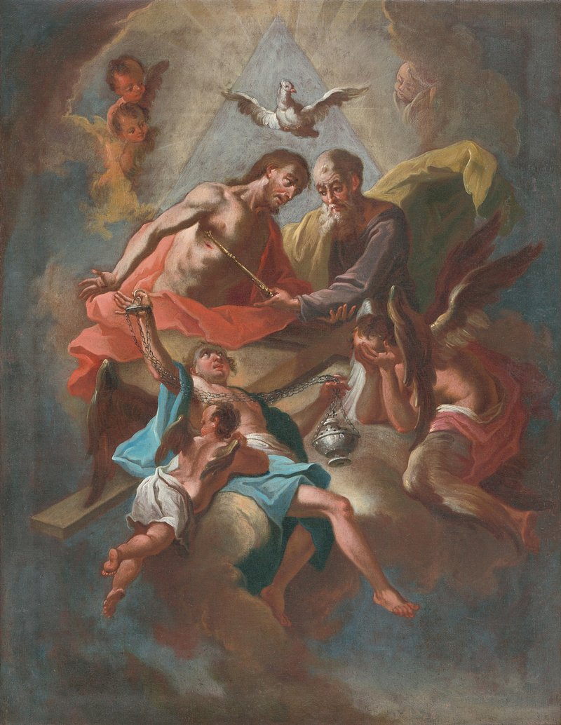
10.30am Family Communion
The Music Group will be leading music at this service
Celebrating St. Luke

Notices for inclusion in the bulletin please email to me by Tuesday of each week
officeststephenfradley@gmail.com
Please take Bulletin away with you

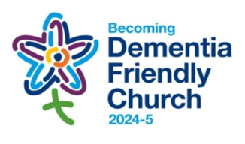

Diary Dates

October 2025

Sunday 19th 10.30am Family Communion
We are celebrating St. Luke,
Doctor and Evangelist

Saturday 25th October
10am-12 noon Coffee Morning
with Bacon baps, coffee and Cake
10am-12 noon Churchyard Clear up

Sunday 26th 10.30am Family Communion

Refreshments are served after every service



Welcome to our Worship today
If you are visiting for the first time, please introduce yourself so that we may welcome you personally

19th October 2025 St Luke

Collect
Almighty God,
you called Luke the physician whose praise is in the gospel,
to be an evangelist and physician of the soul:
by the grace of the Spirit and through the wholesome medicine of the gospel, give your Church the same love and power to heal;
through Jesus Christ your Son our Lord,
who is alive and reigns with you,
in the unity of the Holy Spirit, one God,
now and for ever.

Readings
Isaiah 35. 3-6 2 Timothy 4. 5-17 Luke 10. 1-9

Post Communion
Lord God,
the source of all truth and love,
keep us faithful to the apostles’ teaching and fellowship,
united in prayer and the breaking of bread,
and one in joy and simplicity of heart,
in Jesus Christ our Lord.

ST STEPHEN’S CHURCH


COFFEE MORNING

SATURDAY 25TH OCTOBER
10AM – 12 NOON

A FUNDRAISER FOR
St Stephen’s Church Fradley

Bacon Baps Coffee and Cakes
Raffle Homemade Produce





ST STEPHEN’S CHURCH

AUTUMN
CHURCHYARD
CLEAR-UP

SATURDAY
25TH OCTOBER
10AM-12 NOON

PLEASE come and help

Delicious Refreshments Available

Bring your gardening utensils
Rakes, Wheelbarrows, Brushes, Garden Shears,
Hand forks, Hedge Cutters

Forthcoming Events

November 2025

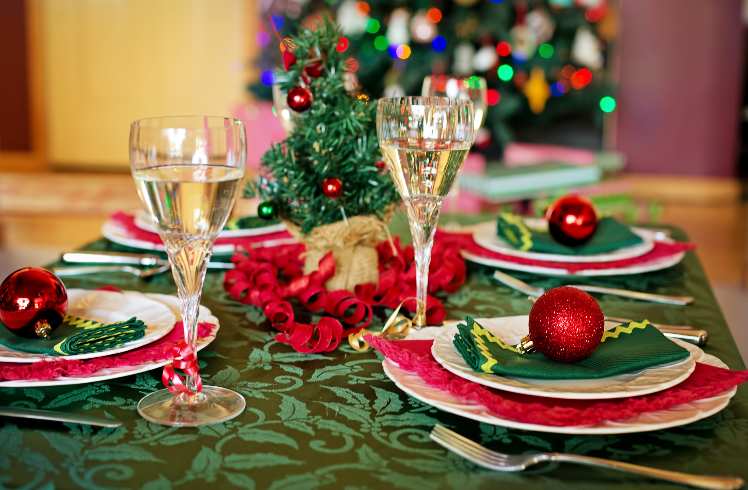

Sunday 23rd Christmas Meal at The Swan at Fradley Junction

****


Friday 28th Iva’s Christmas Quiz. 7.00pm Community Hall. Quiz with children’s only round. Raffle. Teams of 4 or 6

Saturday 1st November
at All Saints Church Alrewas
3pm All Souls Service
Commemorating the Faithful Departed
All are welcome
If you would like the name of a loved one commemorated at this service please sign the sheet at the back of church
or email Rev Elizabeth Wall ayton265@gmail.com

Benefice Service
at All Saints Church, Alrewas
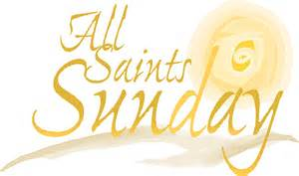

2nd November
10am Family Communion
celebrating All Saints

We welcome the Rt Revd Dr Tim Wambunya
Bishop of Wolverhampton
to preside and preach at this service
Do join us!

Can you help to support St Stephens Church?
St Stephen’s Church is heavily dependent on voluntary donations and income from events in order to fulfil its ministry to the local and wider communities.
If you would like to support us at this time,
donations can be made via our Just Giving page.
We are grateful for any donation, large or small.

https://www.justgiving.com/
fundraising/ststephensfradley

Contact us
Revd. Elizabeth Wall
01543 254891
Email: ayton265@gmail.com

Churchwarden
Marian Derry
01283 791573

St Stephen’s Administrator: Di Cooper
07930162991
officeststephenfradley@gmail.com

Find us on
ACNY https://www.achurchnearyou.com/church/4123/
Face bookwww.facebook.comststephensfradley

DC 17/10/25

