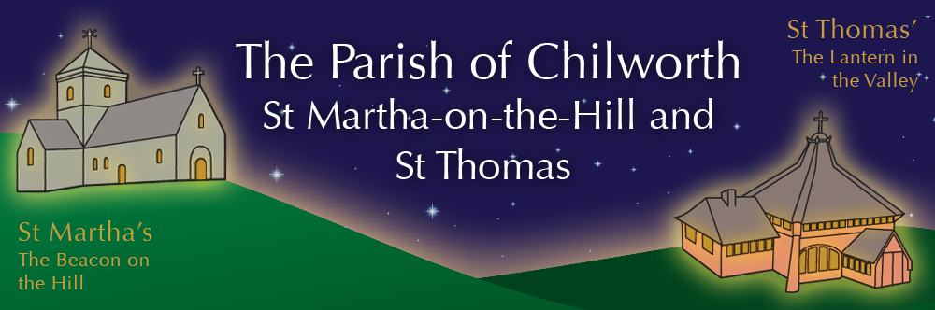

NOTICES: - 5th OCTOBER 2025
Priest David Oakden – Revdavid@parishofchilworth.org.uk - 01483 534293 (day off Friday)
Do let me know of anybody or anything that you would like to be prayed for.
www.parishofchilworth.org.uk and find us on https://www.achurchnearyou.com

***********Psalm 25:1-2(NLT)********
O Lord, I give my life to you. I trust in you, my God! Do not let me be disgraced or let my enemies rejoice in my defeat.
***********************************

Opportunities to pray together: -
Ecumenical Prayer Breakfast 1st Saturday of the month at the Vicarage, from 9am, prayer, coffee and croissant. Next is the 1st November – Thursday evening at St Thomas at 7:30 pm for an hour every other week. ** 16th October.

This Sunday Services: – 16th after Trinty
09:30 St. Thomas – Family Harvest.
11:15 St. Martha’s – BCP Mattins.
14:00 St. Martha’s – Dog Blessing Service.

Next Sunday Services: - 12th October
09:30 St. Peter’s & St. Pauls – Morning Prayer.
11:15 St. Martha’s – Harvest Communion.

Looking further ahead: -
Chilworth Tinies and Toddler Group: St T’s Monday 9:15 – 10:30am
Family Harvest: 5th Oct St T’s 09:30am
B&S Harvest Lunch: 5th Oct St T’s 12:00
Dog Blessing Service: 5th Oct St M’s 14:00
Harvest Communion: 12th Oct St M’s 11:15

Food & Hygiene Bank: -
The Foodbank Larder box is now located in the porch of St Thomas Church. Suggested items are: - Long life milk /tins tuna/ tins meat/ sachets microwaveable rice /pasta sauces/curry sauces/cereal/spreads/ tea/ coffee/ hot chocolate/ tins soup/ baked beans.
The need is great and growing, the Foodbank is struggling to keep up with demand – both through gifts and funds. Please consider if you are able to assist, especially as the autumn is now upon us.
Donations at St Martha’s during services can now be made electronically via our Card Reader.

Chilworth Tinies and Toddler Group: -
Mondays from 9:15 -10:30 meet in St Thomas, play chat, pray and support.

Dog Service 5th October: -
Annual Dog Service at St Martha’s 2pm on 5th October.

Harvest Lunch 5th October: -
A cold Bring and Share Harvest Lunch at St Thomas’ after the service on 5th October at 12.00 with a ‘Ploughman’s theme. A Sign up sheet is at the back of the church – suggested contributions inc bread, cheese, ham, pickles / chutneys, salad items and / or drink. Food is set out buffet style and all are welcome to come and share. Financial contributions can be made, in lieu of food contributions, to Chilworth Foodbank.

Harvest Communion 12th Oct St M’s: -
Celebrate, and bring gifts suitable for the food bank.

Christian Resources Exhibition: -
Sandown Park 15-16 October, oodles of exhibitors showcasing their wares. Worth a visit if you have never been before, plenty of parking, and everything for church, services, youth, etc. etc.

Alexandra Birthday: -
Help Alexandra celebrate her 100th birthday on the 12th October at our Harvest Communion service.

Autumn Sale, Gingerbread & Hot Chocolate: -
Saturday 15th November at St T’s - our Autumn Sale with Gingerbread & Hot Chocolate from 11.00 – 3.00pm. Usual stalls plus various craft stalls and a ‘recycle your last year’s Christmas Gifts’ tombola to get you in the mood for Christmas gift buying. Donations of cakes and gifts welcome. Contact Carole on shattocks@hotmail.com or call 07711 864 488 with offers of help or to have your own stall.

Shoe Box Appeal
We are joining with Albury parish church in filling shoeboxes during October with items to provide Christmas gifts for young / adult / elderly males and females. For more information on contents and shoe box filler ideas please contact Linda on Linda.Holden1@btinternet.com who will liaise with the Albury church co-ordinators. Thank you

