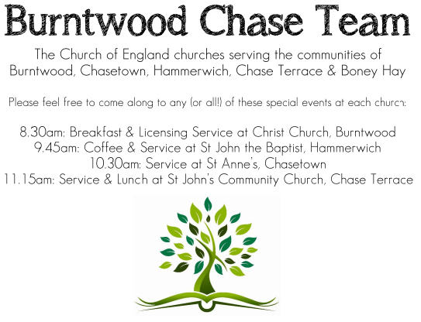 CHRIST CHURCH
SUNDAY 19th October 2025 at 10am

SERVICES:
Sunday 19th October 2025
Holy Communion
18th Sunday after Trinity

Readings:
Jeremiah 31: 27-34
²⁷ The days are surely coming, says the Lord, when I will sow the house of Israel and the house of Judah with the seed of humans and the seed of animals. ²⁸ And just as I have watched over them to pluck up and break down, to overthrow, destroy, and bring evil, so I will watch over them to build and to plant, says the Lord. ²⁹ In those days they shall no longer say:
‘The parents have eaten sour grapes,
and the children’s teeth are set on edge.’
³⁰ But all shall die for their own sins; the teeth of everyone who eats sour grapes shall be set on edge.
³¹ The days are surely coming, says the Lord, when I will make a new covenant with the house of Israel and the house of Judah. ³² It will not be like the covenant that I made with their ancestors when I took them by the hand to bring them out of the land of Egypt—a covenant that they broke, though I was their husband,^{[a]} says the Lord. ³³ But this is the covenant that I will make with the house of Israel after those days, says the Lord: I will put my law within them, and I will write it on their hearts; and I will be their God, and they shall be my people. ³⁴ No longer shall they teach one another, or say to each other, ‘Know the Lord’, for they shall all know me, from the least of them to the greatest, says the Lord; for I will forgive their iniquity, and remember their sin no more.
Luke 18: 1-8

Then Jesus told them a parable about their need to pray always and not to lose heart. ² He said, ‘In a certain city there was a judge who neither feared God nor had respect for people. ³ In that city there was a widow who kept coming to him and saying, “Grant me justice against my opponent.” ⁴ For a while he refused; but later he said to himself, “Though I have no fear of God and no respect for anyone, ⁵ yet because this widow keeps bothering me, I will grant her justice, so that she may not wear me out by continually coming.” ⁶ And the Lord said, ‘Listen to what the unjust judge says. ⁷ And will not God grant justice to his chosen ones who cry to him day and night? Will he delay long in helping them? ⁸ I tell you, he will quickly grant justice to them. And yet, when the Son of Man comes, will he find faith on earth?’

COLLECT FOR TODAY
Almighty and everlasting God,
increase in us your gift of faith
that, forsaking what lies behind
and reaching out to that which is before,
we may run the way of your commandments
and win the crown of everlasting joy;
through Jesus Christ your Son our Lord,
who is alive and reigns with you,
in the unity of the Holy Spirit,
one God, now and for ever.

WHAT’S GOING ON
Upcoming Services

Sunday 26th October Morning Worship 10am
Wednesday 29th October Morning Prayer 9.30am
Saturday 1st November Art Cafe 3-5pm
Sunday 2nd November Holy Communion 10am
Monday 3rd November Cameo Cafe 10-12noon

DEANERY CONFIRMATION SERVICE
Sunday 26th October 2025 at 5pm
At Christ Church, Gentleshaw
With the Bishop of Wolverhampton, the Right Rev’d Dr Timothy Wambunya

Christmas Fayre

Our Christmas Fayre will be on Saturday 15th November, 2-4pm.
Any help to set up would be very much appreciated.

FLOODLIGHTING
If you think about commemorating a special occasion by floodlighting our Church. Please contact Chris Brown on 01543 683862 for details.

PRAYER CHAIN
Christ Church is blessed with a very active prayer chain. If you, or anyone you know, feel that they would like others to pray for them, please speak to Chris Brown on 01543 683862.

HOME COMMUNION
For anyone who is unable to attend church and would like Home Communion,
Steve Morgan is able to carry this out.

VICAR CONTACT DETAILS
Stephen Morgan Tele: 07305 852152
CHURCH WARDENS CONTACT DETAILS
Judith Rogers Tele: 01543 324718
Mike Holmes Tele: 01543 672970
Church Office Tele: 01543 642187 [leave a message and we will respond]
Church Web Site:www.christchurchburntwood.org.uk
Church Email: christchurchburntwood15@gmail.com
Facebook: www.facebook.com/group/christchurchburntwood/

Other Contacts
Matt Wallace St. John’s, Chase Terrace— Tele: 01543 670078
Richard Westwood St. Anne’s, Chasetown—Tele: 01543 686111

NEXT SUNDAY SERVICE
Sunday 26th October at 10am
Morning Worship
Joel 2: 23-31
Luke 18: 9-14
Last Sunday after Trinity

