** SPIRE & LIGHT United Churches**

United Benefice of St Keverne, St Ruan with St Grade & St.Wynwallow (The Lizard)

**\*If you do not wish to receive these notices, please let your Churchwarden know\***

**12th October 2025**

***Trinity 17***

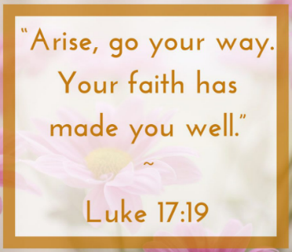**Readings**

**2 Kings 5:1-3, 7-15c**

**Psalm 111**

**2 Timothy 2:8-15**

**Luke 17:11-19**

9.30am – Morning Prayer – St.Peter’s, Coverack

9.30am – Holy Communion - St.Ruan, Ruan Minor

11am – Holy Communion (Mohegan Anniversary) – St.Keverne

11.15am – Café Church – St.Wynwallow, The Lizard

3pm – St.Grade – Harvest Evensong

Next week – Sunday October 19th

9.30am –– Holy Communion - St.Peter’s, Coverack

9.30am – Morning Prayer – St.Wynwallow, The Lizard

11am – Morning Prayer - St.Keverne

11.15am – Family Service – St.Ruan, Ruan Minor

3pm – St.Mary’s, Cadgwith – Sea Harvest

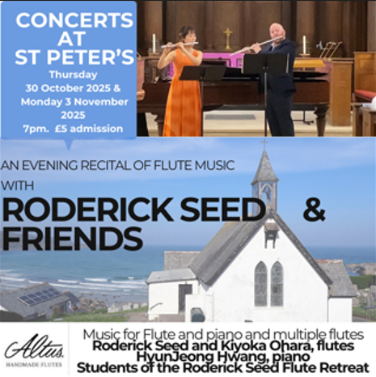

**The Prayer Spot**

We belong to a Benefice of six churches of The Lizard, Ruan, Grade, Cadgwith, Coverack, St Keverne. We have a duty of care to all those in our churches to be together in all we do in the name of Jesus Christ our saviour. God has given us this great gift of prayer - to pray for God's help and guidance in our lives and the lives of others and to ask God to be with us all in all we do in God's name.

Please pray for –

* those in our community who need God's help in their lives which can sometimes can be difficult.
* the people of the Ukraine who need God's help in these difficult times - we pray they will have God's presence in their lives.
* for all those who need hospital treatment, that God will be present with them and their family and will meet their needs.
* the churches in our Benefice - that God will be with us all, giving us the gifts of love to share with all our church members.
* for our Clergy, that God will guide them in all they do for us. Give them the gifts they need. We thank you heavenly Father for those gifts given to us of forgiveness, kindness, justice, generosity and peace - all gifts to share with others.

Remember God is ever present in your life and will answer your prayers in Jesus Christs wonderful name. Be blessed in all you do.

*Faithful Father, we begin today by giving you thanks. Your love endures for ever, it never fails. Though there are many ways in which we have failed we have not exceeded the supply of your mercy and grace. We thank you for revealing yourself to us through your word. As we open the Bible today, we pray we would hear your voice. We ask that your Holy Spirit would be at work, in opening our ears to hear and our hearts to receive your word. May we be transformed into your likeness. Through Jesus Christ our Lord, Amen*

Sam Buchanan

***The Diocese of Truro’s Prayer Diary for this week***

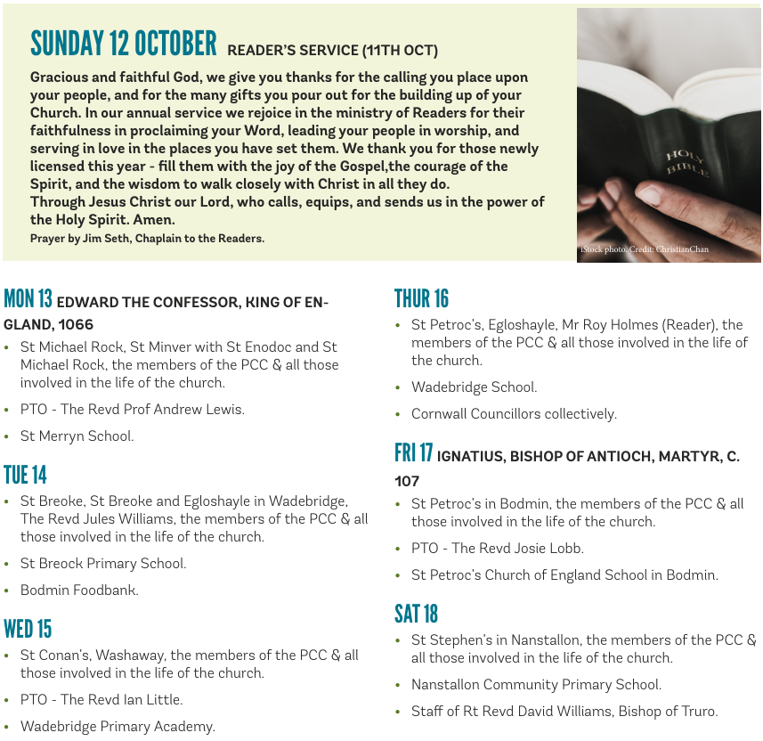

**On the Way Prayers**

Let’s start our prayers this evening by praying for the Church of England, particularly for Dame Sarah Mullally, the newly announced Archbishop of Canterbury. This is a momentous time in the Church of England and we pray that her appointment will bring stability, new life and energy to our church. And we pray for our Diocese, for David and Hugh our Bishops and Clive our Archdeacon. We pray too for our small corner of your church here in Kerrier – that we will all grow in faith and bring others to faith. Lord we ask for your blessing on Claire Thomson who is to be licensed as a Lay Reader at the Cathedral on Saturday. We pray that more people will come forward to train as local lay ministers.

We give thanks for all who minister in our churches and communities and for our Deanery Implementation Team as it works on the profile for the third stipendiary post, praying that people will be called to apply. We give thanks for the learning that goes on in our Deanery and particularly for Robert as he leads the sessions of 1 Corinthians. Lord, we know that we are on a journey, but we trust that you are with us, showing us the way.

All the unrest, both political and racial, wars and violence, can make us doubt. We know how important it is to pray for peace. Let us take a moment to bring before you the Holy Land, as the world commemorates the second anniversary of the Hamas attack on all those young people, we pray for an end to the atrocities in Gaza, for the violence and hatred that the conflict there is spreading throughout your world. We pray for all Jews in our communities – that they can still go about their daily lives without fear. Let us also remember the ongoing conflict in Ukraine. Prince of Peace bring peace to your world, to our community, to our homes and into our hearts.

We give thanks that we are blessed to live in a place of peace and incredible beauty. The recent harvest moon was a magnificent display of your glorious world. Most of our churches have now celebrated harvest and are preparing for the winter months that lie ahead. Let us pray for our farmers, fishermen and all those involved in the tourist industry as they prepare for the quieter, colder, winter months. And our churches also enter a new period – a time of reflection, remembrance and rejuvenation. Let us now pray for anyone or anything that is large in our minds and hearts at the moment.