
SPIRE & LIGHT United Churches
United Benefice of St Keverne, St Ruan with St Grade & St.Wynwallow (The Lizard)

*If you do not wish to receive these notices, please let your Churchwarden know*

2nd November 2025
All Saints/All Souls

Readings All Saints
Isaiah 1:10-18 Daniel 1:1-3, 15-18
Psalm 32:1-8 Psalm 149
2 Thessalonians 1 Ephesians 1:11-end
Luke 19:1-10 Luke 6:20-31

9.30am –– Holy Communion - St.Peter’s, Coverack
9.30am – All Saints/All Souls – a contemplative service including Holy Communion, to remember loved ones departed – St.Wynwallow, The Lizard
11am – Morning Prayer (Said BCP) - St.Keverne
11.15am – Morning Prayer – St.Ruan, Ruan Minor
4pm – All Soul’s Service (a contemplative service to remember loved ones departed – St.Keverne

REMEMBRANCE SUNDAY – Nov 9th

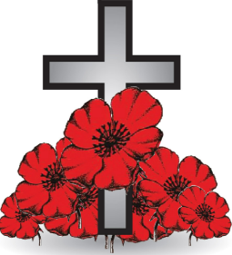
10.40am – St.Keverne
10.45am – St.Ruan
10.45am – St.Wynwallow
12.30pm – St.Peter’s
3pm – Evensong – St.Grade


Tickets also available at Tregullas Farm Shop, The Lizard


The Prayer Spot
Lord Jesus Christ, as we pray today, please be with us and guide us in all we do and say in your wonderful name.
Help us to remember that you are a God who cares, who understands and who meets all our needs. We pray for the benefice and Deanery we belong to and we thank you for the faithful people you have brought together.
Remind us that we have been brought to faith by our saviour Jesus Christ to enjoy our time together. We thank you Lord Jesus for your presence in our lives and the love you have given us to share with others. Keep us strong in our faith and close to you. Help us to be always there for others in their time of need.
You have given us gifts to use, to reach out to give comfort to those around us who are in need.
Heavenly Father we live in a world that is slowly destroying itself, through greed, hatred and with no care or concern for others. Remind us that we can bring love, care and understanding into the world by reaching out into our communities and showing our love to all. We pray for those in our communities who need Gods help as they care for others, for those in need of hospital care but also those who look after them.
Loving God, be with us always. Remind us daily we are brothers and sisters in Christ, that God is ever present in our lives, through his wonderful Holy Spirit that he gives us freely. God Bless you all
O Lord our rock and Redeemer, guide our thoughts and our words in our discussions today. Let our hearts be filled with your praise. Let us never forget the good things you do for us. You have forgiven our sins. You have rescued us from death. You have crowned us with love and tender mercies. Renew our strength and refresh our souls. Through Jesus Christ our Lord, Amen
Sam Buchanan

The Diocese of Truro’s Prayer Diary for this week

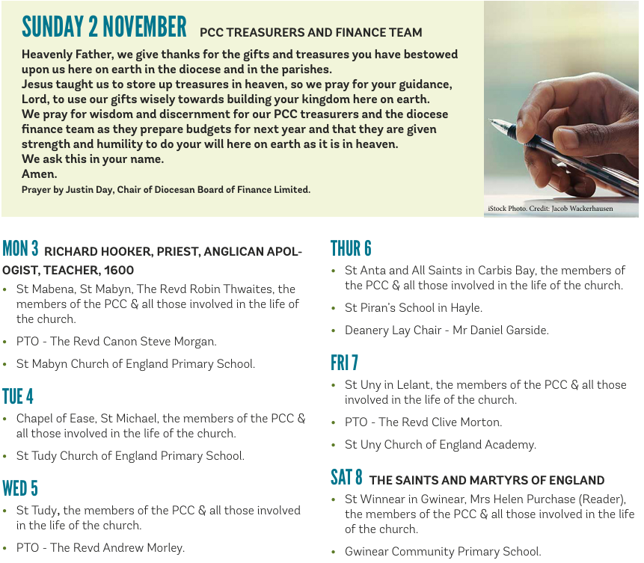

On the Way Prayers

As we enter this period of Remembrance, let us for a moment remember one of our loved ones who we see no longer. We pray for all those suffering with dementia, who can no remember even who their loved one is. Lord we thank you for memories, some may worry us but many can bring us great joy.

A reflective prayer for All Hallows Eve: Lord, we will face all that most concerns us: our fears, the shadowed places of the mind; the coming of winter darkness; the cold thin place between waking and sleep. We call to mind the powerless, the lonely, those who most fear the knock at the door; all those deceived by the world’s empty promises; all those cowed by menaces or threats. We stand with those weak in body, mind or spirit and those seduced by treats or hurt by tricks. Lord, your light shines into every darkness. You told us: pray ‘deliver us from evil’. Your Spirit gives us hope, gives us courage, a candle in the window unhurt by the wind.
A prayer for All Saints Day: Almighty and everlasting God, we praise your holy name for all the saints throughout the ages who have kept the lamp of faith burning brightly. Grant that we who are following in their steps may keep that light shining, that the darkness of this world may be lit by him who is the light of the world, ever your Son, our Saviour, Jesus Christ.

A prayer for All Souls Day: God of time and space, in your hands you hold all that you have made. You breathe new life into all creation; and without you there is no life, for our lives are hidden in you. As we remember those we love, but see no longer, help us to believe that none are forgotten by you, and eternal rest grant to them, O Lord, and let perpetual light shine upon them. May their souls and all the souls of the faithful departed, through the mercy of God, rest in peace. Amen

As our children have been enjoying the freedom and fun of the half term break, let’s just take a moment to pray for them. Life is a game – help them Lord to play it. Life is an adventure, help them Lord to be daring and adventurous and learn through all their experiences. We pray that they will all be safe. And we pray for those of us who are planning on welcoming children into our churches on Friday to learn a little bit about this period of remembrance.

Now let’s just pray for anything that is troubling us right now, for anyone who needs the comfort of our collective prayers or to give thanks for something that has happened in our churches or communities this past week.

Finally we pray for each other, for the problems that we each harbour in our hearts, for the things that keep us each awake at night and for the strength to keep going, to keep our own churches alive and our communities drawn to both the vibrancy and the peace and tranquillity that can be found in the walls of our beautiful buildings.

And so until we meet again may God be within us, God be beside us, God be behind us, and God be before us. Amen

