Psalm 119: 129 to 136
Just a reminder you can find out more that is happening and get in touch via our website
https://allsaintschurchkirkhallam.enablecomcloud.co.uk/
or A Church Near You website
www.achurchnearyou.com/church/13402/
These are our two official, authorised websites, other sites may have our name but actually are nothing to do with the church.

Please stand, if able, and join in the verses in bold

Your decrees are wonderful;
therefore my soul keeps them.
The unfolding of your words gives light;
it imparts understanding to the simple.
With open mouth I pant,
because I long for your commandments.
Turn to me and be gracious to me,
as is your custom towards those who love your name.
Keep my steps steady according to your promise,
and never let iniquity have dominion over me.
Redeem me from human oppression,
that I may keep your precepts.
Make your face shine upon your servant,
and teach me your statutes.
My eyes shed streams of tears
because your law is not kept.

Glory be to the Father and to the Son and to the Holy Spirit,
as it was in the beginning, is now and ever shall be,
world without end. Amen
Distribution of Communion –currently the Priest will dip the communion wafer in the wine while we discern a safe way to bring the common cup back into worship, as we want everyone to feel included and safe. We also have gluten free wafers available.
A big ‘thank you’ to the students at
Kirk Hallam Community Academy
for making this Remembrance display
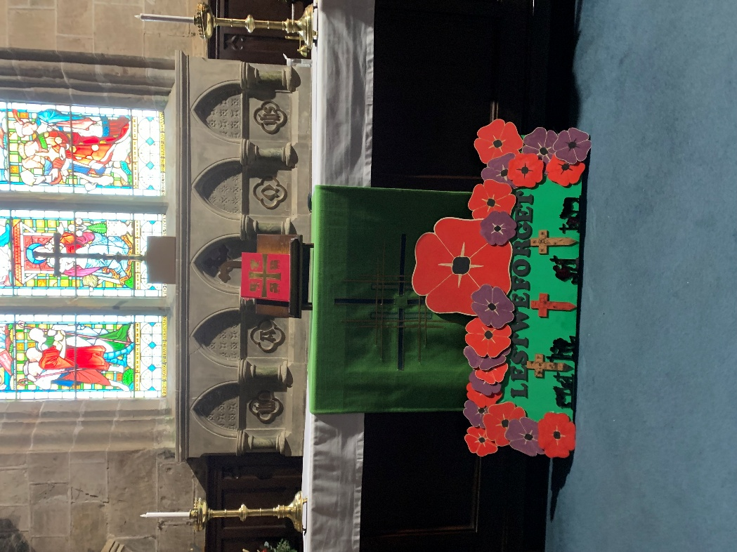

In our weekly prayers for our parish
This week we pray for God’s blessing on Ridgeway Drive, Rowan Close, and Sandringham Place.

New Testament Readings from the Lectionary

Monday 27th John 13: 1 to 11
Tuesday 28th Simon & Jude, Apostles Luke 6:12 to 16
Wednesday 29th John 13: 21 to 30
Thursday 30th John 13: 31 to end
Friday 31st Martin Luther, Reformer John 14: 1 to 14
Saturday 1st All Saints Day Luke 9: 18 to 27

We are using the readings from the
Church of England’s Morning Prayer service.
All Saints Church
Refreshments After the Morning Service
Please stay seated after the service and a hot drink will be brought to you in the pews.
Church contact information
Contact: Rev’d Christine - revchristine@outlook.com
The Rectory, The Village, West Hallam, DE7 6GR
Landline 0115 646 1497
Rev’d Ailsa -revailsahunt@gmail.com
Tel - 07356064856

Churchwardens – Mrs Janet Wheeldon, -Tel: 0115 8771593
Mrs Linda Gregory – linda.gregory3@icloud.com
https://www.achurchnearyou.com/church/13402/
https://www.facebook.com/allsaintskirkhallam
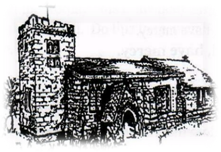
Kirk Hallam
Disabled Toilet in Friendship House.
Disabled Toilet in Friendship House.

Working with God to transform lives & communities.
Please can you ensure your mobile is on silence, or off during the service, it is affecting people with hearing aids and the loop system.

26th October – Last Sunday After Trinity – Bible Sunday
10.00am Communion Service with Rev’d Ailsa & Eileen
4.00pm BCP Evening Prayer with Rev’d Christine

Forthcoming Events
Mon 27th 4.00pm Interring ashes of Trevor Watkins
Mon 27th 6.00pm Young People’s Confirmation Class
Tues 28th 6.00pm Home Group in Friendship House
Weds 29th 9.30am Morning Prayer at UCAS, Stanley Common
Fri 31st 1.00pm Funeral of Patricia Crowe in church
Fri 31st 6.00pm Choir Practice in Friendship House
Sat 1st 10.00am Prayer Meeting in Friendship House
Mon 3rd 11.00am Funeral of Dulcie Reece in church
Tues 4th 11.30am Mid Week Remembrance Service
with local schools

2nd November – Fourth Sunday Before Advent
10.00am Communion Service with Rev’d Christine
4.00pm BCP Evening Prayer with Alan and Eileen
It’s Good to Talk! If you spot that someone is missing, please pop a news sheet through their door, & if you’ve time, call for a chat - just to check they’re OK & to let them know that they are not forgotten!
‘So whether you eat or drink or whatever you do, do it all for the glory of God’ 1 Corinthians 10:31

