St. Aidan’s Church October 2025
Hub Leader | Rev Sandra Jones | 07598 847391 | sandra.jones@churchwigan.org
Associate Hub Leader | Rev Sue Fulford | 01942 242369 | sue.fulford@churchwigan.org
Self-Supporting Minister | Rev Sue Thomas | 07877 704645 | sue.thomas@churchwigan.org
Reader | Helen Steele | 01744 894111 | hrsteele@tiscali.co.uk
Assistant Warden | Barbara Goulden | 01744 894694 | staidansverger@yahoo.com
Assistant Warden | Peter Hughes | 01744 732890 | pjh1950@hotmail.com

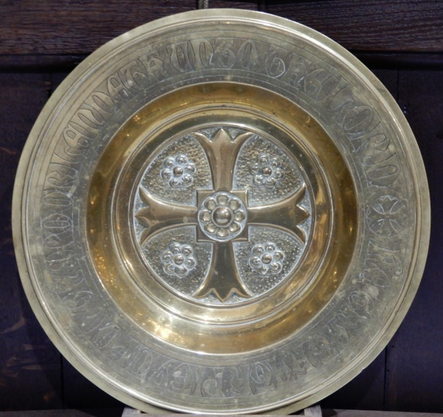
Wigan South Bible passage for 2025:
‘May the God of hope fill you with joy and peace as you trust in him, so that you may overflow with hope by the power of the Holy Spirit.’ Romans 15:13

St Aidan’s Mission Statement
Our Mission is to:
Introduce people to Jesus
Become more like Jesus
Do what Jesus does

Upcoming Services:
Oct 5th 10am Holy Communion Celebrant Rev Dave Hamlett ,
Oct 12 th 10am Sta’s4all at school 4pm Evening Prayer
Sept 19th 10am Morning Worship 4pm Remembering Loved Ones Service
Sept 26th 10am Beacon Service, 4pm Holy Communion Celebrant Rev Sue Fulford

Wednesday Holy Communions 10am:
Wed 1st and 17th Oct will be at St. Aidan’s, celebrants Rev Sue Thomas and Rev Sandra respectively. Wed 8th and 22nd Oct Holy Communion will be at Holy Trinity.

The Remembering Loved Ones Service is co-ordinated by the Pastoral Care Team joined by Rev Dave Hamlett (who comes to our Bereavement Group on the first Friday each month) and Rev Sue Thomas. If you would like a name adding to the list for the Remembering Loved Ones Service at 4pm on October 19th please let either Margaret Stott or Barbara Goulden know by Sunday October 12th. All are welcome at this service.

The Parish Gift and Heritage Day.
A huge thank you to those who came along as volunteers to do church tours, refreshments and more, and to those who donated to Parish funds. It was nice to see Councillors Betts and Gill and to see a few other visitors. It was a very interesting Heritage day, the re-appearance of the millennium hanging was appreciated, the time-line went down well, as did the various photographs, and we all had a great time watching the recording of a walking day (mid 80’s we think) and saying – ‘oh look it’s Ron Buxton’ ‘Is that Cliff Stockley?’ ….. Thanks to Marlene Roby for donating the paintings of places in Billinge, which were available for sale. This sale is ongoing. The total raised is not yet available before going to print, so will be included next month.
I asked the question – what is happening today which will be seen as a part of our history in 50 years time? Our history books, last published in 2006 need updating. What would you want to include for future generations to know and understand? Please drop me a line to tell me, and I will try to take this forward.
June Phillips asked if I knew when the 2 stained glass windows on the south side of church (which were very dark) were split, inserting some lighter glass, and the removed dark blue pieces put into the 3rd window on that side of the church. I can remember it happening, so it was after 1982, but I don’t have a specific date. Does anyone have any ideas?
Thank you to all who brought contributions to the Harvest Festival. The church looked lovely in it’s harvest decorations. The gifts that were brought were given to the Pantry. Well done to the pupils from St Aidan’s school who grew some wonderful pumpkins which were displayed in church.

A sincere thanks to all those who bought tickets, those who came and those who made donations to Bethany’s Concert for her charity work in Kenya next summer. The standard was exceptional, enjoyed by all, and she was thrilled to nearly £600 – some donations are still trickling in.
Patricia and John would like to thank all those who attended the Macmillan Coffee morning at their home. It was a busy event with lots to eat, as well as quizzes and good company. They are so grateful to everyone for their generosity. They made a wonderful £875 for the charity.

The Friendship Group was enjoyed by 40 people in September, including a visitor from Halifax! They next meet on Thursday October 23rd in church from 2pm. Terry will be talking about his trip to Iceland. (Jennifer says that it’s not the supermarket!) This is open to all comers. It is a place to make new friends as well as sharing time with those that you may know.

The next Committee meeting will be on October 21st.
Safeguarding - We are called to share the good news of God’s Salvation through Jesus Christ. This good news speaks of a welcome for all, with particular regard for those who are most vulnerable into a community where the value and dignity of every human being is affirmed and those in positions of responsibility and authority are truly trustworthy. Our volunteers regularly update their safeguarding qualifications. Being faithful to our call to share the gospel therefore compels us to take with the utmost seriousness the challenge of preventing abuse from happening and responding well where it has.

I wonder if you know who you would contact if you had concerns about a church member or someone in our community? There is a notice at the back of church with contact details on it. If you have concerns you can contact Peter Hughes or Helen Steele. Our Wigan South Parish Safeguarding officer is Helen Weavers (077963 34457) and the Diocesan Safeguarding Advisor is Andrew Holmes (07940 378139)

If you believe a child or adult is in immediate danger of significant or serious harm, contact the emergency services on 999.

Across the Hub:
Saturday 4th October – An afternoon with Trinity Girl’s Band at St Andrews Church, Garswood starts at 2pm. Tickets priced at £7 including refreshments. Please contact Ros Unsworth (01942 712390) for more information.
A new monthly worship community is being launched in Rectory School on October 5th, starting at 12.30 including food, fun, worship and prayer. It is primarily intended for young families and people who do not normally come to church. Please pray for the team there.
The next ‘Start’ course is being held on Wednesdays at 7pm at St Aidan’s, starting on October 8th. Got questions about life and the Christian faith? ‘Start’ will help you discover more about God, Jesus and the journey of life. It is also a good refresher course for those of a mature faith. It lasts for 8 weeks. Contact Revd Sandra Jones of Revd Sue Fulford if you would like to know more.
Note the date – Sunday 7th December at 11am Stuart Barton will be commissioned as a Local Missional Leader at Holy Trinity Church. Stuart has been doing a great job whilst in training. Please pray for Stuart as his ministry is confirmed. It is a bit close to our own service time, but there is an open invitation for all to attend.

The Registers 2025
Funerals or Burial of Ashes – ‘May they rest in peace’
Date | Name |  | Date | Name
04/09/25 | Helen Margaret Mathers |  | 23/09/25 | Harold Eli Ratcliffe
18/09/25 | David Hickling
Holy Matrimony - ‘all the days of their lives’
27/09/25 | Rosie Murray and Simon Dore

Donations and Remembrance
I am sorry that the donations for September were not available at the time of publishing, so will be included in the November Newsletter.

Prayer for the Parish

If anyone needs to be added to our prayer list please let Helen Steele or Margaret Stott know. The person or family must give permission for any name to be added to the list. Our ‘sick list’ has people listed by their first names so that some confidentiality is preserved. These people are known to God as we pray in this way.

For confidential prayer needs contact Jennifer Berry for the St Aidan’s Prayer Circle on 01942 389715 or Brenda Bridge on 01744 894528.



Please pray for all those you know who need God’s healing touch, those who are struggling in Body, Mind and Spirit, and from our parish we pray especially for Tracey-Ann, Jeanette, Roy, Linda, Young Olivia, Baby Ellie, Jack, Caroline, Bill, Jeff and Alan. Remember the bereaved and all who are feeling the pain of separation from their loved ones, whether that is recent or a while ago. We pray for the family and friends of David Hickling, Harold Eli Ratclife and Geoff Berg who died recently.
Please pray for us to continue to move forward with our Mission Plan, give thanks for the activities in church which enable us to reach out to our local community and our current volunteers and to ask for God’s guidance in further development. Please pray also for an improvement in our financial position.

