
WELCOME!
ST STEPHEN’S CHURCH IS OPEN
10am-3pm daily
for Private Prayer and Reflection

BULLETIN
26th October 2025
The Last Sunday after Trinity
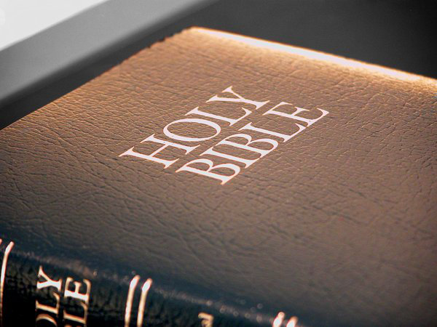
10.30am Family Communion

Notices for inclusion in the bulletin please email to me by Tuesday of each week

officeststephenfradley@gmail.com
Please take Bulletin away with you



Diary Dates

October 2025

Sunday 26th 10.30am Family Communion
Refreshments are served after every service


Monday 27th 10.30am Funeral of Dennis Seal
Wednesday 29th2-4pm Wednesday Welcome
Thursday 30th 9.30am Events Committee

November 2025

Sunday 2nd No service at St Stephen’s
We join with All Saints Alrewas at 10am
for their Patronal Festival.
Bishop Tim will be joining us

Sunday 9th Remembrance Sunday
10.30am Family Communion
with Act of Remembrance
6pm Remembrance Service
with the Uniformed organisations

Welcome to our Worship today
If you are visiting for the first time, please introduce yourself so that we may welcome you personally.

26th October 2025

Collect

Merciful God,
teach us to be faithful in change and uncertainty,
that trusting in your word
and obeying your will
we may enter the unfailing joy of Jesus Christ our Lord.

Readings

Ecclesiasticus 35. 12-17 2 Timothy 4. 6-8, 16-18
Luke 18. 9-14

Post Communion Prayer
God of all grace,
your Son Jesus Christ fed the hungry
with the bread of his life
and the word of his kingdom:
renew your people with your heavenly grace,
and in all our weakness
sustain us by your true and living bread;
who is alive and reigns, now and for ever.



IF YOU CAN PLEASE MAKE A DONATION
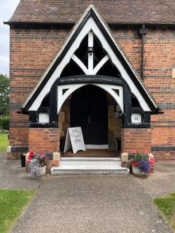
It costs £3,500 each month
to meet the running expenses of our beautiful church,
which we have to raise.
At this time we are not managing to meet these costs.
If you feel that you could make a donation to help it would be hugely appreciated.
THANK YOU



Forthcoming Events

November 2025



Sunday 23rd Christmas Meal at The Swan at Fradley Junction

****


Friday 28th Iva’s Christmas Quiz. 7.00pm Community Hall.
Quiz with children’s only round. Raffle.
Teams of 4 or 6

Saturday 1st November
at All Saints Church Alrewas
3pm All Souls Service
Commemorating the Faithful Departed
All are welcome
If you would like the name of a loved one commemorated at this service please sign the sheet at the back of church
or email Rev Elizabeth Wall ayton265@gmail.com

Benefice Service
at All Saints Church, Alrewas
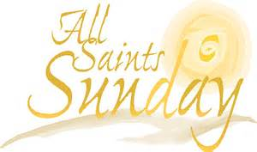

2nd November
10am Family Communion
celebrating All Saints

We welcome the Rt Revd Dr Tim Wambunya
Bishop of Wolverhampton
to preside and preach at this service
Do join us!

Can you help to support St Stephens Church?
St Stephen’s Church is heavily dependent on voluntary donations and income from events in order to fulfil its ministry to the local and wider communities.
If you would like to support us at this time,
donations can be made via our Just Giving page.
We are grateful for any donation, large or small.

https://www.justgiving.com/
fundraising/ststephensfradley

Contact us
Revd. Elizabeth Wall
01543 254891
Email: ayton265@gmail.com

Churchwarden
Marian Derry
01283 791573

St Stephen’s Administrator: Di Cooper
07930162991
officeststephenfradley@gmail.com

Find us on
ACNY https://www.achurchnearyou.com/church/4123/
Face bookwww.facebook.comststephensfradley

DC 22/10/25

