**St John the Evangelist Church, Trent Vale**

**Newsletter Autumn 2025**

**It is clearly Autumn as thousands of acorns cover the pavement, snatched from the old oak tree opposite the Black Lion pub.**

**It must have seen many changes and heading towards the church can be seen the charred, black, beams of the roof of the Furama Palace restaurant, formerly The Swan pub. Treasurer Nick took a message from us sympathising with the owners as they begin talks with the insurers.**

**Our church building sits surrounded by neatly mown lawns. The tall Rudbeckia sway in the breeze. Soon builders’ cabins will be arriving, heralding the start of the work to renovate the church.**

**Orders have been placed in Yorkshire for the seating and in Pendle the artist awaits a date to begin the beautiful new stained-glass window.**

**We hope to return to the church by Christmas 2026. So much hard work has been done to reach this point by our Church Wardens and PCC members.**

**As a worshipping church we have not been becalmed during the last three years taking on the challenge to adapt and find new and exciting forms of worship. During that time Revd Liz arrived; Revd Mike has moved from Hartshill Church to become Assistant Minister at St Marks, Shelton which has now reopened after years of exterior renovation, as a member of the Hanley Team Ministry.**

**Unfortunately, Mike’s wife, Revd Fran of Penkhull, is unwell and we continue to hold her and Revd Mike in our prayers. Revd Liz now has extra duties and is assisted by Alan Smith and Mike Whittaker and we now hold joint services once a month with some services lay-led which have included moving testimonies from Church Warden Sam and from Josie Ankers telling of their journeys of faith through changing family circumstances and illness over the years. We found these very revealing and inspiring. Church Warden Eileen played a beautiful on-screen film of a “Conversation with God”.**

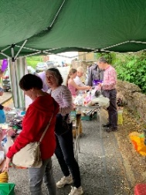**Over the summer there have been outdoor opportunities to set up a gazebo and stall to offer goods and time for chat and prayer. The first was held at Penkhull church as part of their Mystery Plays.**

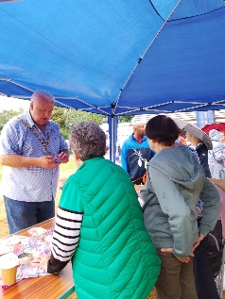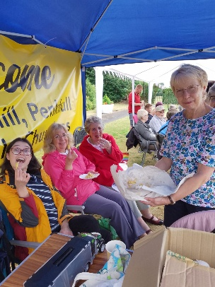**The second was the ‘Picnic on the Green’ held at the headquarters of Penkhull Village Brass with its former bowling green surrounded by colourful planters. Under gazebos, the band played a variety tunes and melodies and the three churches met and set up the stall once again, though this time it rained non-stop. This did not discourage people attending including the Lord Mayor, Councillor Steve Watkin who chatted in the rain in his shirt sleeves.**

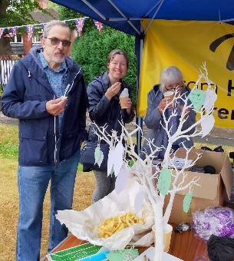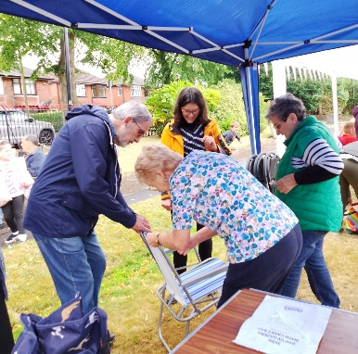**Refreshments were served in the Club House. I decided some hot food would be welcome and went to the local prize-winning Fish and Chip shop and ordered £10 of chips. The owner Mangal Singh, on hearing of our event, kindly gave a further order free of charge! I promised him I would vote for him in the following round of voting. The amount of chips was welcomed with much laughter, the happy mood continuing as we began to pack up and I videoed the hilarious spectacle of six people endeavouring to collapse the vicar’s camp chair. The weather did not dampen our spirits. Much like the many challenges all our three churches are facing.**

**The following Saturday Steve attended Springfield Manor’s first anniversary. A bouncy castle proved to be an opportunity for carers to gently place Mavis Brown inside for a very careful bounce. Husband Selwyn and son watched and their son carefully joined his Mum in this happy activity. Monthly visits are now paid by Revd Liz and church members.**

**Our Monday morning Welcome Spaces continues to be popular with about forty attending each week to enjoy the free refreshments. Three loaves are toasted with many asking for the homemade marmalade.**

**It is an opportunity to fundraise not only for our church but for charities as well.**

**On Monday 28th September Steve organised a Macmillan Coffee Morning with the sale of cakes, a raffle and Bingo and a clothes stall. £200 was raised for this worthwhile cause.**

**Local Councillor Waseem Akbar is a regular visitor making it an opportunity for people to share their concerns. On 11th August he brought MP Gareth Snell and Councillors Alistair Williams and Majid Khan, a former Lord Mayor and visitor to our church when he was in office.**

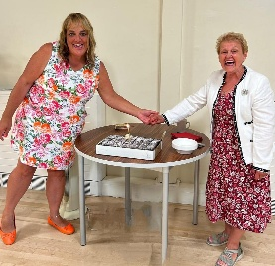**Visiting us on recent Sundays have been Revd Alan Betts and Matthew, Bishop of Stafford who told of his reluctance to join in any dancing activities at his son’s wedding but that mustn’t stop us from rejoicing in our worship. I gave him a copy of our Centenary Newsletter proving St John’s is always keen to party.**

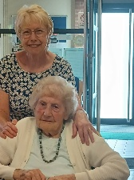**I’d like to thank everyone for their generosity for celebrating my own birthday which among the cakes was one from Sam with a health warning as it was a huge alcoholic Black Forest Gateau.**

**We have congratulated Jean Preston on her ninety-sixth birthday and who continues to worship with three generations of her family and enjoys all our social outings.**

**Scotty held a party for his fortieth and Janet and Neil McAvoy celebrated their Golden Wedding anniversary.**

**On Sunday 5th October we were joined by Penkhull Village Brass for our Harvest Festival service led by Revd Liz. The long table of donations was piled high with food for the Food Bank. There were also lovely cakes for enjoying after the service.**

**Bishop Matthew will be coming back for a Confirmation Service on Sunday 2nd November.**

**On Saturday 22nd November we will be holding our annual Christmas Fair. Then on Sunday 7th December is Star Sunday, an opportunity to remember loved ones by placing named stars on the huge Christmas tree in the Foyer, with the names displayed on the screen with soft music playing. Always a very special day.**

**We will be visiting the New Vic Theatre on Friday 12th December for “Eric’s Christmas Turkey”, once again a trip organised by Jackie Barnes. The last show “Eric’s HiDeHi” saw her husband Steve and Steve Copner taking part in the ‘Knobbly Knee and Glamorous Granny’ competition, much to the applause of the contingent from St John’s.**

**On Sunday 14th December we will be holding the Benefice Carol Service. Local children will enjoy a free Christmas party funded by Cllr Waseem who is also generously offering £500 towards the Welcome Spaces morning expenses.**

**We know a great deal of planning and hard work will be needed to complete these services and events.**

**A regular visitor to our services, Nello, has been travelling extensively and visited many churches, spreading his faith.**

**We are truly blessed to have Revd Liz and such committed Church Wardens in Eileen and Sam and members of the church family who give so much to our worship and outreach.**

**Our sincere thanks too to Revd Adrian and the congregation at Trentham Parish Church for all their support and encouragement.**

**We hope you have enjoyed reading of our life here in Trent Vale and send you our love and hopes that you will be able to enjoy the future months leading to Christmas.**

**Bobbie and all your friends at St John’s Trent Vale.**



**(Autumn Newsletter October 2025)**