The Parish of Saint Peter with st martin Edmonton IN THE DIOCESE OF LONDON (1817)
Vicar: The Revd Tina Kelsey
Tel: 07512710085 020 8807 7431
email: tina.jk42@yahoo.co.uk stpetersedmonton@gmail.com

Online shopping donations www.easyfundraising.org.uk Card Reader at back of church
Tax payers: please fill in a pink gift aid form/use a white envelope
Planned giving Scheme for your weekly/monthly pledges; please fill in a green form
Standing Order/Digital donations
BACS Acc Name: St Peter with St Martin PCC Acc No: 60795178 Sort Code: 20-53-00
Social Media Links
YouTube: St Peter the Apostle Edmonton Website: www.achurchnearyou.com
Instagram: stpeterschurchedmonton Blog: http://www.stpeterloweredmonton.blog
Twitter: @peters_with Facebook: St Peter with St Martin Church, Lower Edmonton
Welcome to St Peter’s. If you need help, please speak to those at the back.
If you are confirmed or usually receive Communion you are welcome to receive it here.
No photography during the service & please ensure your phone is off/silent. Epistle read in the reader’s preferred language. Please pray the Lord’s Prayer in your preferred language.

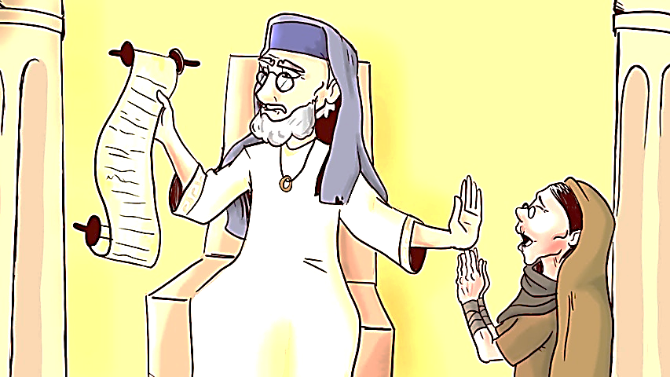
Eighteenth Sunday after Trinity:
19 October 2025 9.30am

Hymns
Processional: No 3 Father we praise thee
Gradual: No 631 Fight the good fight
Offertory: No 621 Dear Lord and Father
(Collection is taken: card reader at back)
Communion: No 629 Father hear the prayer
Recessional: No 634 Firmly I believe and truly

Readings (Year C)
Old Testament: Genesis 32:22-31
Epistle: 2 Timothy 3:14-4:5
Gospel: Luke 18:1-8

Collect
Almighty and everlasting God
Teach us to be open to your truth
and to trust in your love
that we may live each day with confidence in the salvation which is given
through Jesus Christ your Son our Lord
who is alive and reigns with you,
in the unity of the Holy Spirit,
one God, now and for ever
Amen

From Psalm 121
R My help comes from the Lord
the maker of heaven and earth
I lift up my eyes to the hills
from where is my help to come?
My help comes from the Lord
the maker of heaven and earth R

He will not let your foot to be moved
and he who watches over you will not fail Behold he who keeps watch over Israel shall neither slumber nor sleep R

The Lord himself watches over you
the Lord is your shade at your right hand
so that the sun shall not strike you by day nor the moon by night R

The Lord shall preserve you from all evil;
it is he who shall keep you safe t
he Lord shall watch over your going out
and your coming in
from this time forth and for evermore R
Alphabet Church: P is for Parish Church: In England, a church serving an area under the spiritual care of a Church of England member of the clergy.

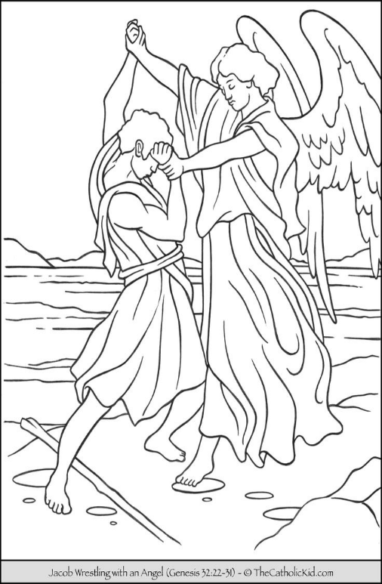
Old Testament: Genesis 32:22-31
The same night he got up and took his two wives, his two maids, and his eleven children, and crossed the ford of the Jabbok. He took them and sent them across the stream, and likewise everything that he had. Jacob was left alone; and a man wrestled with him until daybreak. When the man saw that he did not prevail against Jacob, he struck him on the hip socket; and Jacob's hip was put out of joint as he wrestled with him. Then he said, ‘Let me go, for the day is breaking.’ But Jacob said, ‘I will not let you go, unless you bless me.’ So he said to him, ‘What is your name?’ And he said, ‘Jacob.’ Then the man said, ‘You shall no longer be called Jacob, but Israel, for you have striven with God and with humans, and have prevailed.’ Then Jacob asked him, ‘Please tell me your name.’ But he said, ‘Why is it that you ask my name?’ And there he blessed him. So Jacob called the place Peniel, saying, ‘For I have seen God face to face, and yet my life is preserved.’ The sun rose upon him as he passed Penuel, limping because of his hip.

Epistle: 2 Timothy 3:14-4:5
But as for you, continue in what you have learned and firmly believed, knowing from whom you learned it, and how from childhood you have known the sacred writings that are able to instruct you for salvation through faith in Christ Jesus. All scripture is inspired by God and is useful for teaching, for reproof, for correction, and for training in righteousness, so that everyone who belongs to God may be proficient, equipped for every good work. In the presence of God and of Christ Jesus, who is to judge the living and the dead, and in view of his appearing and his kingdom, I solemnly urge you: proclaim the message; be persistent whether the time is favourable or unfavourable; convince, rebuke, and encourage, with the utmost patience in teaching. For the time is coming when people will not put up with sound doctrine, but having itching ears, they will accumulate for themselves teachers to suit their own desires and will turn away from listening to the truth and wander away to myths. As for you, always be sober, endure suffering, do the work of an evangelist, carry out your ministry fully.

Gospel: Luke 18:1-8
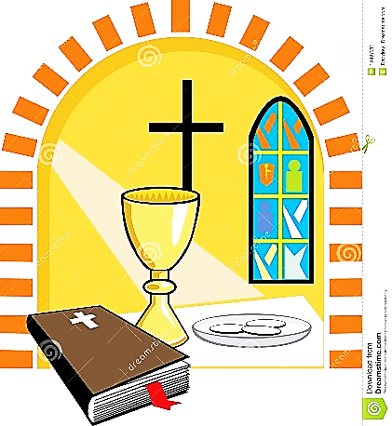
Then Jesus told them a parable about their need to pray always and not to lose heart. He said, ‘In a certain city there was a judge who neither feared God nor had respect for people. In that city there was a widow who kept coming to him and saying, “Grant me justice against my opponent.” For a while he refused; but later he said to himself, “Though I have no fear of God and no respect for anyone, yet because this widow keeps bothering me, I will grant her justice, so that she may not wear me out by continually coming.” ’ And the Lord said, ‘Listen to what the unjust judge says. And will not God grant justice to his chosen ones who cry to him day and night? Will he delay long in helping them? I tell you; he will quickly grant justice to them. And yet, when the Son of Man comes, will he find faith on earth?’

Post Communion Prayer
Lord We praise and thank you O Christ for this sacred feast;
for here we receive you, here the memory of your passion is renewed,
here our minds are filled with grace and here a pledge of future glory is given where we shall feast at that table
where you reign with all your saints for ever
Amen

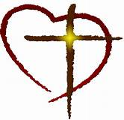
PARISH PRAYERS OF INTERCESSION
We pray in the name of Jesus Christ and in the power of the Spirit alongside Christians throughout the ages and around the world

For the lost, the lonely, the grieving and the hungry, Those on our prayer board and in our parish and communities including: Kathy Draper, Margaret Johnson, John Higson, Ghislaine Glover, Errol Mullings, Waple Beckles, Marilyn Noel, Anne, Paul Allen, Michael Savage, Havva, Gary, Maureen Currie, Jason Noel, Sister Aelred
& all known personally to us.

Father we leave them in your healing hands you know their needs
much better than we
For Archbishop Stephen, Bp Sarah, Bp Anderson & all faith leaders
For King Charles & the royal family
For world leaders & governments
For all living & working in Gordon Road
For lasting peace in places of conflict

For the recently departed including Norma Corbin, Zaliha Mustafa-Savage, and all who have died this past week

For those at their year’s mind including: James Throp, John Eldridge, Ivan Katchay, Ethel Williams, Ivan Griffith, Tony Worrell


May they rest in peace and rise in glory

The Sanctuary candle has been sponsored by Hydee for Edwina & Joshua

PARISH NOTICES

20 Monday (Feria)

21 Tuesday (Feria)
1pm: Foodbank

22 Wednesday (Feria)
10.30am Mass
7.30pm: Prayer Vigil

23 Thursday (Feria)

24 Friday (Feria)
9am-12pm Community Coffee Morning

25 Saturday (Crispin & Crispian 267)
10am-12pm: Saturday Sale

26 Bible Sunday
9.30am: Parish Mass
(Is 45:22-end, ps119, Rom 15:1-6,
Luke 4:16-24)

Lord
You are love,
you are hope
you are joy,
you are courage
you are peace,
you are justice
you are friendship
you are compassion
You are the same
yesterday, today and for ever

This month’s 100 Club Winners:
Timothy Munt, Claire Munt

Wanted: Boys/teens Trainers & Boots
Promise Homes Uganda; please give to Hydee
--------------------------------------------------

Sunday 26 Oct Bible Sunday
Bring your bibles in for a blessing
-------------------------------------------------
Saturday 1 Nov MU All Saints BBQ 4pm-7pm
Tickets from Hydee
---------------------------------------
Sunday 2 Nov All Souls Service 3.30pm
The list is at the back of church for the names of your departed loved ones. Only the names on this list will be read out.
------------------------------------------
Saturday 22 Nov Xmas Fayre 11am-3pm
Please start bringing in your donations and think about which stall you can run.
Planning meeting TODAY after Mass
----------------------------------------
Sat 29 Nov 5.30pm St Paul’s Advent Carols
If you would like to go to this please sign the sheet at the back of church
------------------------------------------
Put the dates in your diary; Spread the word!

God’s blessing be on you this week; do get in touch if you need too. Revd Tina
Welcome to the weekly St. Peter’s quiz. Have fun and learn something new. (279)

Bible: Genesis
1 After he had sent them across the stream, he sent over all his what?
2 So Jacob was left alone, and a man wrestled with him till when?
3 When the man saw that he could not overpower him, he what?
4 Then the man said, ‘Let me go, for it is what?

General:
1 What is the largest Spanish-speaking city in the world as of 2025?
2 Which country has the most islands?
3 In Australia, what is commonly known as a bottle shop?
4 In which U.S. state is the country's busiest airport located as of 2025?
Last week answers
Bible
1 This command shows compassion
2 Praising God
3 And he was a Samaritan
4 Cleansed

General
1 yellow
2 12
3 10,080 minutes
4 St Stephen’s Day

