Westfield Church Notices Sunday 28th September

Valerie writes:

Harvest Festival

This week we give thanks to God for farmers who grow our food. It's very easy to take the food on our plates for granted. Let's take a moment to think about those who grow our food and those who transport it.

Lord God, we thank you for your great faithfulness,
through summer and winter, springtime and harvest.
Give us strength to flourish and to support each other
as we grow into the people you want us to be.
Help us this harvest season not to store up what we have for ourselves but to share with those around us.
In Jesus' name
Amen

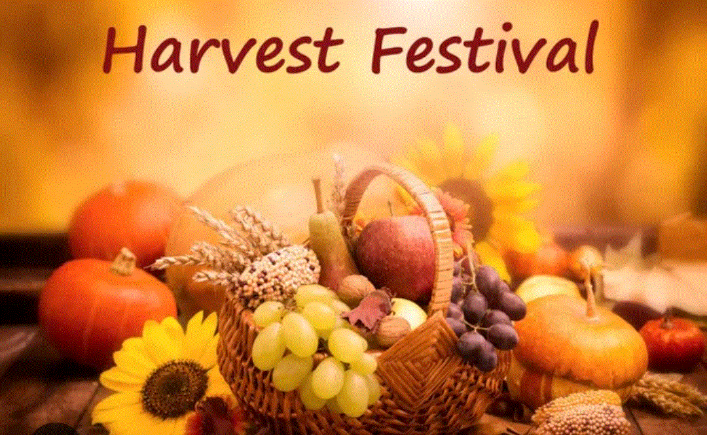

What’s on:

Sunday 28th September
8.00am: Prayer Book Communion
9.30am: Morning Praise Harvest Festival

Wednesday 1st October
9.30am: Holy Communion
10.30am: Warm Space Community Hub

Congratulations to Margaret
Margaret received her Order of St Richard at Chichester Cathedral on Saturday 20th September. Here are some photos of Margaret at the Cathedral receiving her well-earned award. Congratulations Margaret
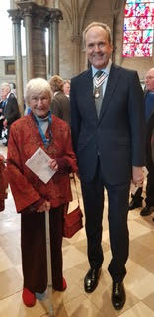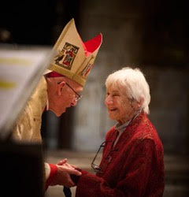

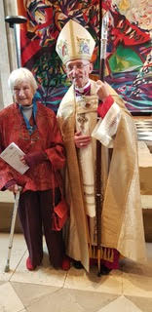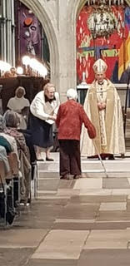

Prayer:

If you would like a situation prayed about urgently, please contact the church Prayer Share. Contact Dawn 01424 255423 / 0750 7745 159

If you know anyone who would like to be added to the notices, please send me an email with their details. If you don’t want to receive this email each week, or would rather receive it in a different format, please let me know.
Please give information for notices to me by Thursday morning (contact details below).
Have a good week everyone,
Tony Demarco tonydemarcohastings@gmail.com

