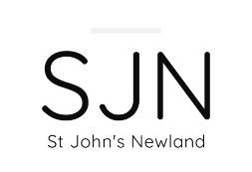
SJN Newsletter 17 - October 2025
Harvest
A huge thank you to all those who contributed to the harvest collection last Sunday. The items were collected on Monday by Westbourne House homeless hostel, who were very grateful for the donations, which will help with their valuable support for those using the centre.

Bonfire party
An outdoor service and bonfire for the whole community is planned for the evening of Sunday November 2nd at 5pm. Please see attached flyer. It would be great to have extra support for this so, if you are able to help with serving drinks, hot dogs or as a steward, please let Jake or Hannah know. You can email them on revjmadin@gmail.com or revhmadin@gmail.com.

Giving
A reminder that the Parish Giving Scheme is the best way to give regularly to St. John's but it is currently in the process of setting up a new website and is currently offline until the Thursday 30 October.

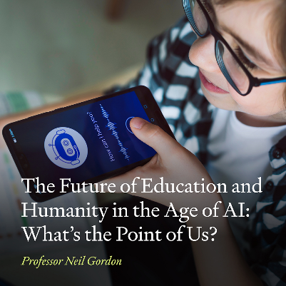
Public Lecture: The Future of Education and Humanity in the Age of AI: What's the Point of Us?
Public lecture by Professor Neil Gordon, university of Hull. All welcome.
In a world increasingly shaped by artificial intelligence, what remains uniquely human? In this Inaugural Lecture, Professor Neil Gordon draws on decades of experience in computing, education, and ethical leadership to explore how AI is transforming learning, decision-making, and our collective sense of purpose. With some playful nostalgia of early home computers to the profound implications of generative AI in classrooms and clinics, this talk journeys through the promises and perils of our technological age. With global challenges like educational equity and digital health disparities in view, Professor Gordon asks: how do we ensure that human experience, creativity, and moral agency remain central? Join us for a thought-provoking talk that blends personal reflection, societal insight, and a call to action - inviting educators, technologists, and citizens alike to reimagine the future of learning and life in the age of intelligent machines. For more details and to register go to: Attendees ⋮ Neil Gordon | Inaugural Lecture ⋮ Blackthorn Events


Heart 4 Hull


Upcoming events from Heart 4 Hull:
Church Planting & Renewal workshop This is the 5th theme that was identified in the Heart for Hull vision for the Deanery. The evening will allow plenty of space to share learning, experiences and encourage discussion about what we need to consider for planting and renewal in the deanery. The workshop will take place on Thurs 23 Oct at St Barnabas, Swanland. 6.15pm for refreshments and 6.30pm start.

To book a place please email: heart4hull@yorkdiocese.org

If you would like to receive the email version of the newsletter, please send your email address to SJNHull@outlook.com.

