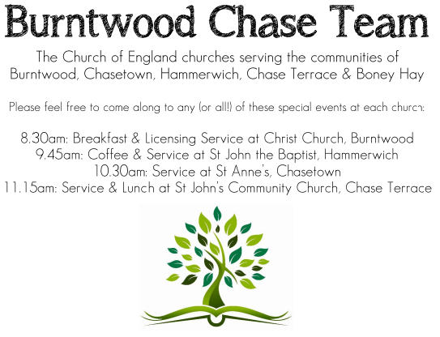 CHRIST CHURCH
SUNDAY 2nd November 2025 at 10am

SERVICES:
Sunday 2nd November 2025
Holy Communion
4th Sunday before Advent

Readings:
Isaiah 1: 10-18
¹⁰ Hear the word of the Lord,
you rulers of Sodom!
Listen to the teaching of our God,
you people of Gomorrah!
¹¹ What to me is the multitude of your sacrifices?
says the Lord;
I have had enough of burnt-offerings of rams
and the fat of fed beasts;
I do not delight in the blood of bulls,
or of lambs, or of goats.
¹² When you come to appear before me,
who asked this from your hand?
Trample my courts no more;
¹³ bringing offerings is futile;
incense is an abomination to me.
New moon and sabbath and calling of convocation—
I cannot endure solemn assemblies with iniquity.
¹⁴ Your new moons and your appointed festivals
my soul hates;
they have become a burden to me,
I am weary of bearing them.
¹⁵ When you stretch out your hands,
I will hide my eyes from you;
even though you make many prayers,
I will not listen;
your hands are full of blood.
¹⁶ Wash yourselves; make yourselves clean;
remove the evil of your doings
from before my eyes;
cease to do evil,
¹⁷ learn to do good;
seek justice,
rescue the oppressed,
defend the orphan,
plead for the widow.
¹⁸ Come now, let us argue it out,
says the Lord:
though your sins are like scarlet,
they shall be like snow;
though they are red like crimson,
they shall become like wool.

Luke 19: 1-10
He entered Jericho and was passing through it. ² A man was there named Zacchaeus; he was a chief tax-collector and was rich. ³ He was trying to see who Jesus was, but on account of the crowd he could not, because he was short in stature. ⁴ So he ran ahead and climbed a sycomore tree to see him, because he was going to pass that way. ⁵ When Jesus came to the place, he looked up and said to him, ‘Zacchaeus, hurry and come down; for I must stay at your house today.’ ⁶ So he hurried down and was happy to welcome him. ⁷ All who saw it began to grumble and said, ‘He has gone to be the guest of one who is a sinner.’ ⁸ Zacchaeus stood there and said to the Lord, ‘Look, half of my possessions, Lord, I will give to the poor; and if I have defrauded anyone of anything, I will pay back four times as much.’ ⁹ Then Jesus said to him, ‘Today salvation has come to this house, because he too is a son of Abraham. ¹⁰ For the Son of Man came to seek out and to save the lost.’

COLLECT FOR TODAY
Almighty and eternal God,
you have kindled the flame of love
in the hearts of the saints:
grant to us the same faith and power of love,
that, as we rejoice in their triumphs,
we may be sustained by their example
and fellowship;
through Jesus Christ your Son our Lord,
who is alive and reigns with you,
in the unity of the Holy Spirit,
one God, now and for ever.

WHAT’S GOING ON
Upcoming Services

Monday 3rd November Cameo Cafe 10-12noon
Wednesday 5th November Morning Prayer 9.30am

Sunday 9th November Morning Worship for Remembrance
at 10am & 10:45am Service of Remembrance at Burntwood Memorial.

Wednesday 12th November Morning Worship

Cameo Cafe
Cameo Cafe will be open on Monday 3rd November, 10 till 12 noon.
All welcome for a cuppa and a biscuit or two.

Christmas Fayre

Our Christmas Fayre will be on Saturday 15th November, 2-4pm.
Any help to set up would be very much appreciated.

FLOODLIGHTING
If you think about commemorating a special occasion by floodlighting our Church. Please contact Chris Brown on 01543 683862 for details.

PRAYER CHAIN
Christ Church is blessed with a very active prayer chain. If you, or anyone you know, feel that they would like others to pray for them, please speak to Chris Brown on 01543 683862.

HOME COMMUNION
For anyone who is unable to attend church and would like Home Communion,
Steve Morgan is able to carry this out.

VICAR CONTACT DETAILS
Stephen Morgan Tele: 07305 852152
CHURCH WARDENS CONTACT DETAILS
Judith Rogers Tele: 01543 324718
Mike Holmes Tele: 01543 672970
Church Office Tele: 01543 642187 [leave a message and we will respond]
Church Web Site:www.christchurchburntwood.org.uk
Church Email: christchurchburntwood15@gmail.com
Facebook: www.facebook.com/group/christchurchburntwood/

Other Contacts
Matt Wallace St. John’s, Chase Terrace— Tele: 01543 670078
Richard Westwood St. Anne’s, Chasetown—Tele: 01543 686111

NEXT SUNDAY SERVICE
Sunday 9th November at 10am
Morning Worship
Job 19: 23-27a
Luke 20: 27-38
Remembrance Sunday

