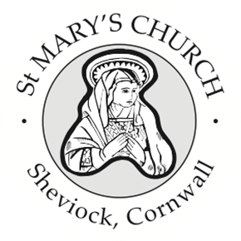
St Mary’s Church, Sheviock
Notices for Sunday 19 October 2025

- I’m very pleased to advise that Stephanie is back at home much sooner than we could have imagined, so we are now able to send flowers. If you would like to contribute, please see Fiona after the service.
- We were very sad to hear the news that Peter England, a faithful servant of St Mary’s for many years, died earlier this month. Unfortunately, we do not have any details for his funeral.
- We also give thanks for the wonderful life of Thelma Wells, a much loved member of our congregation who died at the incredible age of 103. Thelma’s funeral will be at Bodmin Crematorium on Friday 7th November at 1:30 pm.
- Thank you for the contributions at the Pet Service held on 5th October which raised £125 towards Guide Dogs for the Blind and a reminder that we do have application forms to join the Liskeard & Looe Foodbank 200 Club. Our thanks to anyone who has brought a Gift Day envelope today – or contributed online. Fiona will be accepting donations through to the end of November.
- The Book Club will be meeting on Wednesday 22 October at 3pm in Sheviock Memorial Hall, when we will be looking at Chapters 3 and 4 of “Coming back to God when you feel empty” Whispers of Restoration from the Book of Ruth. Please do join us – each session is self-contained so it doesn’t matter if you can’t attend them all.
- Looking ahead to November we have our normal Church care morning on Saturday 1st November between 0900 and 1200 and help is always much appreciated.
- On Sunday 2nd November we have our All Souls Service at 4pm with Revd Michael. There are fliers at the back so please do drop one into anyone you know who would benefit from this reflective service. We will also be remembering all the souls within our churchyard at this service.
- There is no service at St Mary’s on Remembrance Sunday, but we do have an Armistice Day Service outside by the war memorial on Tuesday 11th November at 10:45.
- Our Services for October to December are published on the noticeboards and A Church Near You website and I am now able to advise that we will be holding an “early” Midnight Mass on Christmas Eve at 9pm. We would ask everyone to bear with us as we navigate our way through this transition and new patterns of service are established across the Benefice. On the weeks when we don’t have a service at St Mary’s, we really do encourage everyone to visit one of the other churches in our Benefice.

Weekly Services
A full list of weekly services and events for Rame & Rivers churches is published in the weekly Benefice Newsletter –please let Paul Gribble know if you are not receiving it (or receiving it twice!)

Next Sunday 26th October at 10 am
No service at St Mary’s - Combined Benefice Service at Millbrook

Sunday 2nd November at 4pm
All Souls Service led by Revd Michael Johnson

