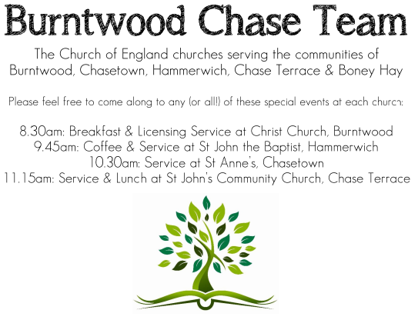 **CHRIST CHURCH**

SUNDAY 5th October 2025 at 10am

**SERVICES:**

**Sunday 5th October 2025**

**Harvest**

**Holy Communion**

**16th Sunday after Trinity**

**Readings:**

**Deuteronomy 26: 1-11**

When you have come into the land that the Lord your God is giving you as an inheritance to possess, and you possess it, and settle in it, **2**you shall take some of the first of all the fruit of the ground, which you harvest from the land that the Lord your God is giving you, and you shall put it in a basket and go to the place that the Lord your God will choose as a dwelling for his name. **3**You shall go to the priest who is in office at that time, and say to him, ‘Today I declare to the Lord your God that I have come into the land that the Lord swore to our ancestors to give us.’ **4**When the priest takes the basket from your hand and sets it down before the altar of the Lord your God, **5**you shall make this response before the Lord your God: ‘A wandering Aramean was my ancestor; he went down into Egypt and lived there as an alien, few in number, and there he became a great nation, mighty and populous. **6**When the Egyptians treated us harshly and afflicted us, by imposing hard labour on us, **7**we cried to the Lord, the God of our ancestors; the Lord heard our voice and saw our affliction, our toil, and our oppression. **8**The Lord brought us out of Egypt with a mighty hand and an outstretched arm, with a terrifying display of power, and with signs and wonders; **9**and he brought us into this place and gave us this land, a land flowing with milk and honey. **10**So now I bring the first of the fruit of the ground that you, O Lord, have given me.’

You shall set it down before the Lord your God and bow down before the Lord your God. **11**Then you, together with the Levites and the aliens who reside among you, shall celebrate with all the bounty that the Lord your God has given to you and to your house.

**John 6: 25-35**

**25**When they found him on the other side of the lake, they said to him, ‘Rabbi, when did you come here?’ **26**Jesus answered them, ‘Very truly, I tell you, you are looking for me, not because you saw signs, but because you ate your fill of the loaves. **27**Do not work for the food that perishes, but for the food that endures for eternal life, which the Son of Man will give you. For it is on him that God the Father has set his seal.’ **28**Then they said to him, ‘What must we do to perform the works of God?’ **29**Jesus answered them, ‘This is the work of God, that you believe in him whom he has sent.’ **30**So they said to him, ‘What sign are you going to give us then, so that we may see it and believe you? What work are you performing? **31**Our ancestors ate the manna in the wilderness; as it is written, “He gave them bread from heaven to eat.”’ **32**Then Jesus said to them, ‘Very truly, I tell you, it was not Moses who gave you the bread from heaven, but it is my Father who gives you the true bread from heaven. **33**For the bread of God is that whichcomes down from heaven and gives life to the world.’ **34**They said to him, ‘Sir, give us this bread always.’

**35**Jesus said to them, ‘I am the bread of life. Whoever comes to me will never be hungry, and whoever believes in me will never be thirsty.

**COLLECT FOR TODAY**

O Lord, we beseech you mercifully to hear

the prayers

of your people who call upon you;

and grant that they may both perceive and know

what things they ought to do,

and also may have grace and power faithfully

to fulfil them;

through Jesus Christ your Son our Lord.

who is alive and reigns with you,

in the unity of the Holy Spirit,

one God, now and forever.

***WHAT’S GOING ON***

**Upcoming Services**

**Monday 6th October Cameo Cafe 10-12 noon**

**Wednesday 8th October Morning Prayer 9.30am**

**Sunday 12th October Morning Worship 10am**

**Wednesday 15th October Morning Prayer 9.30am**

**Sunday 19th October Holy Communion 10am**

**Congratulations**

Congratulations to Steve, he has been re -appointed for a further 3 years and it is a real blessing for us all.

**Cameo Cafe**

Our Cameo Cafe will be open tomorrow, Monday 6th October, 10 till 12 noon. All welcome to join us for a cuppa and biscuit or two.

**MOB**

On Wednesday 8th October a MOB meeting will be held at St Matthew’s at 7pm for 7.30pm start.

**FLOODLIGHTING**If you think about commemorating a special occasion by floodlighting our Church.  Please contact Chris Brown on 01543 683862 for details.

PRAYER CHAIN

Christ Church is blessed with a very active prayer chain. If you, or anyone you know, feel that they would like others to pray for them, please speak to Chris Brown on 01543 683862.

HOME COMMUNION

For anyone who is unable to attend church and would like Home Communion,

Steve Morgan is able to carry this out.

VICAR CONTACT DETAILS

Stephen Morgan Tele: 07305 852152

**CHURCH WARDENS CONTACT DETAILS**

**Judith Rogers Tele: 01543 324718**

**Mike Holmes Tele: 01543 672970**

**Church Office Tele: 01543 642187** *[leave a message and we will respond]*

Church Web Site:www.christchurchburntwood.org.uk

Church Email: [christchurchburntwood15@gmail.com](mailto:christchurchburntwood15@gmail.com)

Facebook: [www.facebook.com/group/christchurchburntwood/](http://www.facebook.com/group/christchurchburntwood/)

**Other Contacts**

**Matt Wallace St. John’s, Chase Terrace— Tele: 01543 670078**

**Richard Westwood St. Anne’s, Chasetown—Tele: 01543 686111**

**NEXT SUNDAY SERVICE**

**Sunday 12th October at 10am**

**Morning Worship**

**Jeremiah 29: 1, 4-7**

**Luke 17: 11-19**

**17th Sunday after Trinity**

**DEANERY CONFIRMATION SERVICE**

**Sunday 26th October 2025 at 5pm**

**At Christ Church, Gentleshaw**

**With the Bishop of Wolverhampton, the Right Rev’d Dr Timothy Wambunya**